

DEVELOPMENT OF REAL-TIME MOBILE BANKING TO IMPROVE CUSTOMERS SATISFACTION IN KENYAN BANKS

SYSTEM DOCUMENTATION

SUBMITTED BY,
Caroline john
DIT-01-0349/2025

A SYSTEM DOCUMENTATION SUBMITTED IN PARTIAL FULFILMENT FOR THE AWARD OF DIPLOMA IN INFORMATION TECHNOLOGY BY ZETECH UNIVERSITY

November,2026

DECLARATION

I, Caroline John, declare that this system documentation is my original work. It has not been submitted to Zetech University or to any other institution for the award of a diploma, a degree or any other qualification. Where the work or ideas of other people have been used, they have been acknowledged through in-text citations and the list of references.

Student name: Caroline John
Admission number: DIT-01-0349/2025
Signature: ______________________________ Date: ____________________

Approval by the supervisor
This system documentation has been submitted for examination with my approval as the university supervisor.

Supervisor name: Nicholas Kavoi.
Signature: ______________________________ Date: ____________________

DEDICATION

TABLE OF CONTENTS

CHAPTER ONE: PROJECT PLANNING AND ANALYSIS 1
1.1 Problem statement 1
1.2 Justification 2
1.3 Project objectives 2
1.3.1 General objective 2
1.3.2 Specific objectives 2
1.4 System development methodology 3
1.5 Requirements analysis 3
1.5.1 Users of the system 3
1.5.2 Functional requirements 4
1.5.3 Non-functional requirements 5
1.6 Breakdown of tools and resources to be used 5
1.7 Breakdown of project schedule (Gantt chart) 6
1.8 Legal and ethical considerations 8
1.9 Literature review 8
1.9.1 Introduction to literature 8
1.9.2 Theoretical review 9
1.9.3 Empirical review 10
1.9.4 Review of related systems 11
1.9.5 Research gap 11
1.9.6 Literature summary 12
CHAPTER TWO: PROJECT DESIGN 13
2.1 Introduction 13
2.2 System architecture 13
2.3 User interface design 14
2.3.1 Design approach and list of screens 14
2.3.2 Customer interfaces 15
2.3.3 Administrator interfaces 22
2.4 Logic design 26
2.4.1 Use case design 26
2.4.2 Data flow design 27
2.4.3 Flowcharts 29
2.4.4 Sequence diagram 33
2.4.5 Class diagram 34
2.5 Database design 35
2.5.1 Entity relationship diagram 35
2.5.2 Structure of the database tables 38
2.5.3 Prevention of duplicate notifications in the database 39
2.6 Security design 40
2.7 Chapter summary 40
CHAPTER THREE: PROJECT DEVELOPMENT, TESTING AND DEPLOYMENT 41
3.1 Introduction 41
3.2 Development environment 41
3.3 System structure 41
3.4 Database development and integration 42
3.4.1 Creating the database 42
3.4.2 Connecting the database to the application 44
3.5 Development and debugging of the features (first stage) 45
3.5.1 Authentication and session management 45
3.5.2 Customer dashboard 46
3.5.3 Transaction history and notification history 47
3.5.4 Notification preferences 49
3.6 Development and debugging of the features (second stage) 50
3.6.1 Transaction processing module 50
3.6.2 Notification module 52
3.6.3 Complaint submission and handling 54
3.6.4 Administrator modules 55
3.7 Debugging 61
3.8 System testing 62
3.8.1 Testing approach 62
3.8.2 Functional test cases 62
3.8.3 Non-functional tests 64
3.8.4 Summary of test results 64
3.9 Deployment 65
3.9.1 Deployment environment 65
3.9.2 Deployment procedure 65
3.9.3 Verification of the features in the deployment environment 66
3.9.4 User acceptance testing 67
3.10 Chapter summary 67
CHAPTER FOUR: CONCLUSIONS AND RECOMMENDATIONS 68
4.1 Introduction 68
4.2 Summary of the project 68
4.3 Conclusions 68
4.4 Challenges and limitations 69
4.5 Recommendations 69
4.6 Areas for further study 69
REFERENCES 71
APPENDICES 72
Appendix I: User acceptance testing questionnaire 72
Appendix II: Google Form used for user acceptance testing 73

ABSTRACT

Customers of Kenyan banks increasingly depend on mobile banking to check their balances and confirm their transactions. Many of them, however, receive delayed, missing, duplicated or inaccurate transaction notifications, which lowers their trust and satisfaction and increases the workload of bank staff who must trace transactions and answer complaints. This project developed a Real-Time Mobile Banking Account Balance Notification System that records every deposit, withdrawal and transfer, updates the account balance in the same database operation and sends the customer a message with the new balance immediately afterwards.
The system was analysed and designed using the Agile approach with iterative prototyping. It has a three-tier architecture with web and mobile-friendly pages written in HTML, CSS and JavaScript, business logic written in PHP and a MySQL database. A unique reference for each transaction and a unique key in the notification table prevent more than one message from being sent for the same transaction, and the delivery status of every message is stored so that failed messages can be monitored and resent by administrators. Customers can manage their notification preferences and report notification problems, and administrators can manage customers, monitor transactions, handle complaints and generate reports and audit logs.
The system was tested against its functional and non-functional requirements and deployed in a simulated real-world environment, where it was evaluated through user acceptance testing. The project shows that combining balance updating, immediate notification, duplicate prevention and delivery tracking in one low-cost design can help banks to give customers timely and accurate information. The project recommends that banks give every transaction a unique reference, record the delivery of every notification and protect customer data in line with the Data Protection Act, 2019.
Keywords: mobile banking, account balance notification, real-time notification, customer satisfaction, Kenyan banks.

DEFINITION OF KEY TERMS

Account balance: The amount of money that is available in a customer’s bank account at a given time.
Administrator: A bank employee who uses the system to manage customers, monitor transactions and notifications, and handle complaints.
Audit log: A permanent record of actions carried out in the system, such as logins, transactions and retries of notifications.
Customer satisfaction: The degree to which a customer feels that a service has met or exceeded what they expected.
Duplicate notification: A second or repeated message that is sent for a transaction that already has a notification.
Mobile banking: The use of a mobile phone to access bank services such as checking a balance and making transactions.
Notification: A message, sent by SMS or push notification, that informs a customer about a transaction and the new balance.
Push notification: A message that an application sends directly to the screen of a user’s phone.
Real-time: Happening immediately, without any noticeable delay, as soon as an event takes place.
SMS gateway: An external service that receives a message from the system and delivers it to the customer’s phone as a text message.
Transaction reference: A unique code that identifies a single transaction and is used to prevent duplicate notifications.

ABBREVIATIONS AND ACRONYMS

Abbreviation | Meaning
API | Application Programming Interface
CSS | Cascading Style Sheets
DFD | Data Flow Diagram
ERD | Entity Relationship Diagram
FR | Functional Requirement
HTML | Hypertext Markup Language
ID | Identifier
KES | Kenya Shillings
PDO | PHP Data Objects
PHP | Hypertext Preprocessor
PIN | Personal Identification Number
SMS | Short Message Service
SQL | Structured Query Language
UAT | User Acceptance Testing
UML | Unified Modeling Language
USSD | Unstructured Supplementary Service Data
XAMPP | Cross-platform, Apache, MySQL, PHP and Perl

LIST OF FIGURES

Figure 2.1: Three-tier architecture of the system 14
Figure 2.2: Sketch of the login page 16
Figure 2.3: Sketch of the customer dashboard 17
Figure 2.4: Sketch of the make-a-transaction page 18
Figure 2.5: Sketch of the transaction history page 19
Figure 2.6: Sketch of the notification history page 20
Figure 2.7: Sketch of the notification settings page 21
Figure 2.8: Sketch of the page for reporting a notification problem 21
Figure 2.9: Sketch of the administrator dashboard 22
Figure 2.10: Sketch of the manage customers page 23
Figure 2.11: Sketch of the monitor transactions page 23
Figure 2.12: Sketch of the notification delivery monitor 24
Figure 2.13: Sketch of the notification complaints page 25
Figure 2.14: Sketch of the reports and audit log page 25
Figure 2.15: Use case diagram of the system 26
Figure 2.16: Context diagram (level 0 data flow diagram) 28
Figure 2.17: Level 1 data flow diagram 29
Figure 2.18: Flowchart of the login process 30
Figure 2.19: Flowchart of transaction processing 31
Figure 2.20: Flowchart of the notification process 32
Figure 2.21: Flowchart of retrying a failed notification 33
Figure 2.22: Sequence diagram of a transaction and its notification 34
Figure 2.23: Class diagram of the system 35
Figure 2.24: Entity relationship diagram 37
Figure 3.1: Tables of the database in phpMyAdmin 43
Figure 3.2: Structure of the notifications table showing the unique key on transaction_id 44
Figure 3.3: Login page of the system 46
Figure 3.4: Customer dashboard 47
Figure 3.5: Transaction history page 48
Figure 3.6: Notification history page 49
Figure 3.7: Notification settings page 50
Figure 3.8: Make-a-transaction page 52
Figure 3.9: Notification received on a smartphone after a transaction 54
Figure 3.10: Complaint form 55
Figure 3.11: Administrator dashboard 56
Figure 3.12: Manage customers page 57
Figure 3.13: Monitor transactions page 58
Figure 3.14: Notification delivery monitor 59
Figure 3.15: Complaints handling page 60
Figure 3.16: Reports and audit log page 61
Figure 3.17: System running in the deployment environment on a smartphone browser 66

LIST OF TABLES

Table 1.1: User activities and system features 3
Table 1.2: Functional requirements 4
Table 1.3: Non-functional requirements 5
Table 1.4: Breakdown of tools and resources and their costs 5
Table 1.5: Project schedule (Gantt chart) 7
Table 2.1: Screens of the system 15
Table 2.2: Use cases of the system 27
Table 2.3: Relationships between database tables 37
Table 2.4: Structure of the database tables 38
Table 3.1: Development tools and their roles 41
Table 3.2: Organisation of the system files 42
Table 3.3: Functional test cases 62
Table 3.4: Non-functional tests 64
Table 3.5: Verification of features in the deployment environment 66

CHAPTER ONE: PROJECT PLANNING AND ANALYSIS

1.1 Problem statement
Mobile banking has become a common way for customers of Kenyan banks to check their account balances, make transactions and confirm that those transactions were successful without visiting a bank branch. Despite this convenience, many customers experience challenges associated with delayed, missing, duplicated, or inaccurate transaction notifications. In some situations, a customer may complete a deposit, withdrawal, or transfer but fail to receive an account balance notification immediately. Delays in receiving financial information can make it difficult for customers to know their current account balance and may affect their ability to make timely financial decisions.
Duplicate notifications also create confusion because customers may mistakenly believe that a transaction has been processed more than once. Similarly, inaccurate or outdated balance information can cause customers to misunderstand their financial position. These problems may result in unnecessary customer complaints, reduced trust, and dissatisfaction with mobile banking services.
From the banking institution's perspective, notification-related problems can increase the workload of customer service employees. Staff may be required to investigate missing notifications, reconcile transaction records, respond to customer complaints, and manually confirm account balances. This consumes organizational resources and may reduce operational efficiency.
The problem is further affected by unreliable communication between transaction-processing systems and notification services. Where these systems are not properly integrated, transaction information may not be transmitted to customers in a timely manner. Therefore, there is a need for an improved system that can automatically process account transactions, update balances, and send accurate notifications in real time.
This study therefore proposes the development of a Real-Time Mobile Banking Account Balance Notification System that will provide timely and reliable account balance notifications, minimize duplicate messages, reduce notification errors, and ultimately improve customer satisfaction in Kenyan banks.

1.2 Justification
The study is justified by the increasing dependence of customers on mobile banking services in Kenya. Customers require accurate and timely information about their financial transactions to manage their money effectively. Delayed or inaccurate notifications can negatively affect customer confidence and satisfaction.
The proposed system will provide automated account balance notifications immediately after successful transactions. It will also maintain transaction and notification records to help prevent duplicate messages and improve accountability.
The system will benefit customers by providing convenient access to accurate account information. It will also benefit banking institutions by reducing notification-related complaints and minimizing the manual workload associated with resolving customer queries.
The study will also contribute to the development of reliable digital banking solutions that can improve service delivery and customer experience in the Kenyan banking sector.

1.3 Project objectives

1.3.1 General objective
To develop a real-time mobile banking account balance notification system that improves customer satisfaction in Kenyan banks.

1.3.2 Specific objectives
The general objective will be achieved through the following specific objectives:
- To analyse the requirements of a real-time account balance notification system for bank customers and bank administrators.
- To design and develop a system that records transactions, updates account balances and sends a balance notification immediately after every successful transaction.
- To prevent duplicate and inaccurate notifications and to keep a traceable record of the delivery status of every notification.
- To deploy and test the system in order to establish whether timely and accurate communication improves customer satisfaction.

1.4 System development methodology
The system was developed using the Agile approach with iterative prototyping. Agile was selected because the project runs within one academic semester and the requirements were expected to be refined as parts of the system were built and shown to the supervisor. Building the system in small increments made it possible to test each feature, such as login, balance display and notification sending, before the next one was added.
The work followed six phases that match the six milestones of the project supervision form and the project schedule in Section 1.7. The planning phase defined the problem, objectives and resources. The requirements analysis phase identified what the system must do. The design phase produced the architecture, the database and the interfaces. The development phase built the system using PHP, MySQL, HTML, CSS and JavaScript on a local XAMPP server. The testing phase checked that each feature worked correctly, and the deployment phase hosted the system and carried out user acceptance testing.

1.5 Requirements analysis
Requirements analysis established what the system must do and how well it must do it. The requirements were derived from the problem statement, the objectives of the project, the literature review in Section 1.9 and a study of how existing bank notification services behave.

1.5.1 Users of the system
Two groups of users were identified. Bank customers use the system to log in, view their balance and transaction history, and receive notifications. Bank administrators use the system to manage customer accounts, monitor transactions, follow the delivery status of notifications and handle complaints. The system itself also acts on its own by updating balances and sending notifications when a transaction is recorded. Table 1.1 links the activities of each user to the features that the system must provide.
Table 1.1: User activities and system features
User | User activities | System features
Bank customer | Log in the mobile banking system | Secure login using username, password or PIN
Bank customer | Check account balance and transaction history | Real time account balance display
Bank customer | View and manage notification preferences | Notification settings and delivery status
Bank administrator | Monitor customer accounts and transactions | Admin dashboard for managing accounts
Bank administrator | Manage customers information and notification-related complaints | Customers management and complaints-handling features

1.5.2 Functional requirements
The functional requirements describe the services that the system provides. They are summarised in Table 1.2.
Table 1.2: Functional requirements
ID | Requirement | User
FR1 | Register and securely authenticate users using a username and password or PIN | Customer, Administrator
FR2 | Display the current account balance and transaction history | Customer
FR3 | Record deposits, withdrawals and transfers and update account balances automatically | System
FR4 | Send an SMS or push notification containing the new balance immediately after each successful transaction | System
FR5 | Prevent more than one notification from being sent for the same transaction | System
FR6 | Store transaction and notification history, including the delivery status of each message | System
FR7 | Allow customers to view and manage their notification preferences | Customer
FR8 | Allow administrators to manage customer accounts and monitor transactions | Administrator
FR9 | Allow administrators to follow notification delivery and handle notification complaints | Administrator
FR10 | Generate audit logs and system reports | Administrator

1.5.3 Non-functional requirements
The non-functional requirements describe the qualities that the system must have. They are summarized in Table 1.3.
Table 1.3: Non-functional requirements
Requirement | Description
Performance | Notifications should be generated as soon as a transaction is recorded, and pages should respond quickly.
Reliability | The system should remain available with minimal downtime, and a failed message should be recorded so that it can be resent.
Accuracy | The balance shown in a notification must always match the balance stored in the database.
Security | Passwords and PINs must be stored in encrypted form, and access to data must depend on the role of the user.
Usability | Interfaces and messages should be simple and easy to understand for all customers.
Maintainability | The code and database should be organized so that features can be modified or added easily.

1.6 Breakdown of tools and resources to be used
The hardware, software and other resources needed to complete the project, together with their estimated costs, are shown in Table 1.4. The development software is free or open source and therefore adds no cost to the budget.
Table 1.4: Breakdown of tools and resources and their costs
Tool/Resource | Purpose | Cost (Ksh.)
Laptop | System development, programming, database management, testing and documentation | 30000
Smartphone | Testing the mobile interface and receiving SMS/push notifications | 12000
Internet/Data Bundles | Online research, software installation, system testing and communication | 300
Notebook and Stationery | Recording observations, requirements and research information | 500
Microsoft Word | Preparing research and project documentation | 3000
Visual Studio Code, XAMPP (Apache, PHP, MySQL) and a web browser | Writing the code, running the local web and database server, and testing the pages | 0
TOTAL |  | 45800

1.7 Breakdown of project schedule (Gantt chart)
The project runs for eleven weeks of the September to December 2026 semester, from 6 September to 21 November 2026. The schedule in Table 1.5 maps each specific objective to the activities that achieve it and shows the weeks in which each activity is carried out. Planning and analysis are done in the first three weeks, design in weeks three to five, development and debugging in weeks five to nine, deployment and user acceptance testing in weeks ten and eleven, and the final touches to this documentation in the last two weeks.

Table 1.5: Project schedule (Gantt chart)
Specific objective to project activity mapping | Project activities | 1  06–12 Sep | 2  13–19 Sep | 3  20–26 Sep | 4  27 Sep–  03 Oct | 5  04–10 Oct | 6  11–17 Oct | 7  18–24 Oct | 8  25–31 Oct | 9  01–07 Nov | 10  08–14 Nov | 11  15–21 Nov
(i) To analyze the requirements of a real-time account balance notification system | Plan refinement and problem statement
 | Install and configure Visual Studio Code and XAMPP
 | Learn and set up the PHP and MySQL environment
 | Requirements analysis and literature review
(ii) To design and develop a system that records transactions, updates balances and sends notifications | User interface design (screen sketches)
 | Logic design (flowcharts and UML diagrams)
 | Database design (ERD and table structure)
 | Login, customer dashboard and notification settings
 | Transaction processing module
 | Administrator dashboard and customer management
(iii) To prevent duplicate and inaccurate notifications and keep a traceable record of delivery | Notification module with duplicate prevention
 | Delivery status, retry and complaints handling
 | Reports and audit logs
(iv) To deploy and test the system to establish whether it improves customer satisfaction | System testing and debugging
 | Deployment and user acceptance testing
 | Final system documentation

1.8 Legal and ethical considerations
The system handles information about customers, accounts and transactions, which is personal and financial data. The project was therefore planned within the legal and ethical framework that governs banking and data protection in Kenya. The Data Protection Act, 2019 requires that personal data is processed lawfully, collected for a specific purpose, kept accurate, limited to what is necessary, protected by appropriate security safeguards and kept only for as long as it is needed (Data Protection Act, 2019). The Computer Misuse and Cybercrimes Act, 2018 prohibits unauthorized access to computer systems and data, and the system respects this by allowing users to reach only the pages and records that their role permits (Computer Misuse and Cybercrimes Act, 2018). Banks also owe their customers a duty of confidentiality, and the design therefore keeps account information private to the account holder and to authorized administrators.
The design applies these requirements in practical ways. Passwords and PINs are stored only as hashes, every login, transaction and administrative action is written to an audit log, and notification messages show only the information that the customer needs, such as the transaction type, the amount, the new balance and the last digits of the account number. In line with the principle of data minimization, the system collects only the details that are required to process transactions and deliver notifications.
Ethically, the project uses only simulated customers, accounts and transactions during development, testing and demonstration, so that no real customer data or real money is exposed. Participants in the user acceptance testing take part voluntarily after being told the purpose of the exercise, their responses are anonymous, and they are free to withdraw at any time. The project is also carried out with academic honesty, so that all ideas, theories and sources that were used are acknowledged through in-text citations and the list of references. Finally, the system should treat all customers fairly by sending every customer the same clear, accurate and timely information, regardless of the size of the transaction.

1.9 Literature review

1.9.1 Introduction to literature
This section reviews existing literature on real-time mobile banking account balance notification systems. It studies theories and existing technologies that support mobile banking services. The section also identifies knowledge gaps that explain the development of the suggested system. The review focuses on mobile banking, SMS and push notifications, customer satisfaction, and information systems used in the banking sector.

1.9.2 Theoretical review
This section discusses the theories that explain why customers adopt mobile banking services, what makes an information system successful, and how customers form satisfaction judgements. Together, these theories provide the basis for the design of the proposed real-time account balance notification system.

1.9.2.1 Technology Acceptance Model
The Technology Acceptance Model was proposed by Fred Davis in 1989 to explain how users come to accept and use new technology (Davis, 1989). The model states that two beliefs mainly determine whether a person will adopt a system, namely perceived usefulness and perceived ease of use. Perceived usefulness is the degree to which a user believes that the system will improve their banking experience, while perceived ease of use is the extent to which the user believes that the system can be operated without much effort.
In the proposed system, a customer who receives an accurate balance message immediately after every transaction is likely to see the service as useful, because it removes the need to keep checking the account. Messages that are short and easy to understand make the service easy to use. The model therefore guides the decision to keep notification messages clear, to keep the customer interface simple, and to deliver alerts without any extra action from the customer.

1.9.2.2 Information Systems Success Model
The Information Systems Success Model was developed by William DeLone and Ephraim McLean and later updated by the same authors (DeLone & McLean, 2003). The model holds that the success of an information system depends on system quality, information quality and service quality. These factors influence the intention to use and the actual use of the system, which in turn affect user satisfaction and the net benefits that the users and the organization obtain.
The proposed system applies the model in the following way. System quality is addressed through a reliable connection between the transaction records and the notification service. Information quality is addressed by ensuring that every balance shown in a message matches the balance stored in the database. Service quality is addressed by giving customers a way to view delivery status and by giving administrators a way to handle notification complaints. Customer satisfaction is then expected to follow as the net benefit of the three qualities.

1.9.2.3 Expectation Confirmation Theory
Expectation Confirmation Theory, associated with the work of Richard Oliver, explains satisfaction as the result of comparing what a customer expected from a service with the performance actually received (Oliver, 1980). When performance meets or exceeds expectations, the customer is satisfied and is more likely to continue using the service. When performance falls below expectations, the customer is dissatisfied.
Customers of mobile banking expect to be told the outcome of a transaction immediately and correctly. A delayed, missing or duplicated message is a failure to meet that expectation and lowers satisfaction. The theory therefore supports the choice of timeliness, accuracy and uniqueness of messages as the three qualities that the proposed system must deliver.

1.9.3 Empirical review
This section reviews earlier studies on mobile banking and transaction notifications and what they report about customer satisfaction.

1.9.3.1 Studies on mobile banking adoption and satisfaction
Shaikh and Karjaluoto (2015) reviewed the research on mobile banking adoption and found that perceived usefulness, ease of use, trust and perceived risk are the factors most often linked to customers accepting and continuing to use mobile banking. Their review also shows that customers value timely communication from the bank, because it helps them monitor their accounts and lowers the uncertainty that comes with handling money through a phone.

1.9.3.2 Mobile banking and notifications in Kenya
Studies of the Kenyan banking sector generally report that mobile banking has widened access to financial services and made banking more convenient, since customers can transact without visiting a branch. The same studies point to continuing complaints from customers about delayed alerts, missing alerts and network-related failures. These weaknesses reduce confidence in digital banking and can result in overdrawn accounts and unauthorized transactions that go unnoticed.

1.9. 3.3 Challenges identified in existing notification services
The reviewed studies and existing services show four recurring challenges. The first is delay, which occurs when the message is sent long after the transaction was completed. The second is failure of delivery, which occurs when the message is lost because of network problems or gateway faults. The third is duplication, which occurs when the same transaction triggers more than one message. The fourth is inaccuracy, where the balance in the message differs from the actual balance. These challenges also create extra work for bank staff, who must trace transactions and confirm balances by hand when customers complain.

1.9.4 Review of related systems
Several notification services are already in use in the Kenyan financial sector. Banks send transaction alerts by SMS to registered customers, and many banks also provide mobile applications and USSD menus that allow customers to request their balance. Mobile money services also send a confirmation message with the new balance after each transaction. These services show that customers already expect to be informed of every transaction as it happens.
However, in many of these services the alert is a by-product of the transaction and is not tracked once it has been sent. If the message fails, is delayed or is repeated, neither the bank nor the customer has a simple way of seeing what happened. Customers usually have to call customer care or visit a branch to confirm their balance. The proposed system differs by recording every notification together with its delivery status, by checking for an earlier notification for the same transaction before sending another, and by giving administrators a dashboard to monitor delivery and handle complaints.

1.9.5 Research gap
The reviewed literature explains why customers adopt mobile banking and why timely information is important to them. It also shows that delayed, missing and duplicated notifications remain a problem in practice. What the literature does not offer is a simple and low-cost system that combines four functions in one design, namely updating the balance, sending the notification immediately, preventing duplicate messages and keeping a record of delivery for accountability. The proposed system is intended to fill this gap.

1.9.6 Literature summary
The reviewed literature shows that mobile banking has greatly improved access to banking services and customer convenience. The Technology Acceptance Model and the Information Systems Success Model emphasize that customers adopt systems that are useful, reliable and easy to use, while Expectation Confirmation Theory shows that satisfaction depends on whether the service meets what customers expect. Earlier studies and existing services confirm that timely, accurate and non-repeated notifications are central to those expectations, yet delays, missing alerts and duplicate messages persist. These findings direct the design of the proposed system towards real-time delivery, accurate balances, duplicate prevention and a traceable notification record, which are described in Chapter Two.

CHAPTER TWO: PROJECT DESIGN

2.1 Introduction project design
This chapter describes how the Real-Time Mobile Banking Account Balance Notification System was designed. It explains the architecture of the system, presents a sketch of every user screen, and describes the logic of the system using use case diagrams, data flow diagrams, flowcharts, a sequence diagram and a class diagram. It then presents the design of the database using an entity relationship diagram and the structure of each table, and ends with the security controls that protect the system. The decisions in this chapter follow from the problem statement, the requirements and the literature review in Chapter One, and they form the basis for the development and testing described in Chapter Three.

2.2 System architecture
The system uses a three-tier architecture made up of a presentation tier, an application tier and a data tier, as shown in Figure 2.1. The presentation tier consists of the web and mobile-friendly pages, built with HTML, CSS and JavaScript, through which customers and administrators interact with the system. The application tier is written in PHP and contains the business logic, which includes authentication, transaction processing, balance updating and notification handling. The data tier is a MySQL database that stores users, accounts, transactions, notifications, complaints and audit logs. An external SMS gateway is connected to the application tier to deliver messages to customers.
Figure 2.1: Three-tier architecture of the system
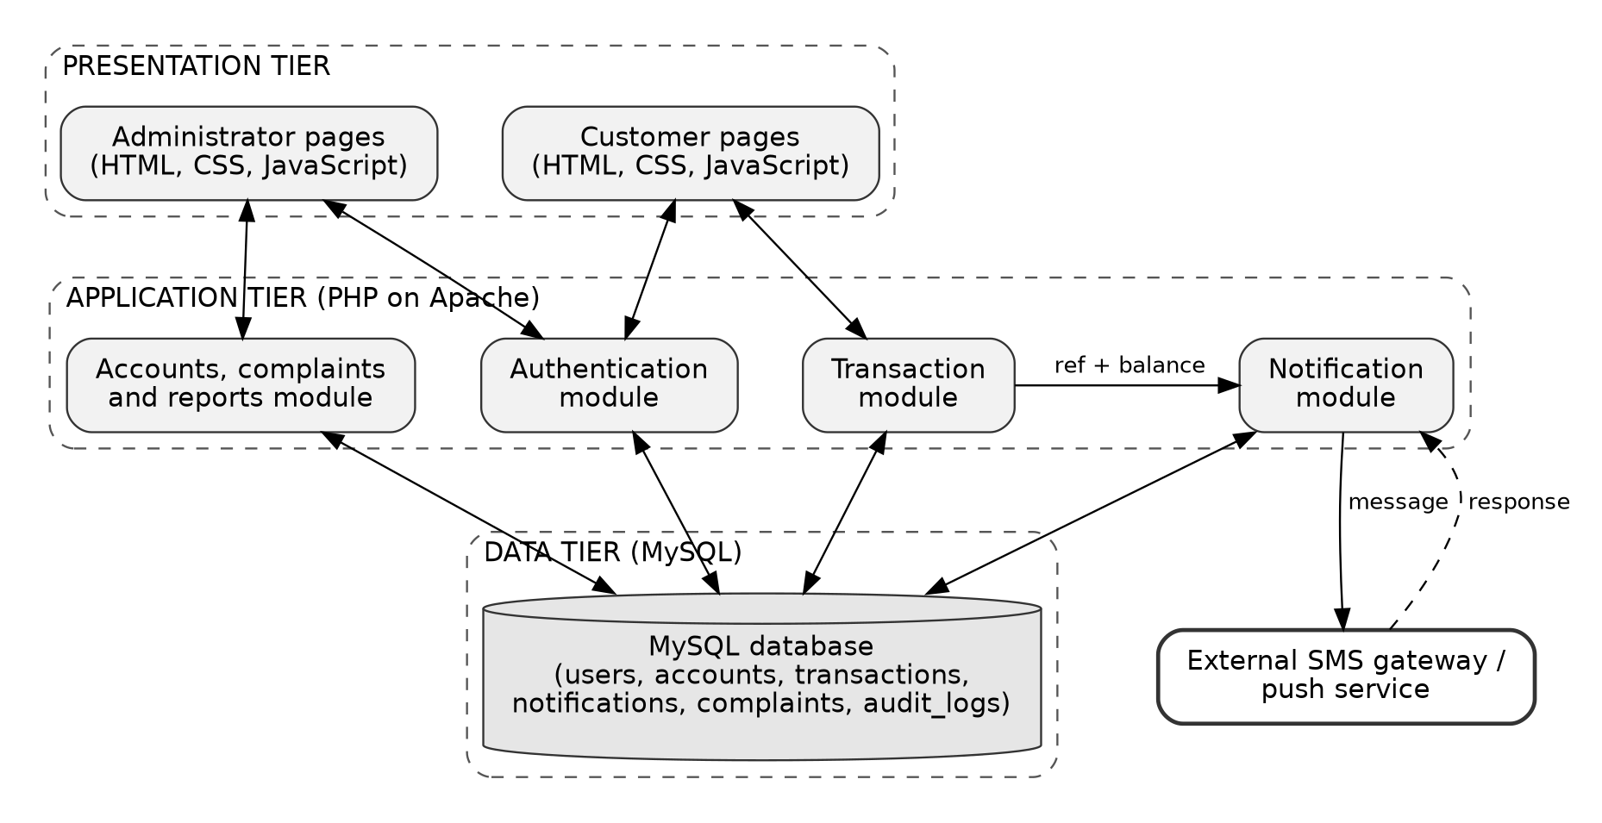
The flow of a transaction through the system is as follows. When a deposit, withdrawal or transfer is submitted, the application tier first validates it and then records it in the database with a unique transaction reference. The account balance is updated within the same database operation, so that the stored balance and the transaction record cannot differ. The notification module then checks whether a notification already exists for that transaction reference. If none exists, it composes a message showing the transaction and the new balance, sends it through the SMS gateway or push service, and stores the result. If the delivery fails, the status is recorded as failed so that it can be retried and monitored by the administrator.
This design supports the three main objectives of the system. Sending the message from the same process that records the transaction supports real-time delivery. Updating the balance and the transaction together supports accuracy. Checking the unique transaction reference before sending supports the elimination of duplicate messages.

2.3 User interface design

2.3.1 Design approach and list of screens
The interfaces were designed to be simple, consistent and readable on both computers and phones. All pages share the same layout, color scheme and navigation so that users can move between them easily. Customers move between pages using a menu at the top of the page, while administrators use a menu at the side of the page. The login page collects the username and password or PIN. The customer dashboard displays the current balance, recent transactions and the status of recent notifications. The notification settings page allows the customer to choose how alerts are received. The administrator dashboard provides pages for managing customers, viewing transactions, monitoring notification delivery, handling complaints and generating reports.
All the screens that the two types of user need were identified from the functional requirements, and a rough sketch of each one was drawn. Table 2.1 lists the screens and the figure in which each sketch is shown.
Table 2.1: Screens of the system
No. | Screen | User | Purpose | Figure
S1 | Login page | Customer, Administrator | Authenticate the user and open the correct dashboard | 2.2
S2 | Customer dashboard | Customer | Show the balance, recent transactions and notification status | 2.3
S3 | Make a transaction | Customer | Submit a deposit, withdrawal or transfer | 2.4
S4 | Transaction history | Customer | Search and view past transactions | 2.5
S5 | Notification history | Customer | View sent messages and their delivery status | 2.6
S6 | Notification settings | Customer | Choose the channel and phone number for alerts | 2.7
S7 | Report a notification problem | Customer | Submit a complaint about a missing, late, duplicate or wrong message | 2.8
S8 | Administrator dashboard | Administrator | Summarize transactions and notification delivery | 2.9
S9 | Manage customers | Administrator | Add, edit, suspend and activate customers | 2.10
S10 | Monitor transactions | Administrator | Filter and review all transactions | 2.11
S11 | Notification delivery monitor | Administrator | Follow delivery status and retry failed messages | 2.12
S12 | Notification complaints | Administrator | Review, respond to and resolve complaints | 2.13
S13 | Reports and audit log | Administrator | Generate reports and view the audit log | 2.14

2.3.2 Customer interfaces
The customer interfaces are used after a customer has logged in. Figure 2.2 shows the login page, which is shared by customers and administrators. It contains a username field, a password or PIN field and a login button, and it displays an error message when the details are wrong.
Figure 2.2: Sketch of the login page
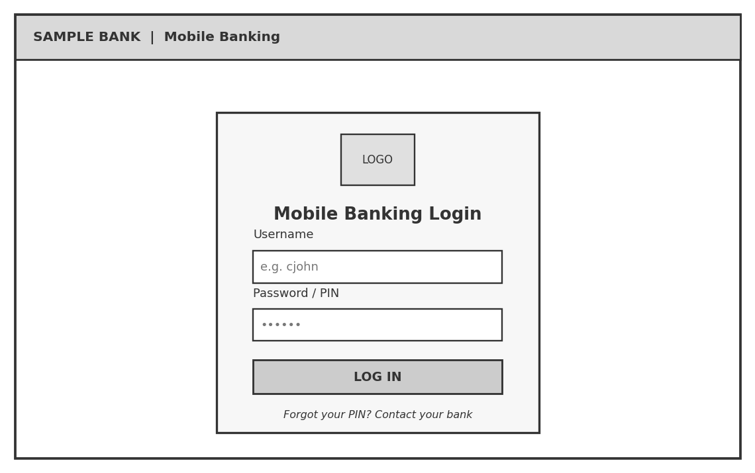
After a successful login the customer arrives at the dashboard in Figure 2.3. The dashboard shows the current account balance, buttons for the three transaction types, a table of the most recent transactions and a panel that shows the delivery status of the latest notifications.
Figure 2.3: Sketch of the customer dashboard
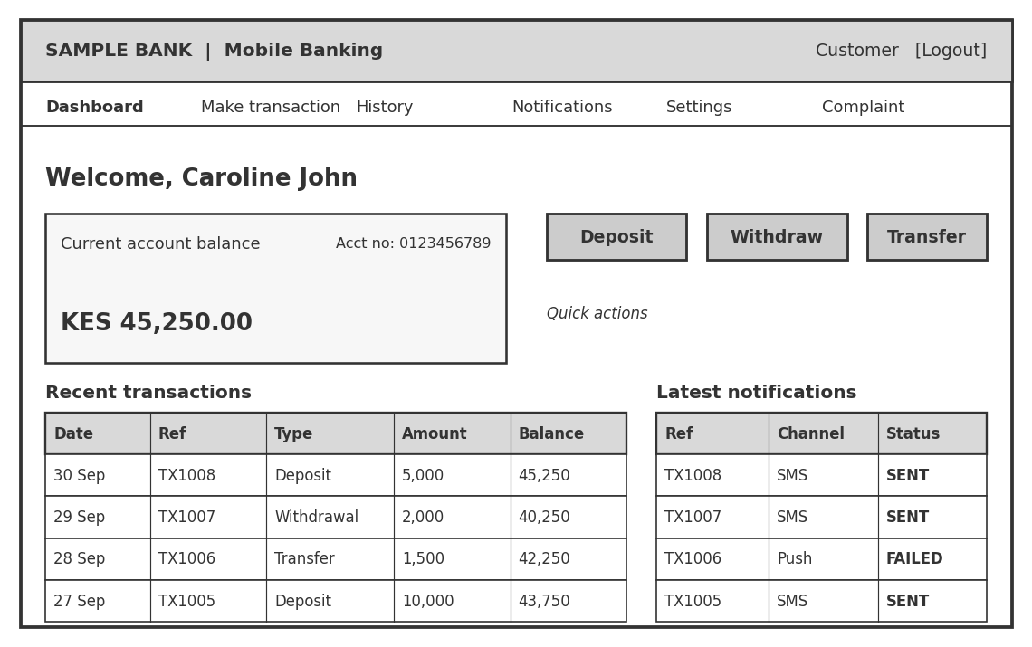
The page in Figure 2.4 lets a customer make a deposit, withdrawal or transfer. The customer selects the transaction type, enters the amount and, for a transfer, the receiving account number, and then confirms with a PIN. The page also reminds the customer that the new balance will be sent as a notification.
Figure 2.4: Sketch of the make-a-transaction page
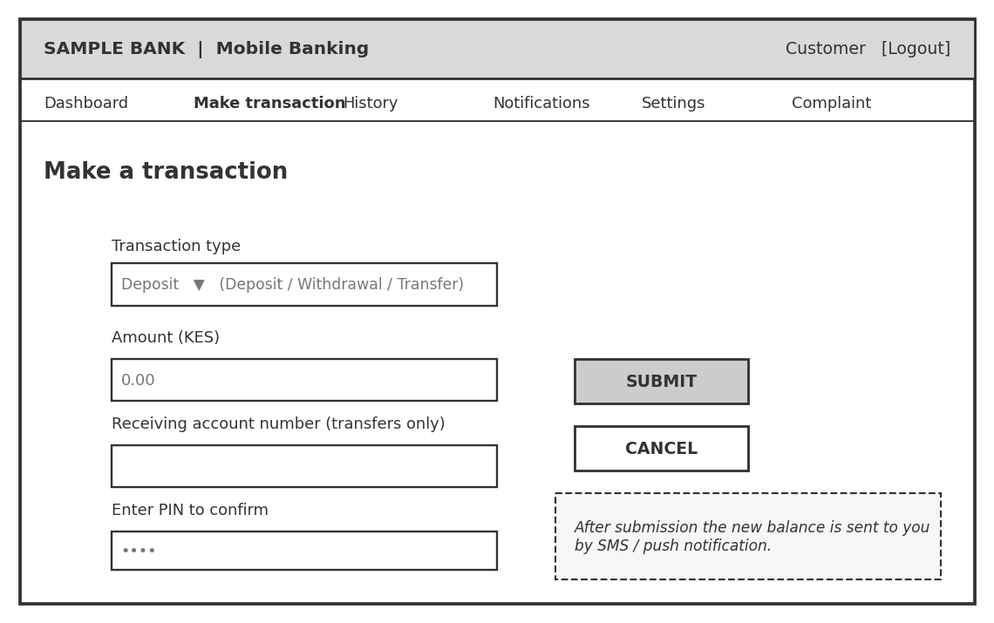
The transaction history page in Figure 2.5 allows a customer to filter past transactions by date and type. Each row shows the date and time, the transaction reference, the type, the amount and the balance after the transaction.
Figure 2.5: Sketch of the transaction history page
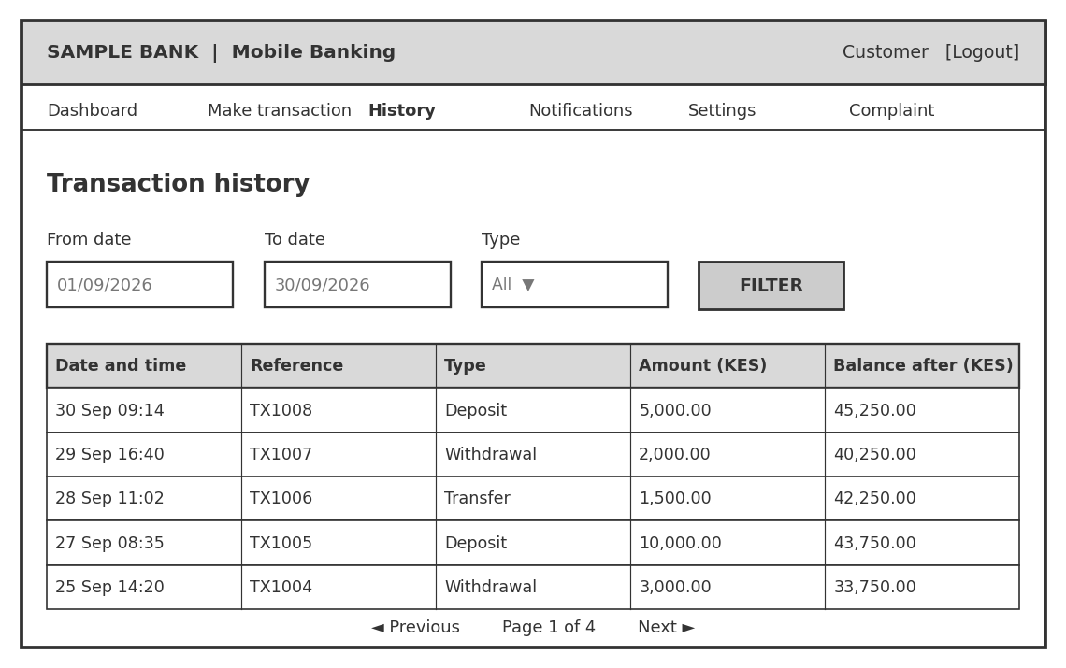
The notification history page in Figure 2.6 lists every message that was sent to the customer, the channel that was used and the delivery status. A button on the page leads the customer to the complaint form when a message is missing, late, repeated or incorrect.
Figure 2.6: Sketch of the notification history page
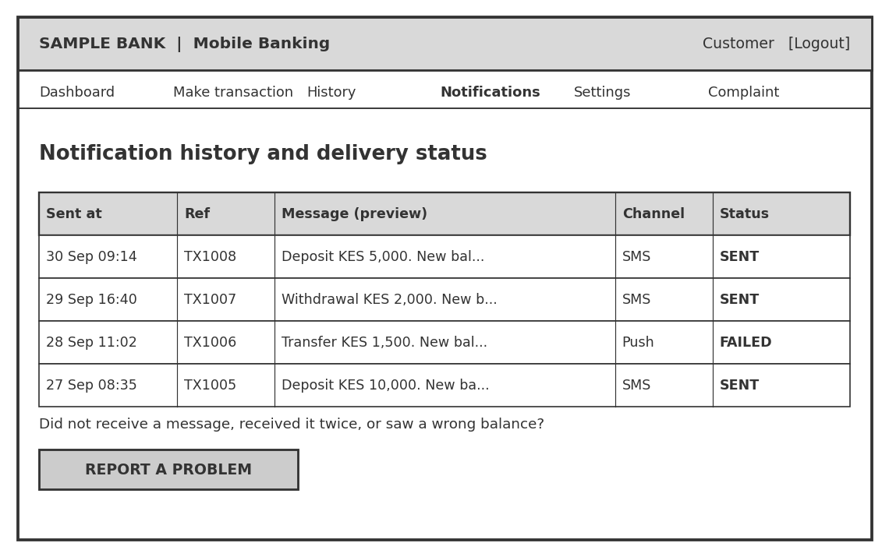
The notification settings page in Figure 2.7 allows the customer to choose whether alerts are received by SMS, by push notification or by both, and to confirm the phone number that receives the SMS alerts. A sample message on the page shows the customer what a notification looks like.
Figure 2.7: Sketch of the notification settings page
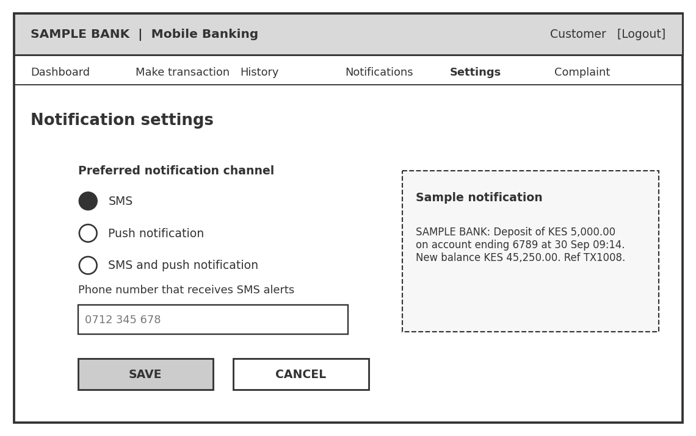
The complaint form in Figure 2.8 lets a customer select the transaction concerned, choose the type of problem and describe it. The complaint is then sent to the administrators.
Figure 2.8: Sketch of the page for reporting a notification problem
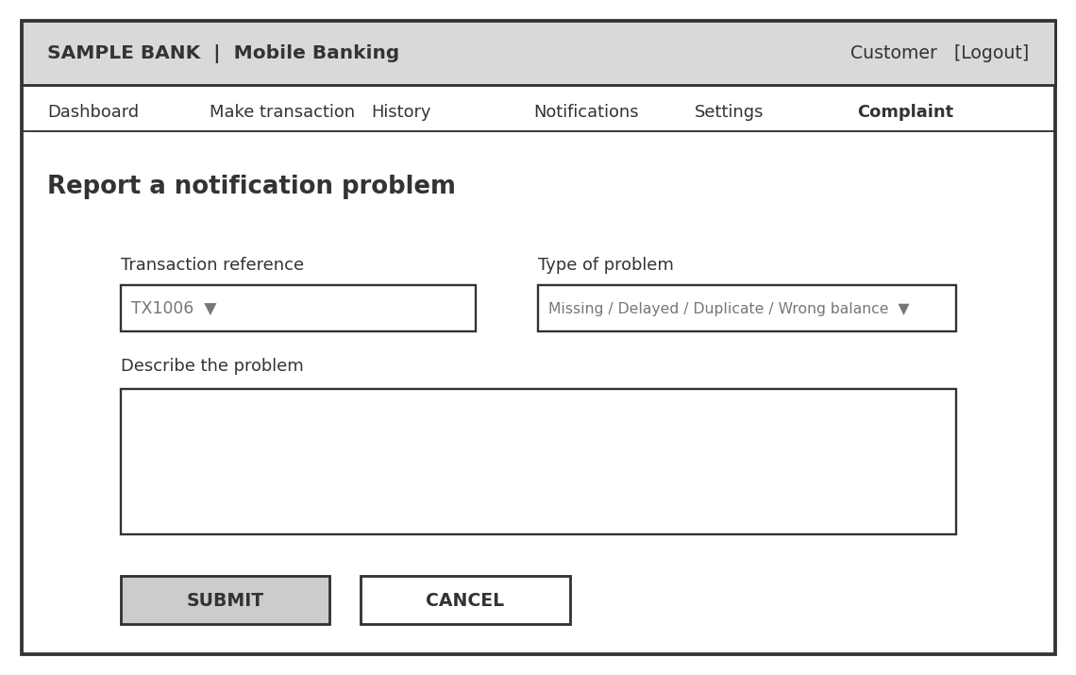

2.3.3 Administrator interfaces
The administrator interfaces use a menu at the side of the page. The dashboard in Figure 2.9 gives a quick summary of the number of customers, the transactions of the day, the notifications sent and the notifications that failed or are pending, together with a chart and a short list of recent failures.
Figure 2.9: Sketch of the administrator dashboard
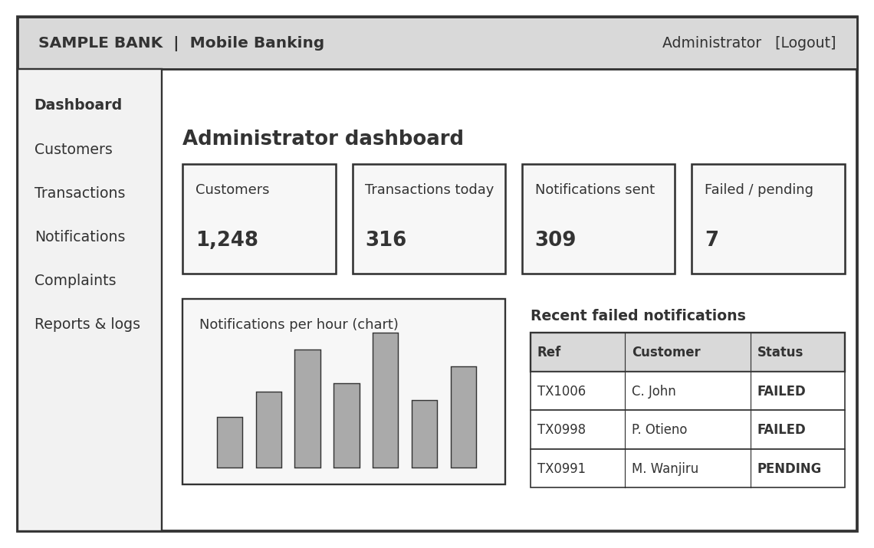
The customer management page in Figure 2.10 lets an administrator search for customers and add, edit, suspend or activate them. A suspended customer cannot log in.
Figure 2.10: Sketch of the manage customers page
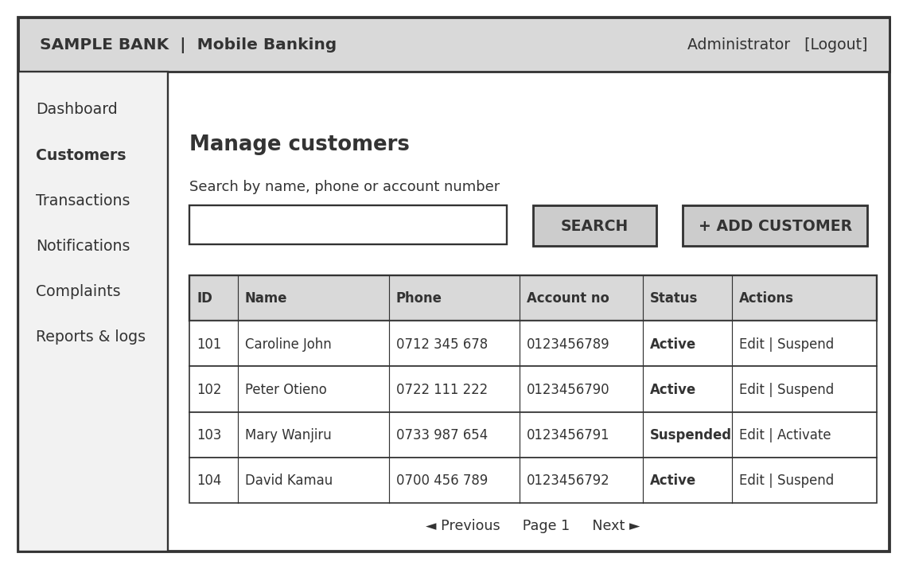
The transaction monitoring page in Figure 2.11 lets an administrator filter transactions by date, account or reference and see, next to each transaction, the status of its notification.
Figure 2.11: Sketch of the monitor transactions page
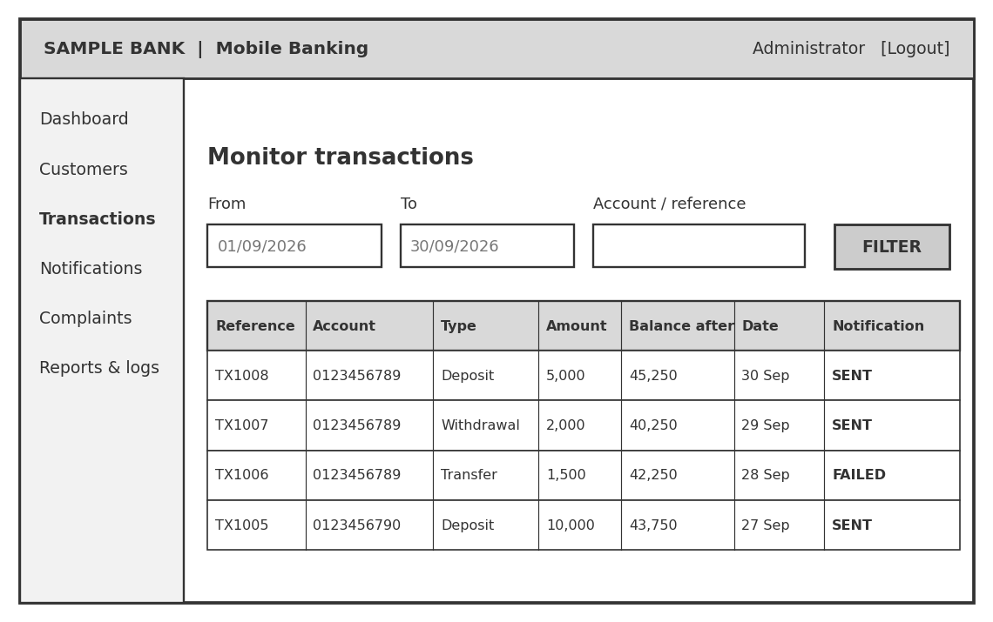
The notification delivery monitor in Figure 2.12 shows all notifications grouped by status. For notifications that failed or are pending, the administrator can press a retry button. A notification that has already been sent cannot be retried, which prevents duplicates.
Figure 2.12: Sketch of the notification delivery monitor
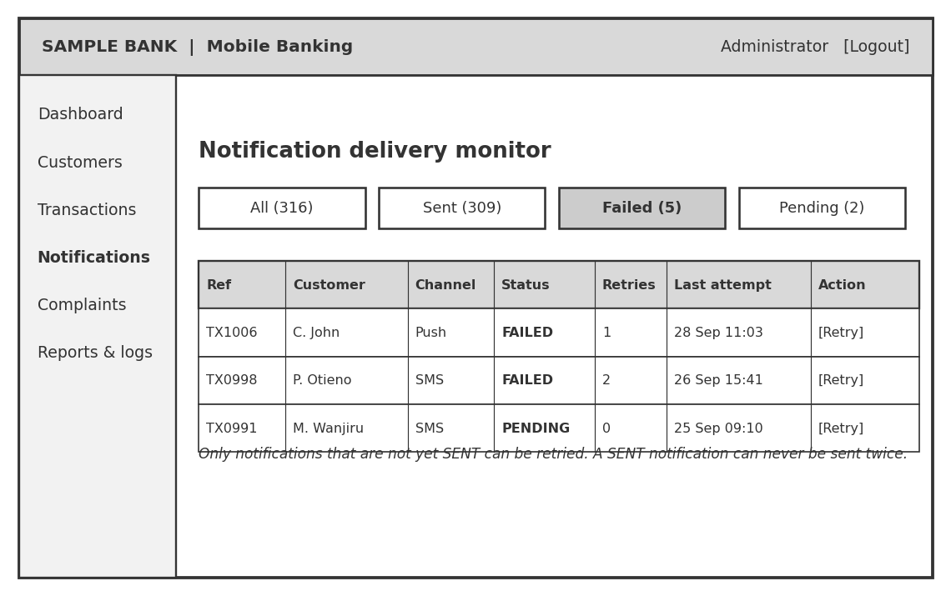
The complaints page in Figure 2.13 lists the complaints received from customers. When a complaint is selected, its details are shown beside the list, and the administrator can type a response and change its status.
Figure 2.13: Sketch of the notification complaints page
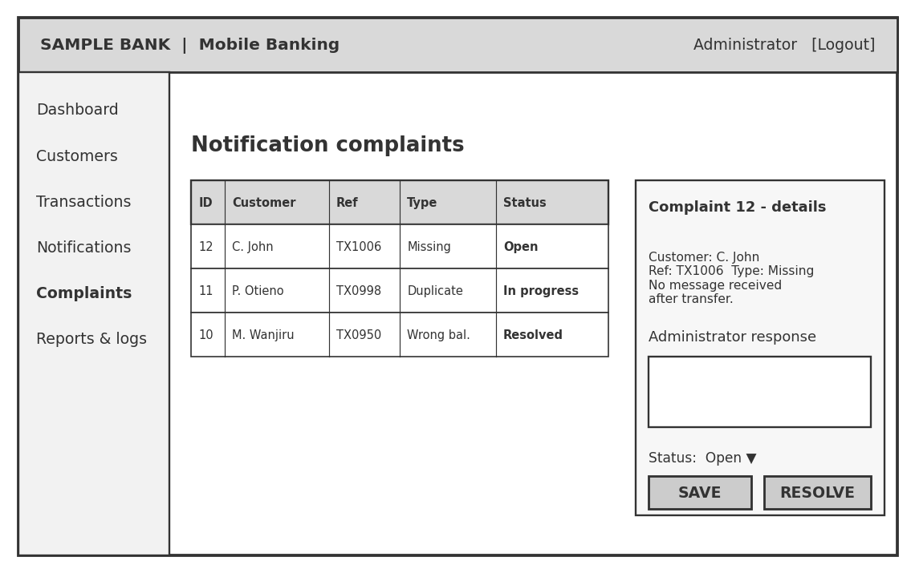
The reports page in Figure 2.14 allows an administrator to generate a report for a chosen period, export it, and view the audit log of actions carried out in the system.
Figure 2.14: Sketch of the reports and audit log page
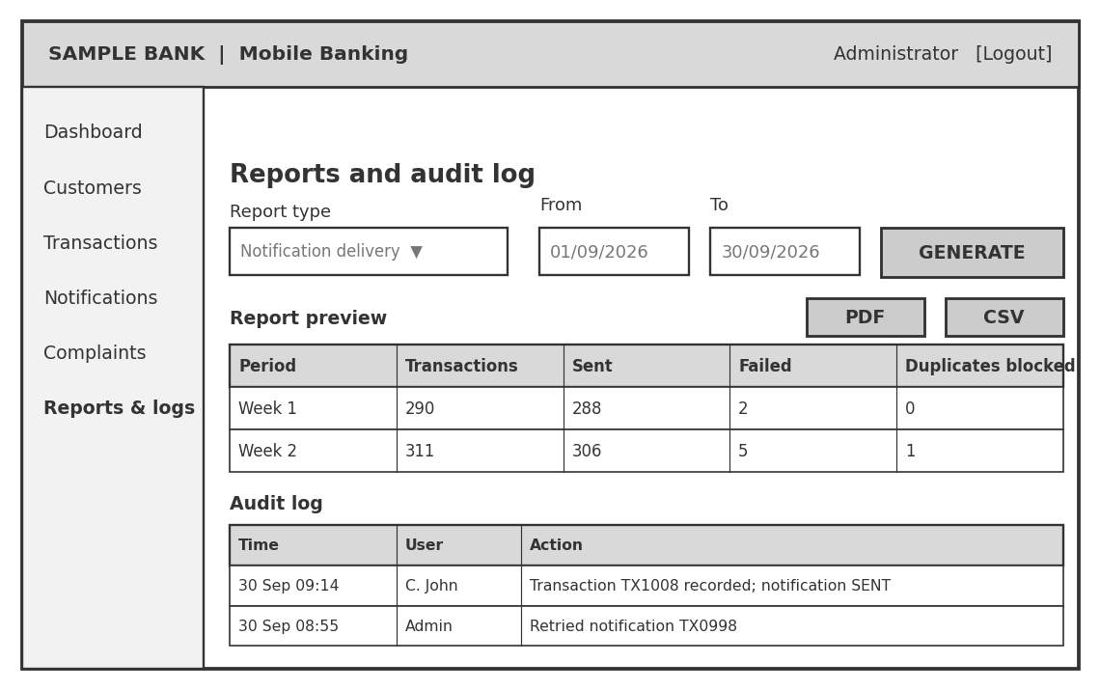

2.4 Logic design
The logic design shows how the components of the system interact. The use case diagram shows who uses the system, the data flow diagrams show how data moves, the flowcharts describe the steps of the main processes, and the sequence and class diagrams show how the modules and objects cooperate.

2.4.1 Use case design
The use cases describe how each user interacts with the system and are shown in Figure 2.15 and listed in Table 2.2. The customer logs in, views the account balance and transaction history, makes transactions, receives notifications and manages notification preferences. The administrator logs in, manages customer accounts, monitors transactions, follows the delivery status of notifications, retries failed notifications, handles complaints and generates reports. Both users can log out when they finish. The system, acting as a third participant, records each transaction, updates the balance and sends the notification through the SMS gateway.
Figure 2.15: Use case diagram of the system
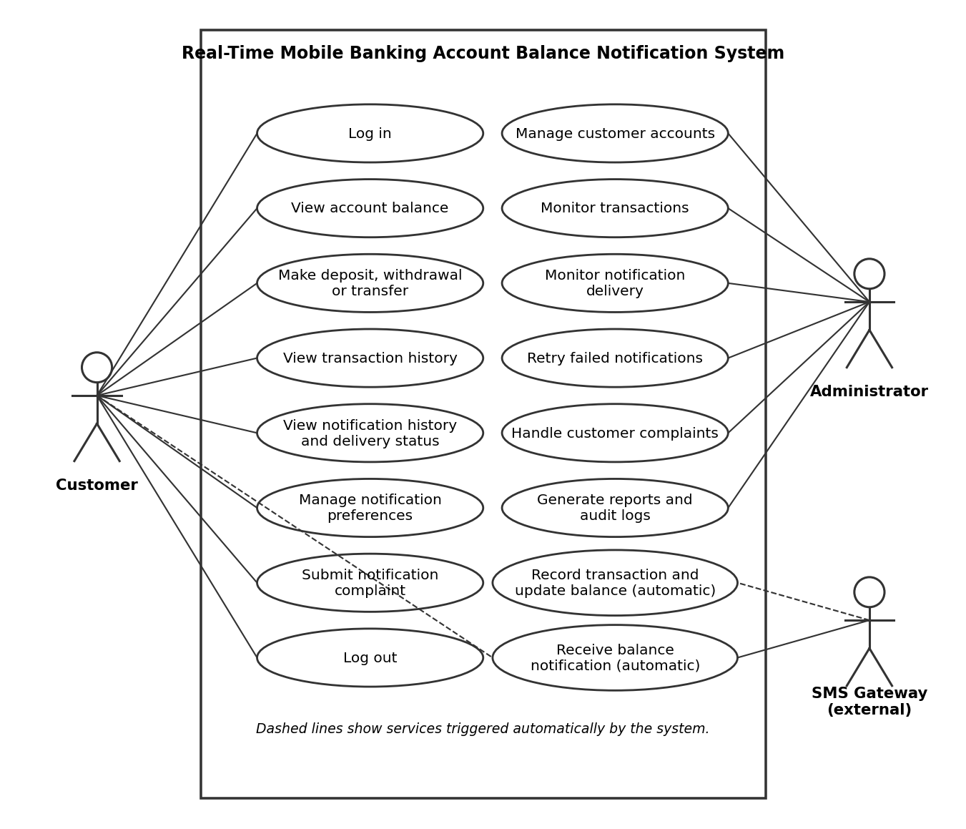
Table 2.2: Use cases of the system
ID | Use case | Actor | Description
UC1 | Log in | Customer, Administrator | The user enters a username and password or PIN and is taken to the correct dashboard.
UC2 | View account balance | Customer | The customer sees the current balance of the account.
UC3 | Make transaction | Customer | The customer submits a deposit, withdrawal or transfer.
UC4 | View transaction history | Customer | The customer filters and reads past transactions.
UC5 | View notification history and delivery status | Customer | The customer sees each message sent and whether it was delivered.
UC6 | Manage notification preferences | Customer | The customer chooses the channel and phone number for alerts.
UC7 | Submit notification complaint | Customer | The customer reports a missing, late, duplicate or incorrect message.
UC8 | Record transaction and update balance | System | The system saves the transaction and updates the balance in one operation.
UC9 | Receive balance notification | Customer, SMS gateway | The system sends the new balance after a successful transaction and the customer receives it.
UC10 | Manage customer accounts | Administrator | The administrator adds, edits, suspends and activates customers.
UC11 | Monitor transactions | Administrator | The administrator reviews transactions and their notification status.
UC12 | Monitor notification delivery | Administrator | The administrator follows sent, failed and pending notifications.
UC13 | Retry failed notifications | Administrator | The administrator resends a notification that failed or is pending.
UC14 | Handle customer complaints | Administrator | The administrator responds to complaints and changes their status.
UC15 | Generate reports and audit logs | Administrator | The administrator produces reports and views the audit log.
UC16 | Log out | Customer, Administrator | The user ends the session.

2.4.2 Data flow design
At the highest level, shown in Figure 2.16, the system exchanges data with three external parties. The customer supplies login details and transaction requests and receives balances and notifications. The administrator supplies account and configuration data and receives reports and delivery statuses. The SMS gateway receives the message to be delivered and returns a delivery response.
Figure 2.16: Context diagram (level 0 data flow diagram)
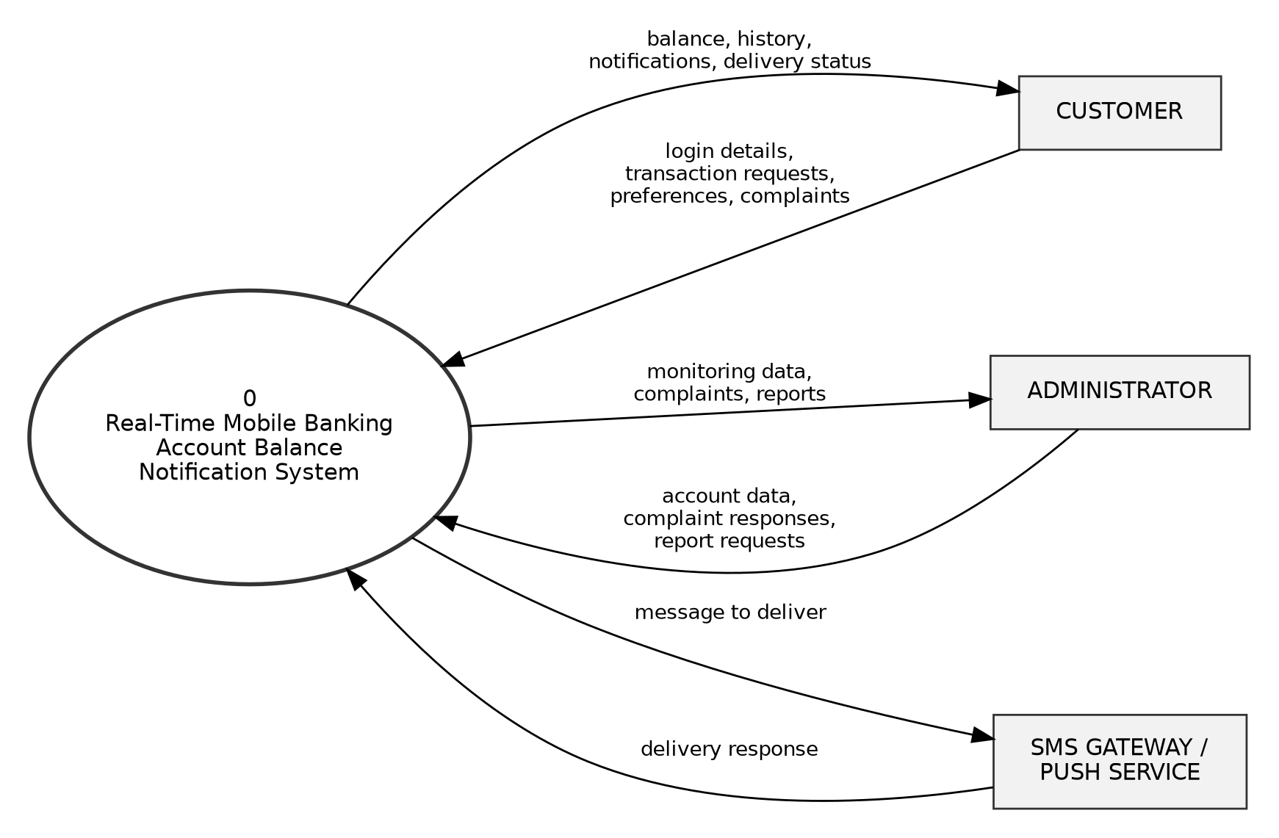
Inside the system, shown in Figure 2.17, transaction data flows from the transaction process to the database, then to the notification process, and the result of delivery flows back to the database, where it becomes available to the administrator. The system has five main processes, namely authenticating users, processing transactions, sending notifications, managing accounts and complaints, and generating reports and audit logs. They use six data stores for users, accounts, transactions, notifications, complaints and audit logs.
Figure 2.17: Level 1 data flow diagram
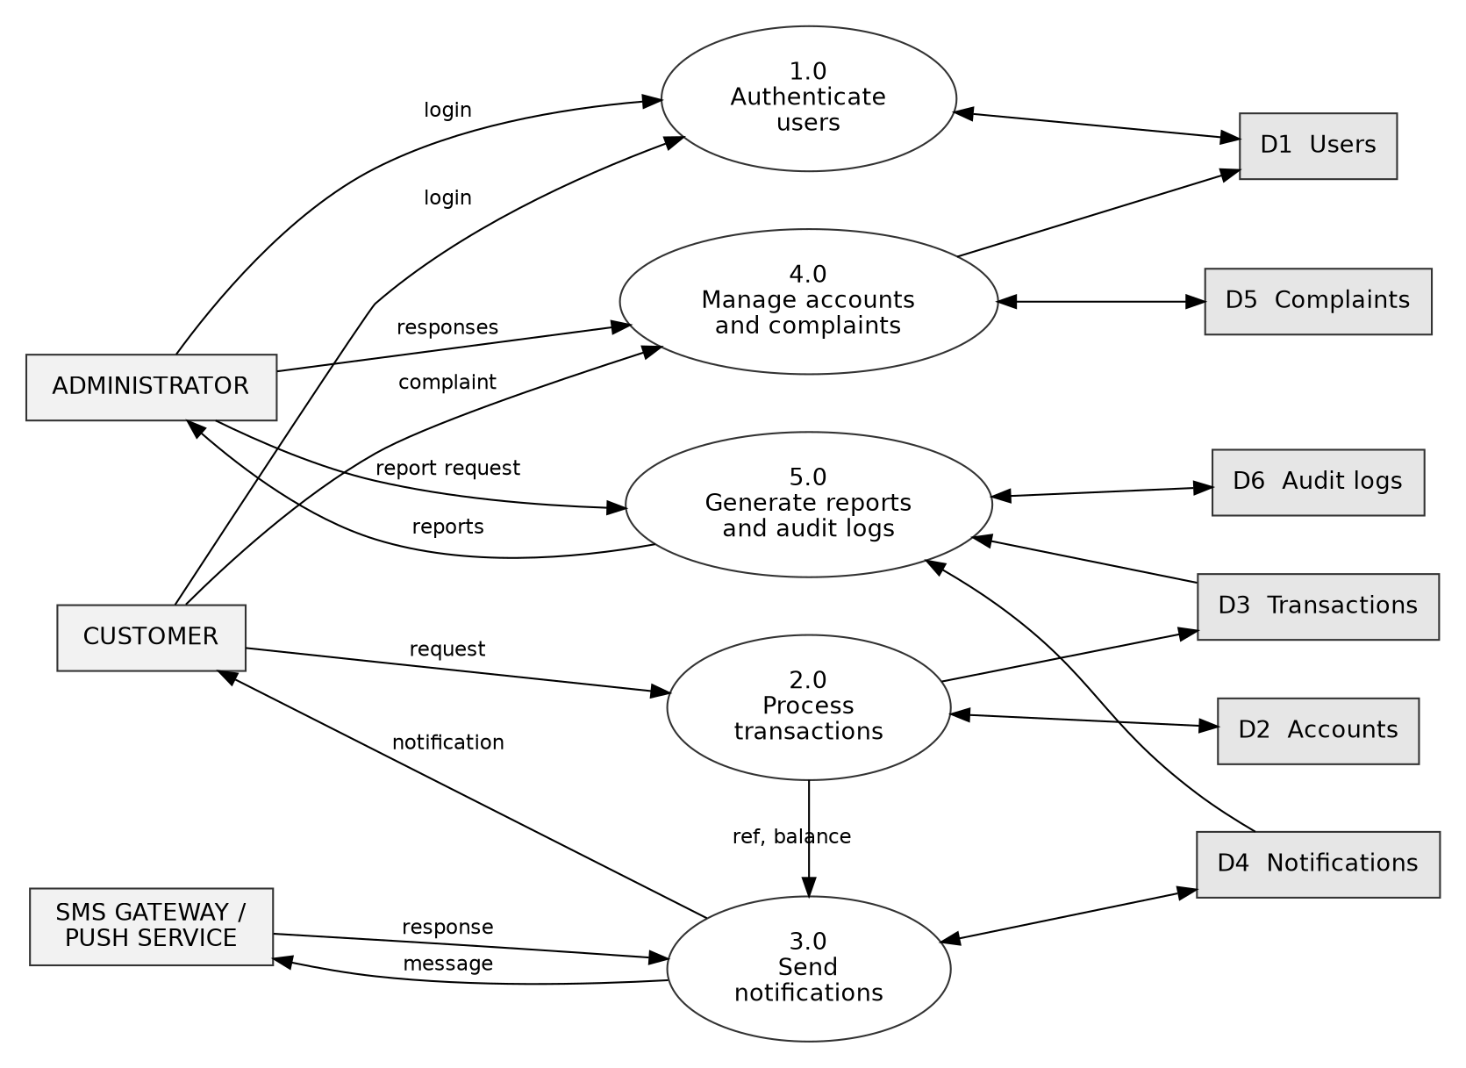

2.4.3 Flowcharts
The login process is shown in Figure 2.18. The system checks the input, looks up the user with a prepared statement and compares the password with the stored hash. A failed attempt is recorded in the audit log and the user is asked to try again, while a suspended account is refused. After a successful login the system starts a session and opens the dashboard that matches the role of the user.
Figure 2.18: Flowchart of the login process
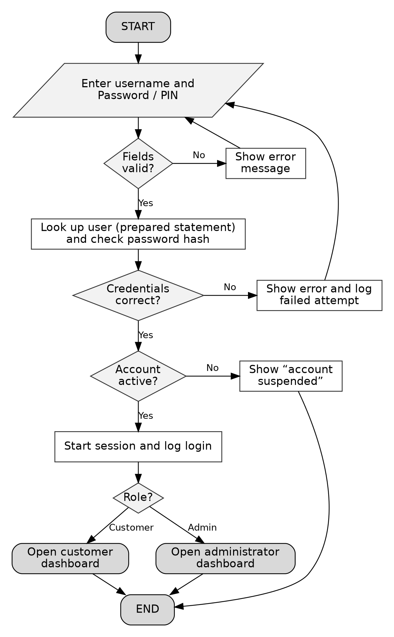
The processing of a transaction is shown in Figure 2.19. The transaction is rejected if the input or PIN is wrong or if the balance is not enough for a withdrawal or transfer. Otherwise a unique transaction reference is generated, and the transaction record and the new balance are saved together inside one database transaction. If saving fails, the whole operation is rolled back so that no partial change remains. If it succeeds, the operation is committed and the new balance is passed to the notification module.
Figure 2.19: Flowchart of transaction processing
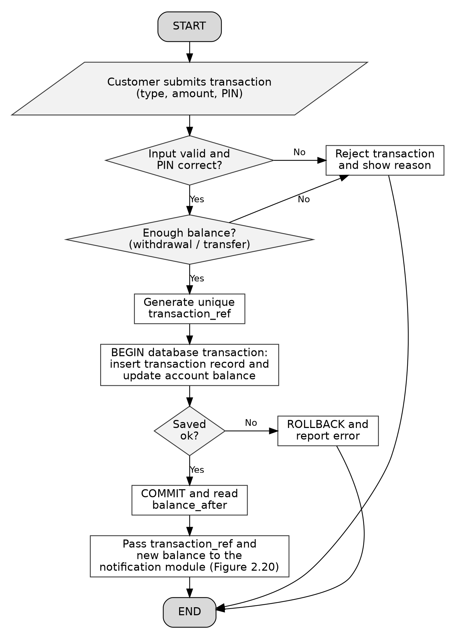
The notification process is shown in Figure 2.20. The module first checks whether a notification already exists for the transaction reference. If it does, nothing is sent again. If it does not, the module composes the message, saves it as pending, sends it through the SMS gateway or push service, and then saves the final status as sent or failed.
Figure 2.20: Flowchart of the notification process
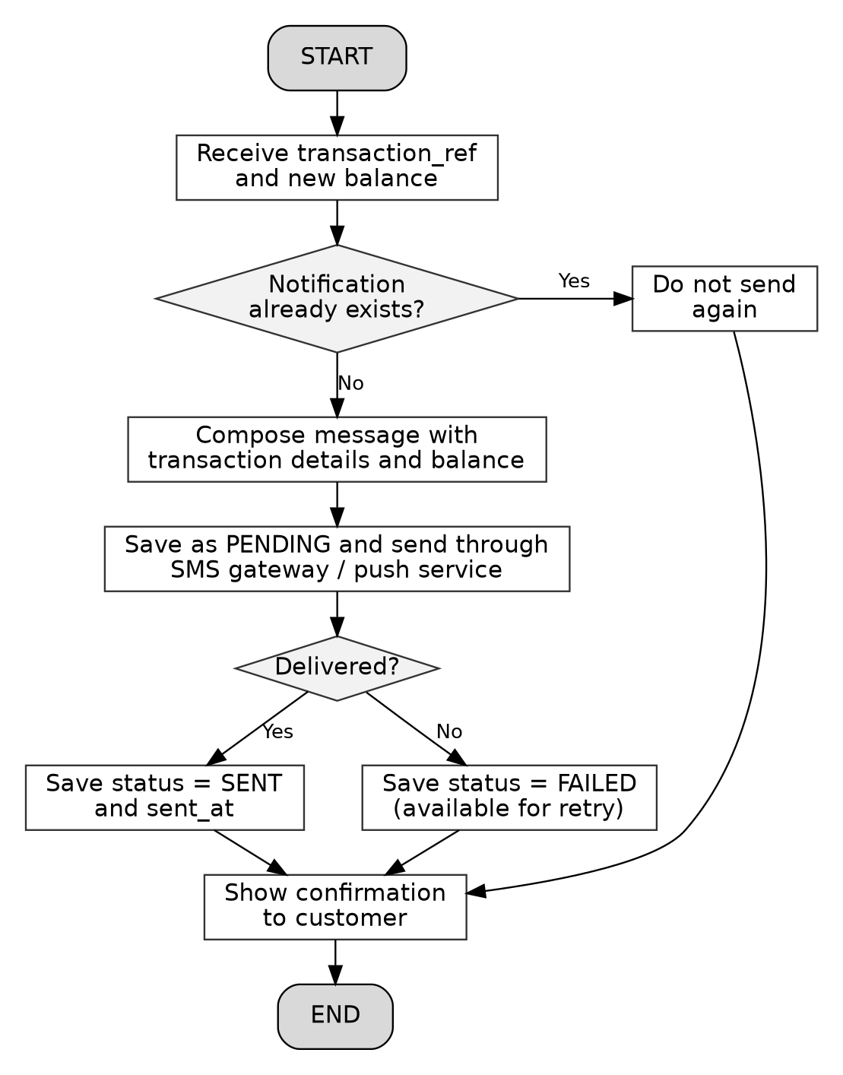
The retry process is shown in Figure 2.21. The administrator can only retry a notification whose status is failed or pending. When the retry succeeds the status changes to send, and when it fails the retry counter increases. Every retry is written to the audit log.
Figure 2.21: Flowchart of retrying a failed notification
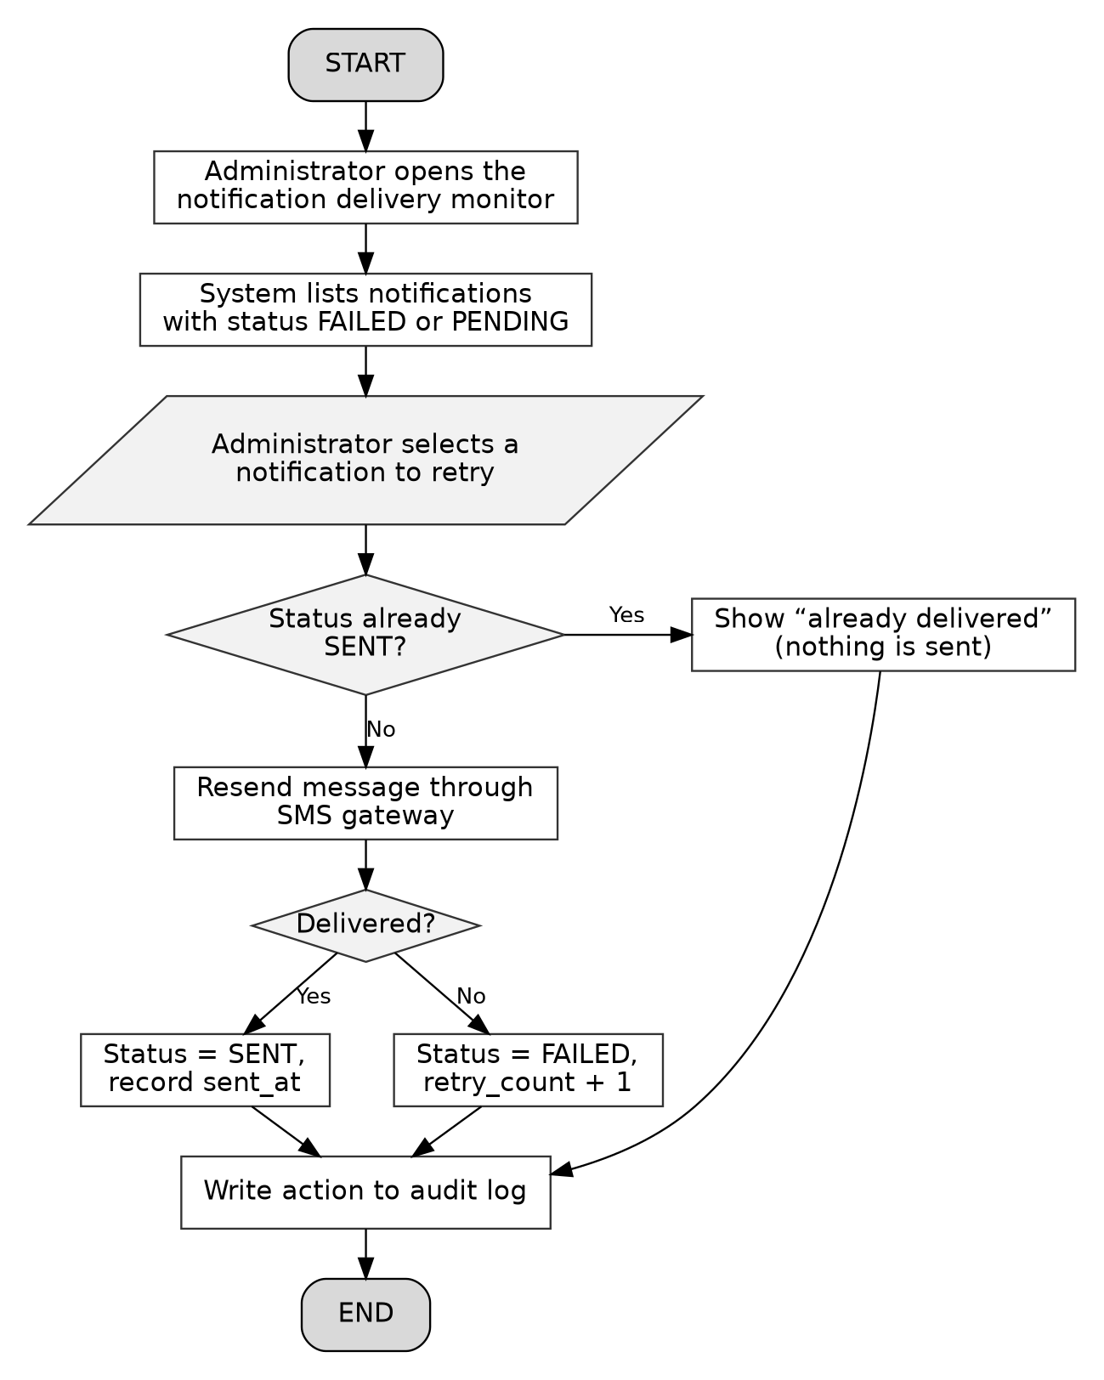

2.4.4 Sequence diagram
Figure 2.22 shows the order of the messages exchanged between the customer, the web interface, the transaction module, the database, the notification module and the SMS gateway when a customer makes a transaction. The diagram shows that the balance is committed to the database before the notification module is called, that the notification module checks for an earlier notification before sending, and that the delivery result is saved in the database.
Figure 2.22: Sequence diagram of a transaction and its notification
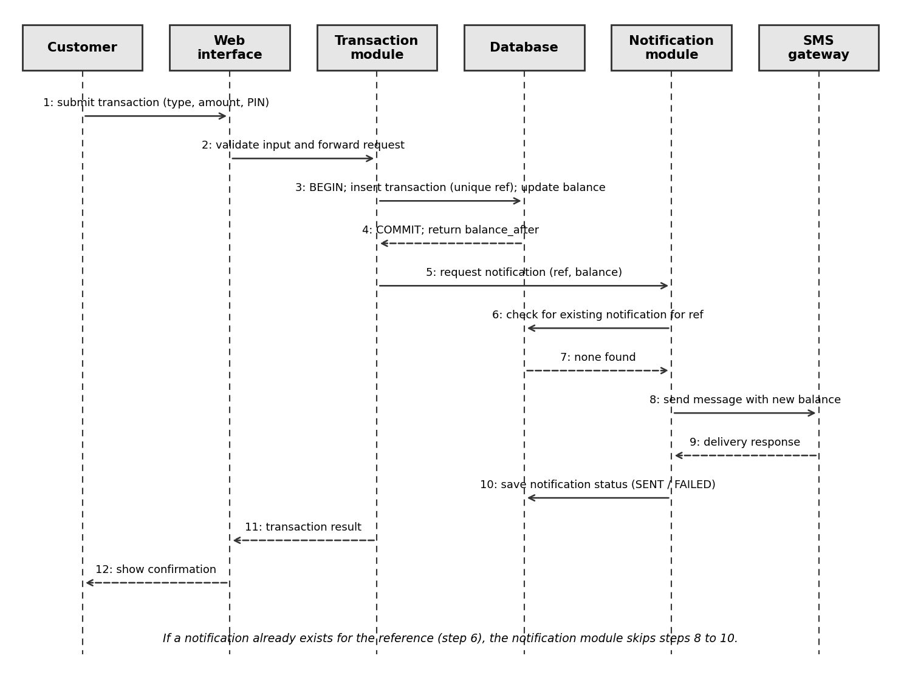

2.4.5 Class diagram
The class diagram in Figure 2.23 shows the main classes of the system, their attributes and their operations. The classes correspond to the tables of the database. A user owns one or more accounts, an account has many transactions, and each transaction triggers at most one notification. A user may submit complaints about notifications and performs actions that are recorded in the audit log.
Figure 2.23: Class diagram of the system
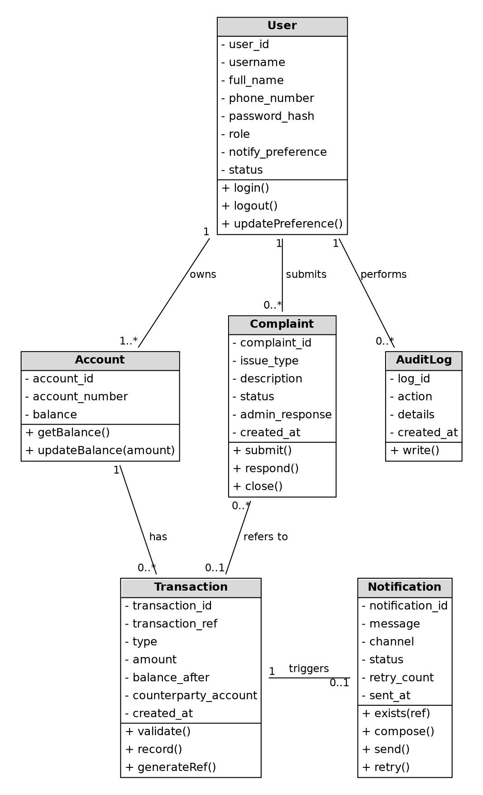

2.5 Database design

2.5.1 Entity relationship diagram
The database was designed using a relational model in MySQL. Six tables store the data of the system, and they are linked through primary and foreign keys, as shown in the entity relationship diagram in Figure 2.24. A user may own one or more accounts, an account may have many transactions, and each transaction may have at most one notification. A user may submit complaints, which may refer to a transaction, and the actions of users are recorded in the audit log. The relationships are summarized in Table 2.3.
Figure 2.24: Entity relationship diagram
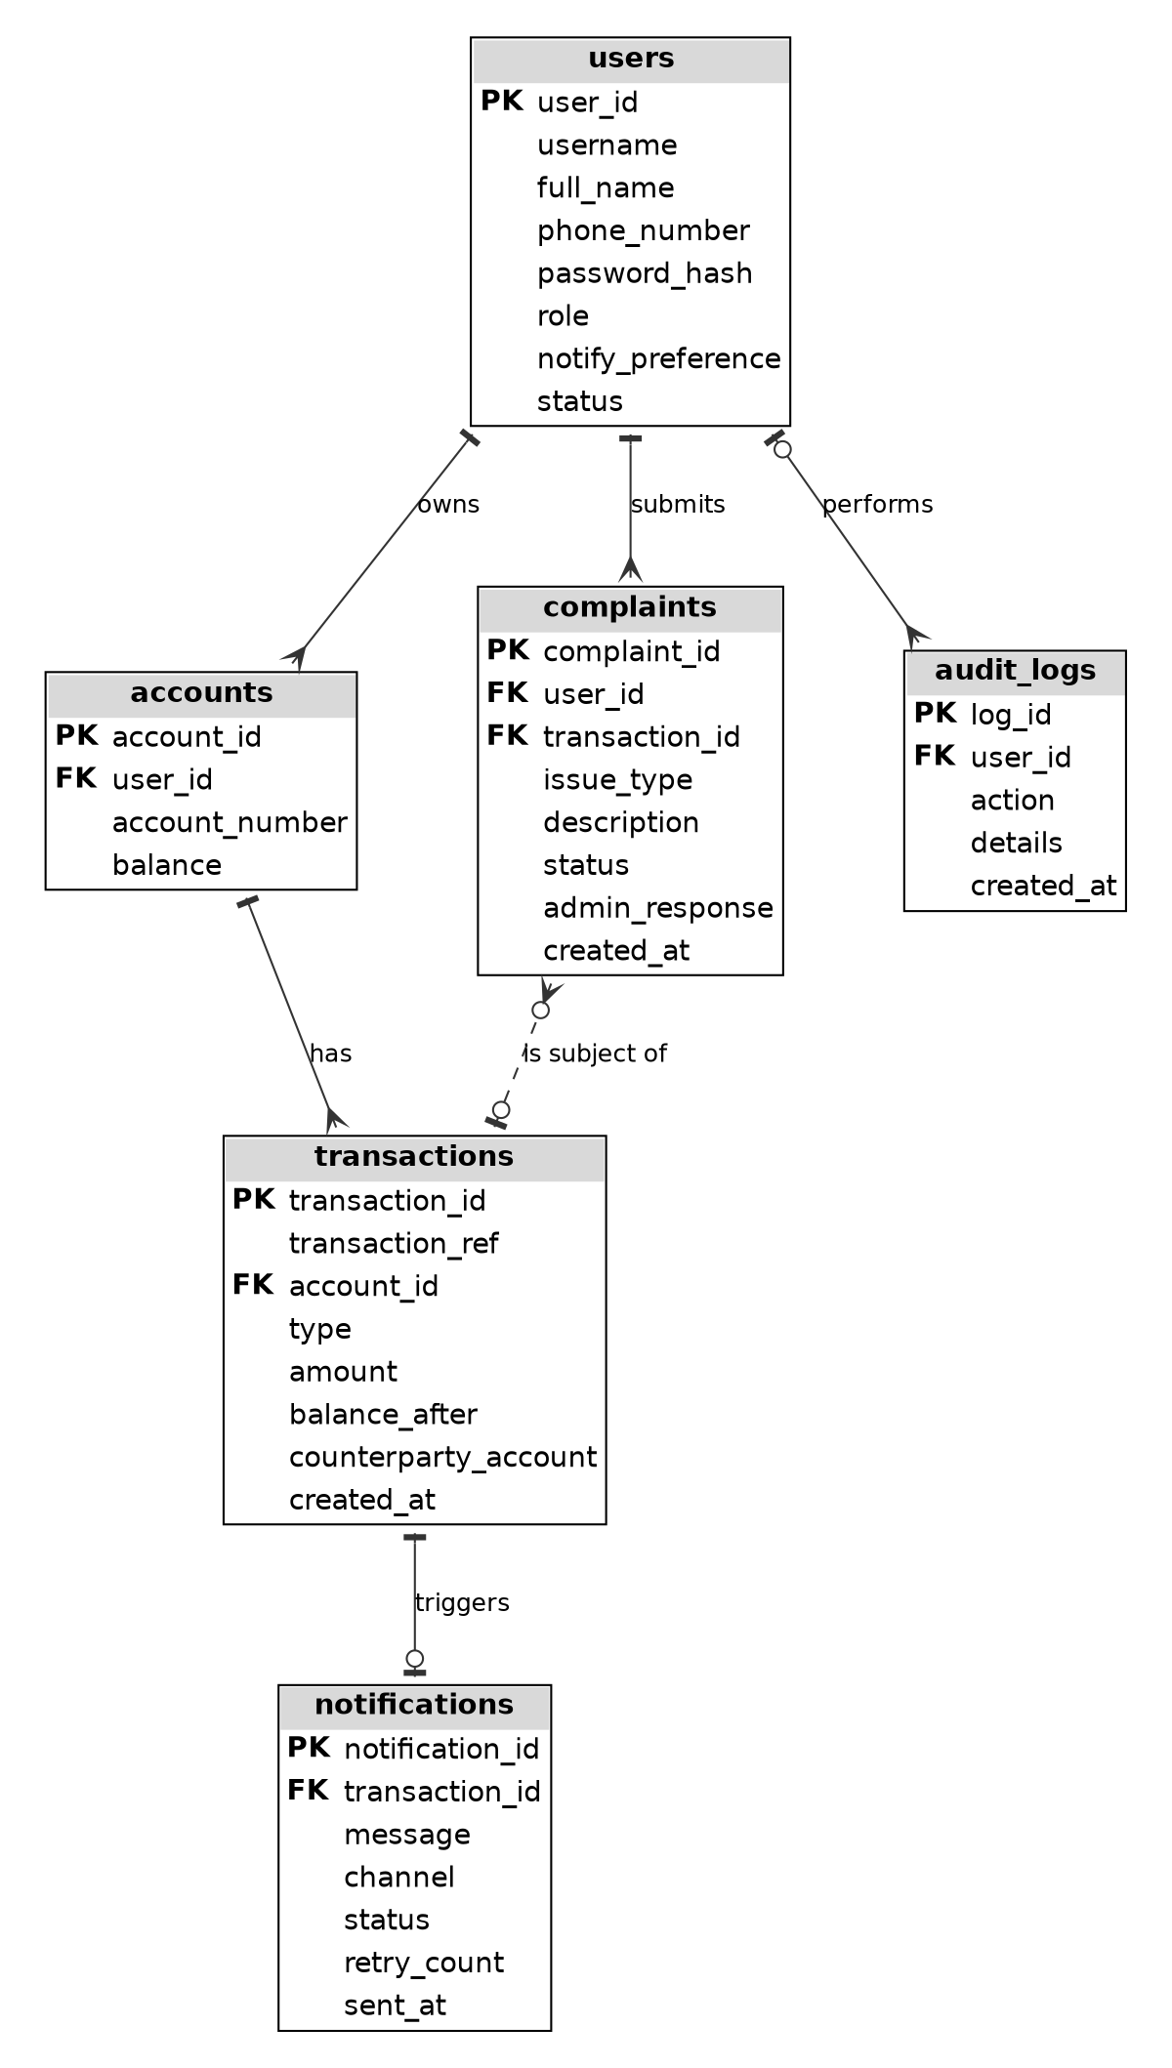
Table 2.3: Relationships between database tables
Table | Relationship | Related table
users | One user owns one or more | accounts
accounts | One account has many | transactions
transactions | One transaction has at most one | notifications
users | One user may submit many | complaints
transactions | One transaction may be the subject of many | complaints
users | One user performs many actions recorded in | audit logs

2.5.2 Structure of the database tables
The fields, data types and purpose of each table are shown in Table 2.4. Money values use the DECIMAL type so that amounts and balances are stored exactly without rounding errors. A transfer is stored as two linked transaction records, one for the sending account and one for the receiving account, each with its own reference, so that both account holders receive a notification. The counterparty field holds the other account in a transfer.
Table 2.4: Structure of the database tables
Table | Field | Type | Description
users | user_id (PK) | INT, auto increment | Unique identifier of the user
users | username | VARCHAR(50), unique | Name used to log in
users | full_name | VARCHAR(100) | Name of the user
users | phone_number | VARCHAR(15) | Number that receives SMS notifications
users | password_hash | VARCHAR(255) | Encrypted password or PIN
users | role | ENUM | Customer or administrator
users | notify_preference | VARCHAR(20) | Preferred notification channel
users | status | ENUM | Active or suspended
accounts | account_id (PK) | INT, auto increment | Unique identifier of the account
accounts | user_id (FK) | INT | Owner of the account
accounts | account number | VARCHAR(20), unique | Unique account number
accounts | balance | DECIMAL(12,2) | Current account balance
transactions | transaction_id (PK) | INT, auto increment | Unique identifier of the transaction
transactions | transaction_ref | VARCHAR(30), unique | Unique reference used to prevent duplicates
transactions | account_id (FK) | INT | Account affected by the transaction
transactions | type | ENUM | Deposit, withdrawal or transfer
transactions | direction | ENUM | Credit (money in) or debit (money out), so both sides of a transfer read correctly
transactions | amount | DECIMAL(12,2) | Amount of the transaction
transactions | balance_after | DECIMAL(12,2) | Balance after the transaction
transactions | counterparty account | VARCHAR(20) | Other account in a transfer, otherwise empty
transactions | created at | DATETIME | Date and time of the transaction
notifications | notification (PK) | INT, auto increment | Unique identifier of the notification
notifications | transaction_id (FK) | INT, unique | Transaction that triggered the notification
notifications | message | TEXT | Content of the message sent
notifications | channel | VARCHAR(20) | SMS or push
notifications | status | ENUM | Sent, failed or pending
notifications | retry count | INT | Number of times a resend was attempted
notifications | sent at | DATETIME | Time the message was sent
complaints | complaint_id (PK) | INT, auto increment | Unique identifier of the complaint
complaints | user_id (FK) | INT | Customer who submitted the complaint
complaints | transaction_id (FK) | INT, may be empty | Transaction the complaint refers to
complaints | issue type | ENUM | Missing, delayed, duplicate or incorrect balance
complaints | description | TEXT | Details written by the customer
complaints | status | ENUM | Open, in progress or resolved
complaints | admin_response | TEXT | Response written by the administrator
complaints | created at | DATETIME | Date and time the complaint was submitted
audit logs | log_id (PK) | INT, auto increment | Unique identifier of the log entry
audit logs | user_id (FK) | INT, may be empty | User who performed the action
audit logs | action | VARCHAR(100) | Action performed
audit logs | details | TEXT | Extra details of the action
audit logs | created at | DATETIME | Date and time of the action

2.5.3 Prevention of duplicate notifications in the database
The transaction reference in the transactions table and the unique transaction identifier in the notifications table are the key features that prevent duplicate messages, because the database will refuse to store a second notification for the same transaction. This protection is enforced by the database itself and does not depend only on the program code, so it still works if the same request is submitted twice, for example when a customer presses the submit button twice.

2.6 Security design
Security controls were included in the design because the system handles financial information. Users must authenticate before accessing any page, and access to pages and data is limited according to the role of the user. Passwords and PINs are stored as hashes and never as plain text. Database queries use prepared statements to protect against SQL injection, and user input is validated before it is processed and escaped before it is displayed, which protects against cross-site scripting. Every transaction and notification is written to an audit log, and a session is ended automatically after a period of inactivity or when the user logs out. These controls also support the requirements of the Data Protection Act discussed in Chapter One.

2.7 Chapter summary
This chapter presented the design of the system. The three-tier architecture separates the interface, the business logic and the data. Thirteen screens were sketched for customers and administrators. The logic of the system was described with a use case diagram, data flow diagrams, flowcharts, a sequence diagram and a class diagram, and the database was designed with six related tables in which unique keys prevent duplicate notifications. The next chapter describes how this design was turned into a working system, how it was tested and how it was deployed.

CHAPTER THREE: PROJECT DEVELOPMENT, TESTING AND DEPLOYMENT
Access to the working system: The system described in this chapter can be opened and used online. Click the link at the end of this paragraph to open the login page, then log in with one of the demonstration accounts shown on that page (customer: john / 1234; administrator: admin / admin123). The online version uses simulated customers and money only. Mobile Banking Demo

3.1 Introduction
This chapter reports how the design in Chapter Two was turned into a working system. It describes the development environment and the organization of the code, the creation of the database and its connection to the application, and the feature-by-feature development and debugging of the customer and administrator modules. It then reports the testing of the system, the deployment of the system in a simulated real-world environment and the user acceptance testing that followed.

3.2 Development environment
The system was built on a laptop using free and open-source tools. Table 3.1 lists the tools and the role that each one played in the project.
Table 3.1: Development tools and their roles
Tool | Role in the project
Visual Studio Code | Code editor used to write the PHP, HTML, CSS and JavaScript files
XAMPP (Apache server) | Local web server that runs the PHP pages
PHP | Server-side language used for authentication, transaction processing and notification handling
MySQL and phpMyAdmin | Database server and the tool used to create, view and test the tables
HTML, CSS and JavaScript | Structure, appearance and behavior of the customer and administrator pages
SMS gateway test (sandbox) facility | Sending test SMS notifications without using the numbers of real customers
Browser developer tools | Inspecting page requests and responses and debugging the interface
Smartphone | Testing the mobile-friendly layout and receiving SMS notifications

3.3 System structure
The code was organized so that each part of the system has its own place, which makes the features easy to modify or extend, as required by the maintainability requirement. The folders and files are described in Table 3.2.
Table 3.2: Organization of the system files
Folder or file | Purpose
index.php | Login page that opens the dashboard that matches the role of the user
config/database.php | Database connection settings used by all pages
includes/auth.php | Session handling, role checks, inactivity timeout and logout
includes/functions.php | Shared functions for validation, reference generation and audit logging
includes/notify.php | Notification module: duplicate check, message composition, sending and saving the status
customer/ | Customer pages: dashboard, make a transaction, history, notifications, settings and complaints
admin/ | Administrator pages: dashboard, customers, transactions, delivery monitor, complaints and reports
assets/ | Style sheets, JavaScript files and images shared by all pages
sql/schema.sql | Script that creates the database, the tables and the simulated starting data
includes/transaction.php | Transaction module: validation, PIN check, one database transaction with row locking, rollback and notification call
includes/sms.php | SMS gateway connection (simulator or Africa’s Talking sandbox) and the outage switch used for testing
includes/layout.php | Shared page header, menus and badges used by all pages
api/balance.php | Returns the current balance so the dashboard updates itself without refreshing
install.php and tests/ | Command-line installer and the automated test scripts

3.4 Database development and integration

3.4.1 Creating the database
The database was created in MySQL using phpMyAdmin and an SQL script, following the structure in Table 2.4. The tables use the InnoDB storage engine because it supports foreign keys and database transactions. Unique keys were placed on the username, the account number, the transaction reference and the transaction identifier in the notifications table, so that the database itself rejects duplicates. Foreign keys link accounts to users, transactions to accounts, notifications to transactions, and complaints and audit logs to users. A small set of simulated customers, accounts and one administrator was added as starting data, with passwords and PINs stored as hashes.
Listing 3.1: SQL that creates the notifications table with the unique key that blocks duplicate messages (sql/schema.sql)
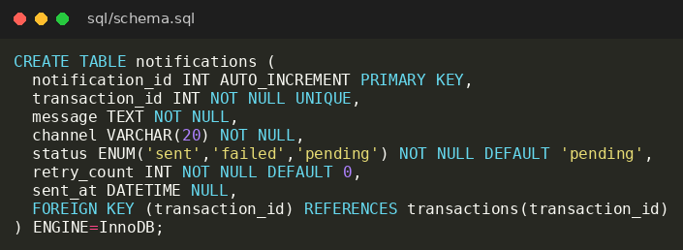

Figure 3.1: Tables of the database in phpMyAdmin
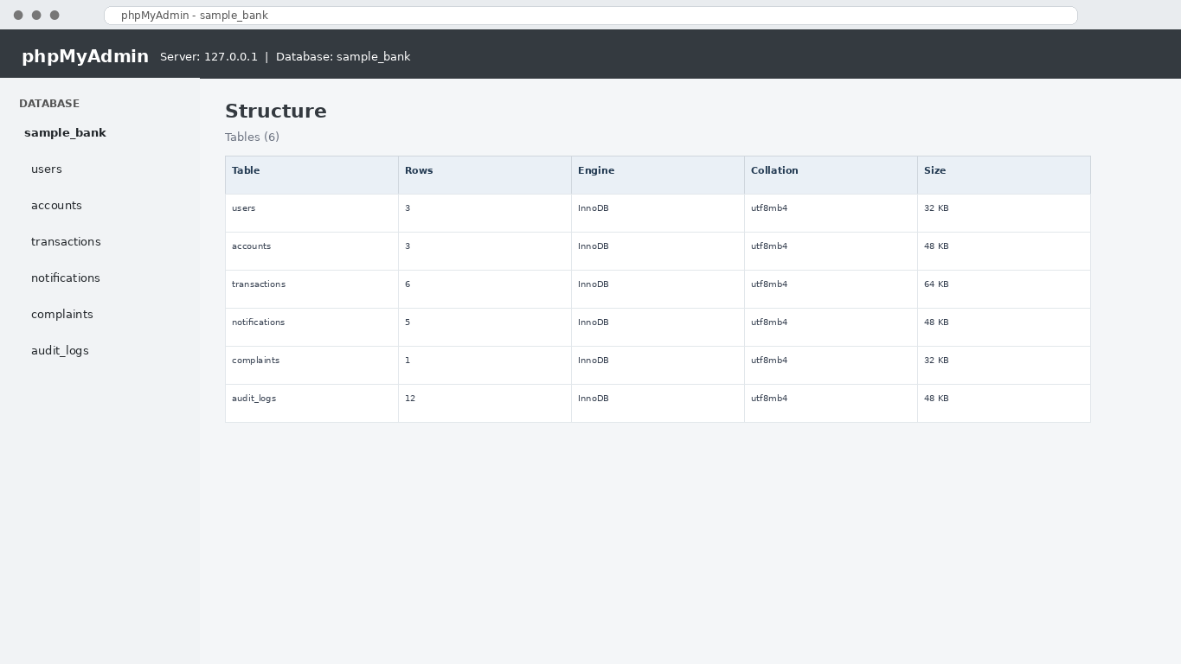

Figure 3.2: Structure of the notifications table showing the unique key on transaction_id
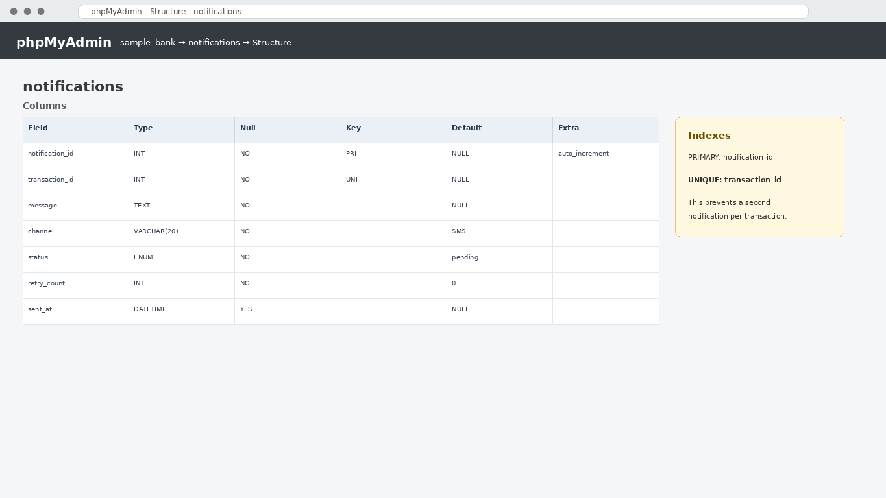

3.4.2 Connecting the database to the application
The application connects to the database through PHP Data Objects, with the connection settings kept in one configuration file so that they can be changed without editing the pages. The connection is set to report errors as exceptions, which makes faults visible during development. All queries that use input from the user are written as prepared statements, which protects the database from SQL injection. Operations that must succeed or fail together, such as saving a transaction and updating a balance, are placed inside a database transaction that is committed only when every step has worked.
Listing 3.2: Database connection using PHP Data Objects (config/database.php)
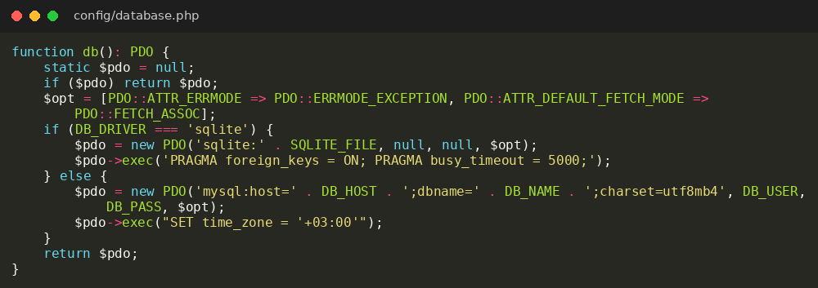

3.5 Development and debugging of the features (first stage)
The system was built feature by feature. Each feature was written, opened in the browser, tested with simulated data and debugged before the next one was started, in line with the Agile approach described in Chapter One. The first stage produced the authentication module, the customer dashboard, the history pages and the notification settings.

3.5.1 Authentication and session management
The login page receives the username and the password or PIN, validates them, and looks up the user with a prepared statement. The submitted password is compared with the stored hash using PHP password verification. If the details are correct and the account is active, a session is started, the session identifier is renewed to prevent session fixation, and the user is sent to the customer or administrator dashboard according to the role. Failed attempts and successful logins are written to the audit log. Every protected page begins by checking that a session exists and that the role is allowed to see the page, and a session that has been inactive for a set period is ended automatically.
Listing 3.3: Login check and page protection (includes/auth.php)
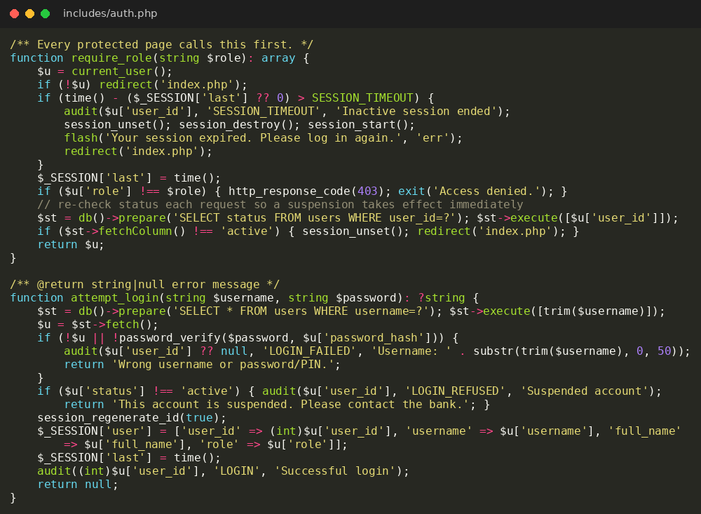

Figure 3.3: Login page of the system
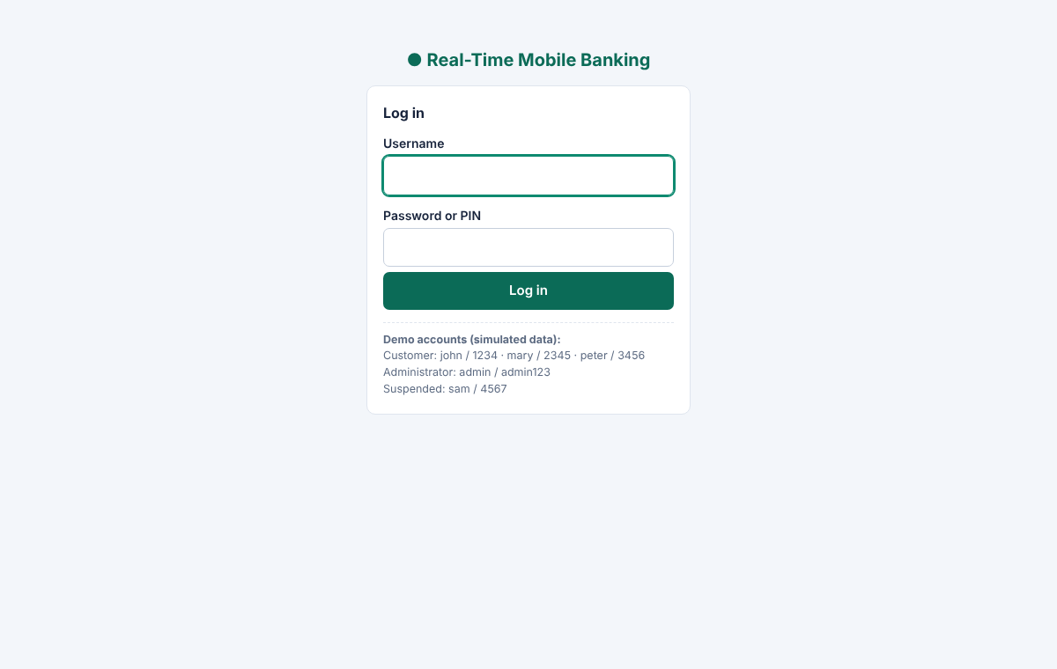

3.5.2 Customer dashboard
The dashboard reads the current balance from the accounts table, the five most recent transactions from the transactions table and the status of the latest notifications from the notifications table. Because the balance shown on the page and the balance sent in a notification both come from the same stored value, the customer always sees consistent information.
Listing 3.4: Balance service used by the dashboard to refresh itself (api/balance.php)
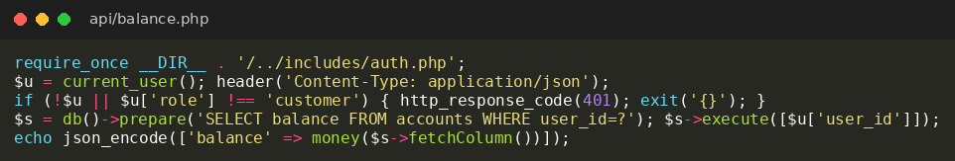

Figure 3.4: Customer dashboard
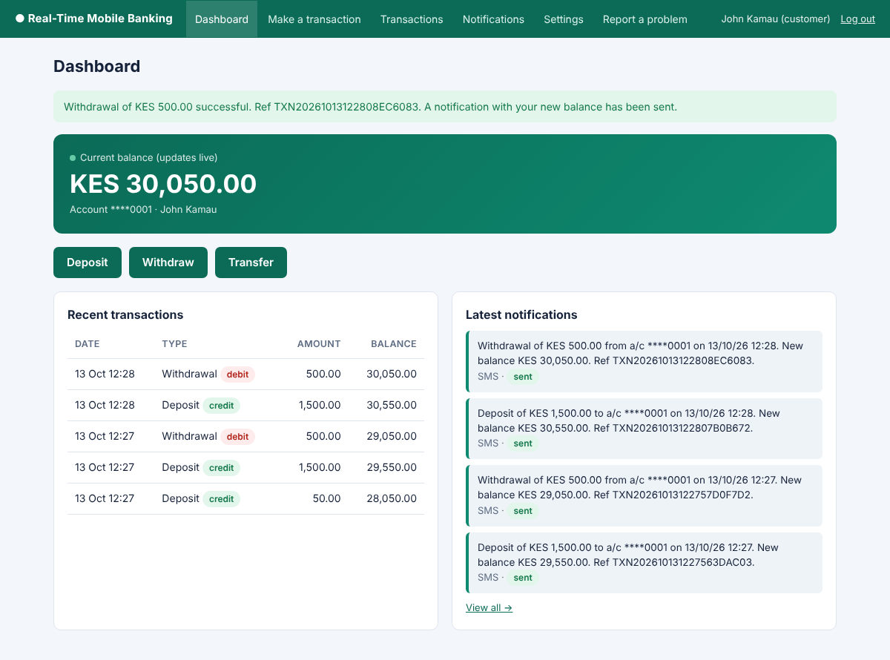

3.5.3 Transaction history and notification history
The history pages read the records that belong to the logged-in customer only. The transaction history can be filtered by date and type, and the results are divided into pages so that long histories load quickly. The notification history shows each message, its channel and its delivery status, and it contains the link to the complaint form. The filters are applied through prepared statements.
Figure 3.5: Transaction history page
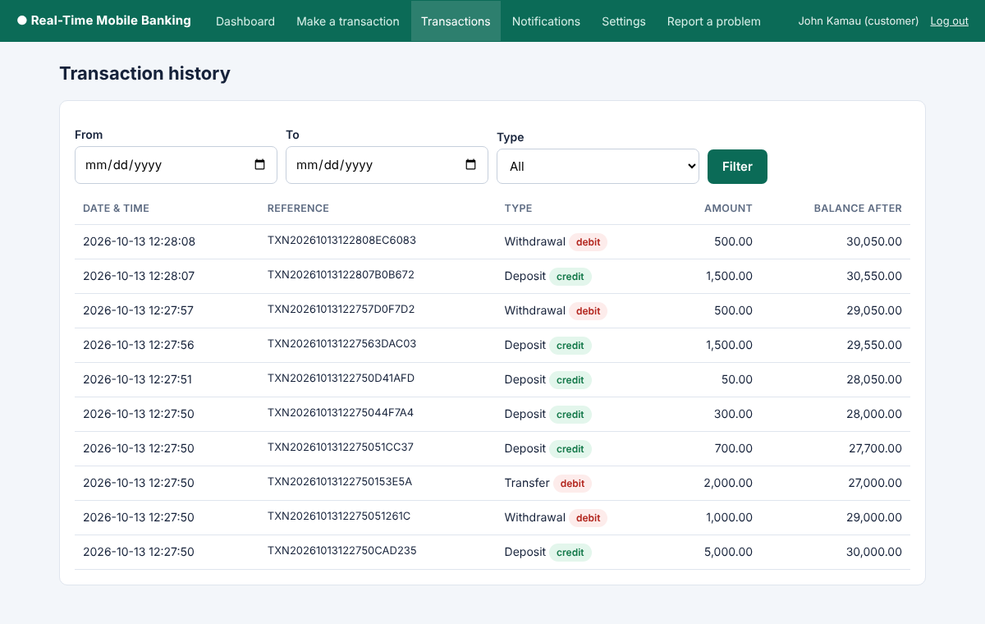

Figure 3.6: Notification history page
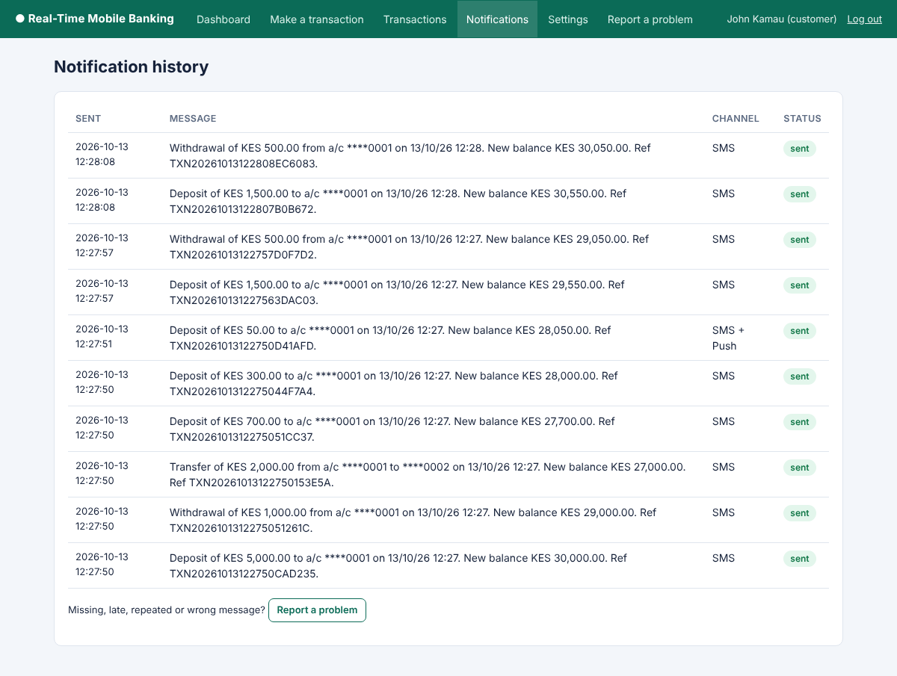

3.5.4 Notification preferences
The settings page lets the customer choose SMS, push notification or both, and change the phone number that receives SMS alerts. The phone number is validated against the format of Kenyan mobile numbers before it is saved, and the saved preference is read by the notification module the next time a transaction is recorded.
Listing 3.5: Saving the notification preferences (customer/settings.php)
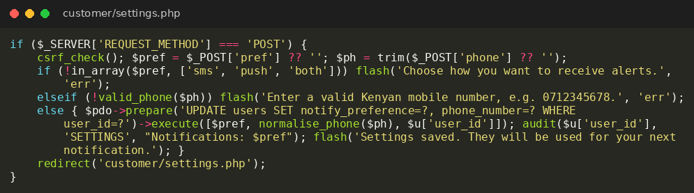

Figure 3.7: Notification settings page
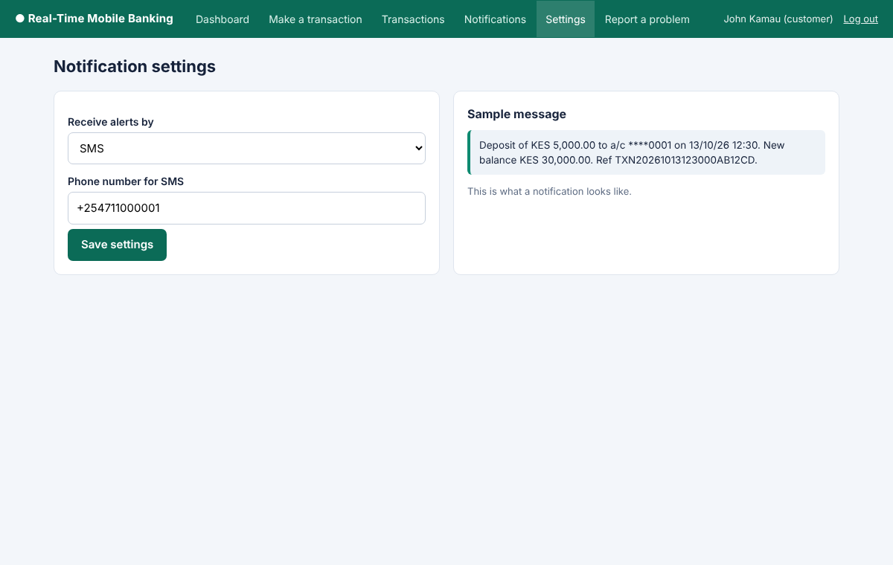

3.6 Development and debugging of the features (second stage)
The second stage produced the transaction processing module, the notification module with duplicate prevention, the complaints feature and the administrator modules. These are the parts of the system that deliver the main objectives of the project.
Each feature in this stage was built in the same order. The database tables that the feature needs were confirmed, the feature was written and connected to the database, and it was then tested with simulated data and debugged before the next feature was started. For this reason each part below reports the feature, its database integration and the faults that were found and corrected while it was being built. The faults are brought together in section 3.7 and the formal testing is reported in section 3.8.

3.6.1 Transaction processing module
When a customer submits a transaction, the module first validates the amount and the transaction type and checks the PIN. The unique transaction reference, made from the date, the time and a random code, is generated when the form is displayed, so that a repeated submission of the same form (a double click or a page refresh) carries the same reference and is rejected by the unique key in the database. It opens a database transaction, reads the account balance while locking the account row so that two requests cannot change the balance at the same moment, and checks that the balance is enough for a withdrawal or transfer. The transaction record and the new balance are then saved, the balance after the transaction is stored in the record, and the database transaction is committed. If any step fails, the database transaction is rolled back and the customer is told that the transaction was not completed. A transfer creates two records, one for each account, so that both account holders are notified. Each transfer record also stores a direction (credit or debit), so that the sender and the receiver each get a correct message.
Database integration. The module works on the account, transaction and balance records. It reads and locks the account row, saves the transaction record and updates the balance inside one database transaction, which is why the tables use the InnoDB engine. The unique key on the transaction reference, created in section 3.4.1, makes the database itself reject a repeated submission, and the direction and the balance after the transaction are saved by this module.
Debugging. Two faults were found in this module. A customer who pressed the submit button twice could create two transactions, so the reference is now generated when the form is shown, the button is disabled after the first click and the page is redirected after saving. The design also did not distinguish the sending record from the receiving record of a transfer, so a direction field was added to the transactions table. The module was tested with normal values, with a withdrawal equal to the balance, and with invalid values such as empty fields, negative amounts and text in numeric fields. The stored records were checked in phpMyAdmin after each test.
Listing 3.6: Transaction processing with locking, commit and rollback (includes/transaction.php)
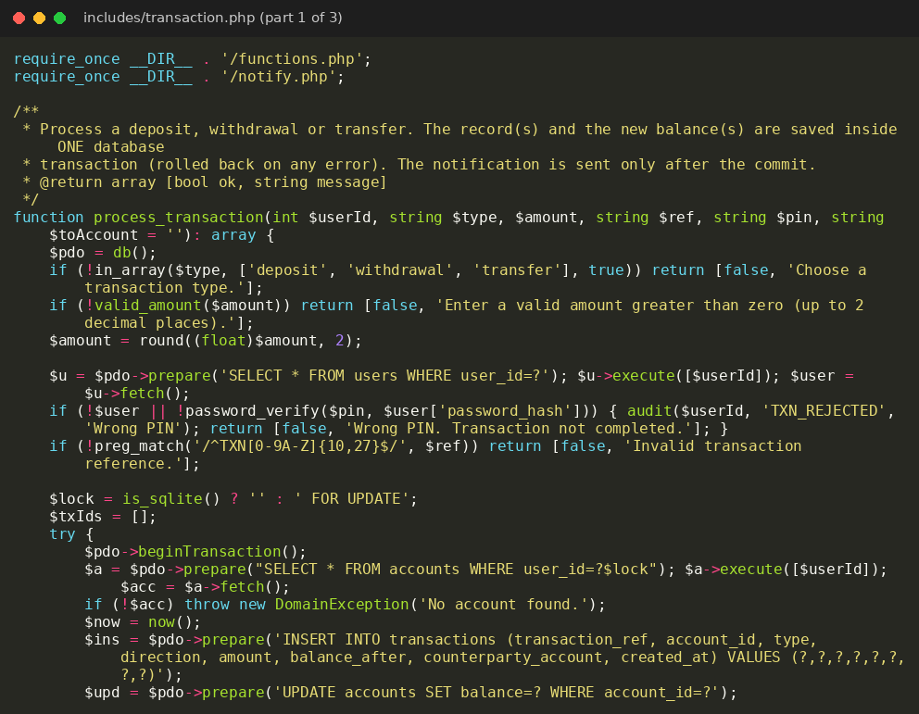
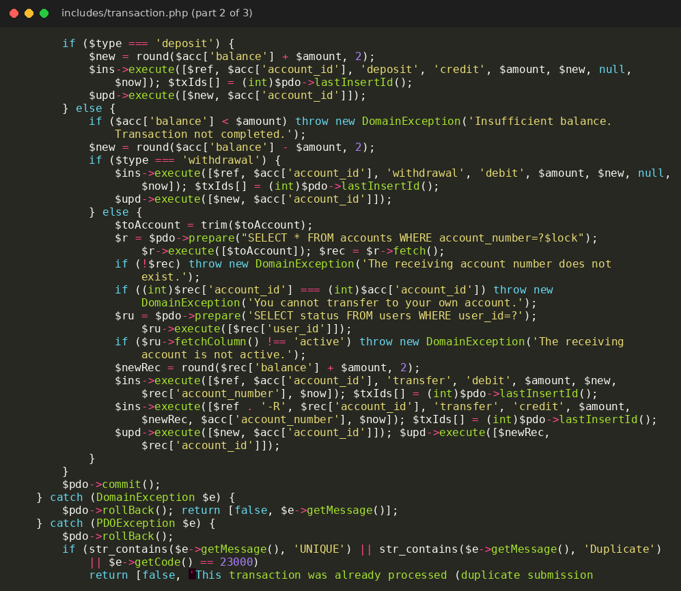
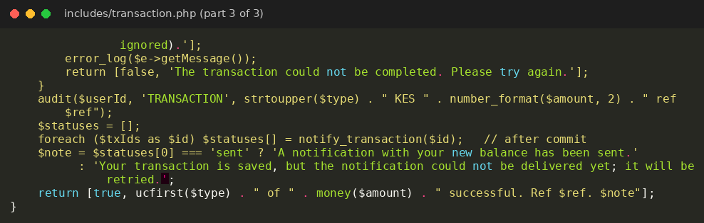

Figure 3.8: Make-a-transaction page
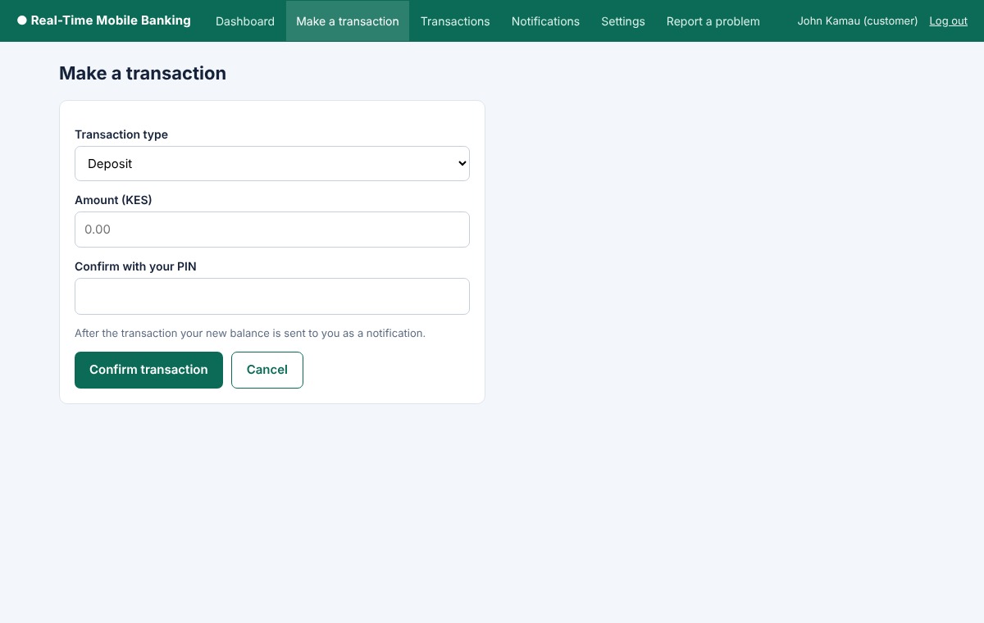

3.6.2 Notification module
The notification module is called only after the transaction has been committed. It first looks for an existing notification for the transaction. If one exists, nothing is sent. Otherwise it composes a short message that states the type of transaction, the amount, the last digits of the account number, the time, the new balance and the reference, and it saves a notification record with the status pending. The unique key on the transaction identifier makes the database reject a second record for the same transaction, even if two requests arrive together. The message is then sent to the SMS gateway with a short time limit, and the notification record is updated to send, together with the time, or to failed when the gateway does not confirm delivery. A failure to deliver never cancels the transaction, because the money movement has already been committed, but it is recorded so that the administrator can retry it.
Database integration. The module reads and writes the notifications table, which is linked to the transactions table by a foreign key. Each notification record holds its status (pending, send or failed) and the time of sending. The unique key on the transaction identifier lets the database block a second notification for the same transaction. Because the module is called only after the commit, an error in this step cannot undo the money movement.
Debugging. The module was tested by completing a transaction and checking that exactly one notification record was created and that the message arrived on the smartphone, as shown in Figure 3.9. The failure path was tested with the gateway outage switch, which changed the status to failed without affecting the transaction. A repeated request for the same transaction was also tested, and the existing record stopped a second message from being sent.
Listing 3.7: Notification module with duplicate prevention (includes/notify.php)
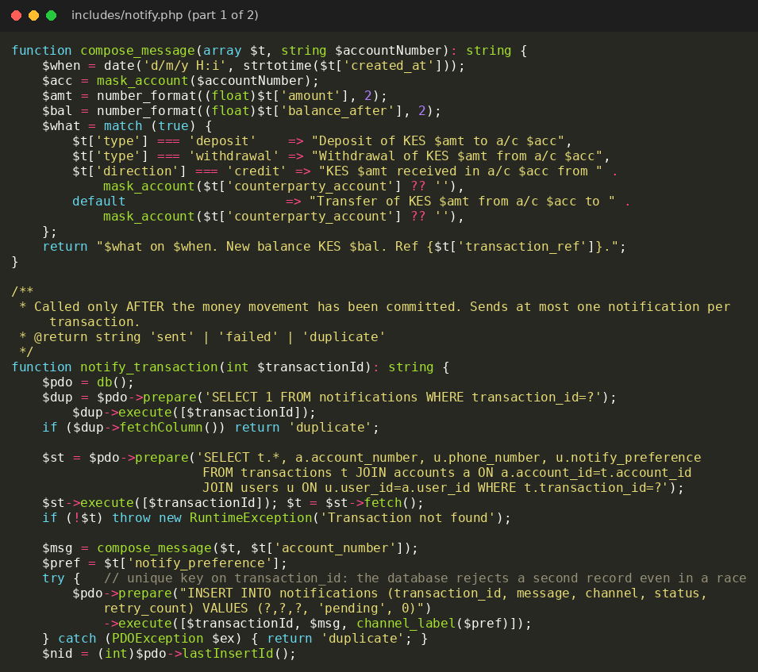
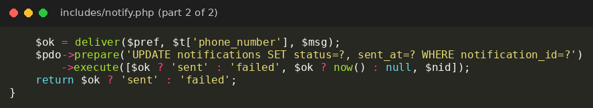

Figure 3.9: Notification received on a smartphone after a transaction
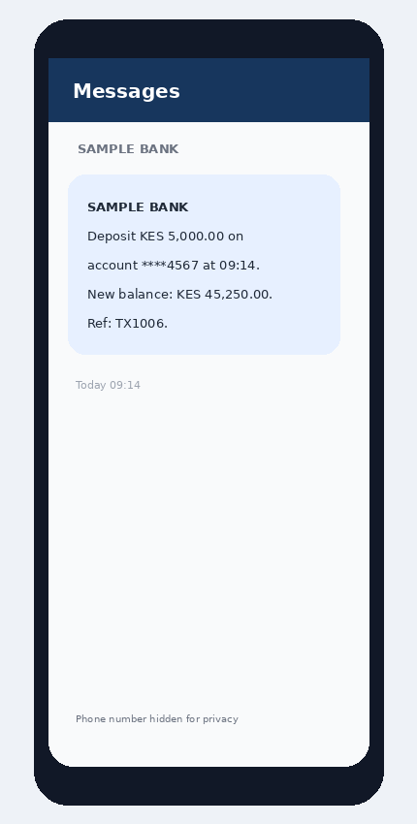

3.6.3 Complaint submission and handling
A customer who finds a missing, late, duplicate or incorrect notification can open the complaint form, choose the transaction and describe the problem. The complaint is saved with the status open. The administrator reads the complaint, writes a response and changes the status to in progress or resolved, and every change is written to the audit log.
Database integration. The complaint form saves a record in the complaints table, linked to the customer who submitted it, with the status open. When the administrator responds, the response and the new status (in progress or resolved) are saved in the same record, and the change is written to the audit log table.
Debugging. The form was tested with valid input and with empty fields. The status changes were followed in phpMyAdmin and on the audit log page to confirm that every change was recorded.
Listing 3.8: Saving a complaint (customer/complaint.php)
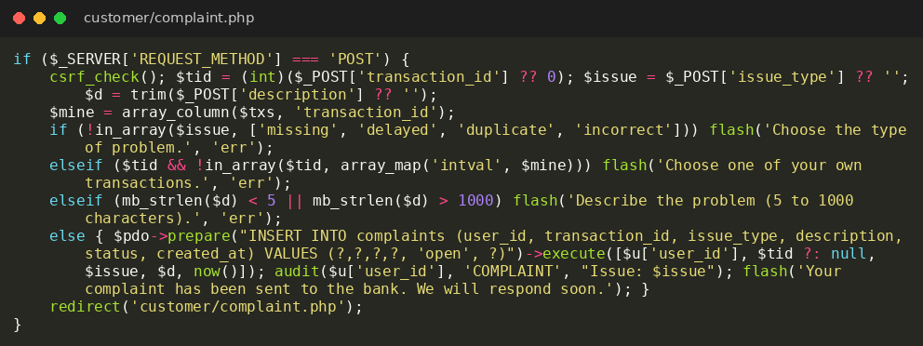

Figure 3.10: Complaint form
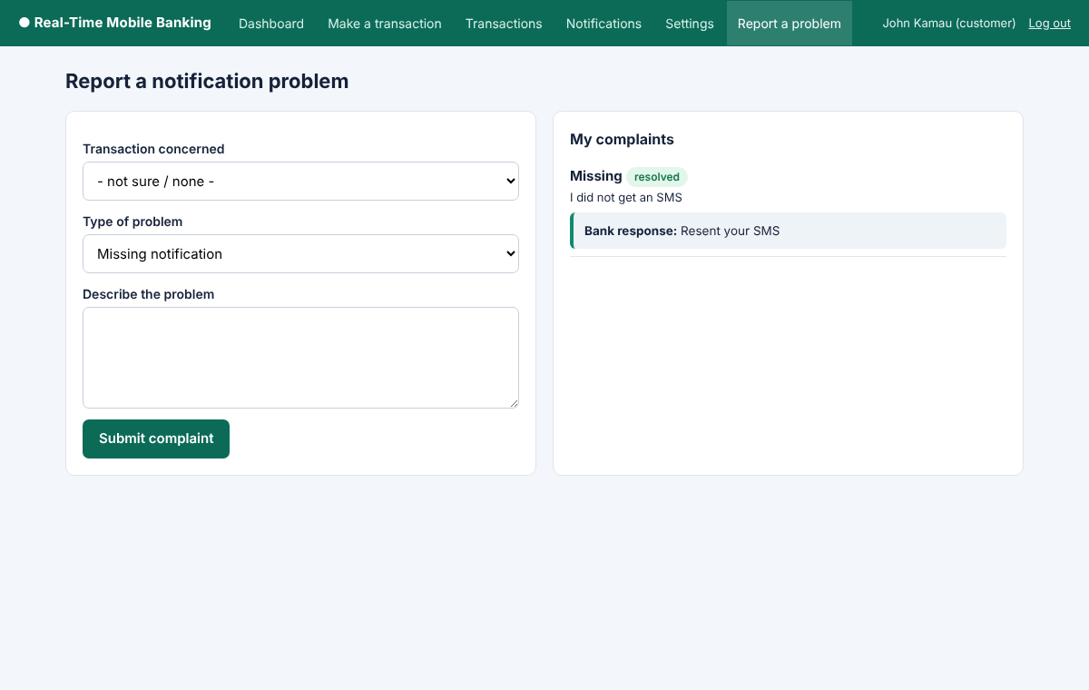

3.6.4 Administrator modules
The administrator dashboard summarises the number of customers, the transactions of the day, the notifications sent and the notifications that failed or are pending. The customer management page allows the administrator to add, edit, suspend and activate customers, and a suspended customer is refused at login. The transaction monitoring page shows every transaction with the status of its notification. The delivery monitor groups notifications by status and offers a retry button for notifications that failed or are pending. The retry action checks the status again before sending, so a notification that has already been sent can never be sent twice. The reports page produces summaries for a chosen period, and the audit log page lists the recorded actions.
Database integration. The administrator pages read the customer, transaction, notification, complaint and audit log records. The dashboard figures and the reports are produced by queries that count and group these records for the chosen period. The customer management actions change the status of the customer record, and the retry action updates the notification record.
Debugging. Three faults were corrected in these pages. A customer suspended by the administrator could keep using a session that was already open, so the account status is now checked on every protected request. The retry action had to be prevented from resending a message that was already sent, so the status is checked before sending and again in the update statement. The top menu was too large and badly arranged on a phone screen, so it now scrolls sideways on small screens.
Listing 3.9: Retrying a failed notification, which refuses a message that was already sent (includes/notify.php)
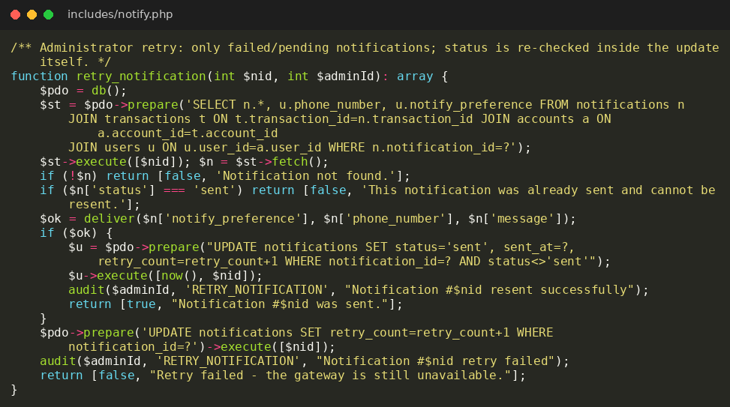

Figure 3.11: Administrator dashboard
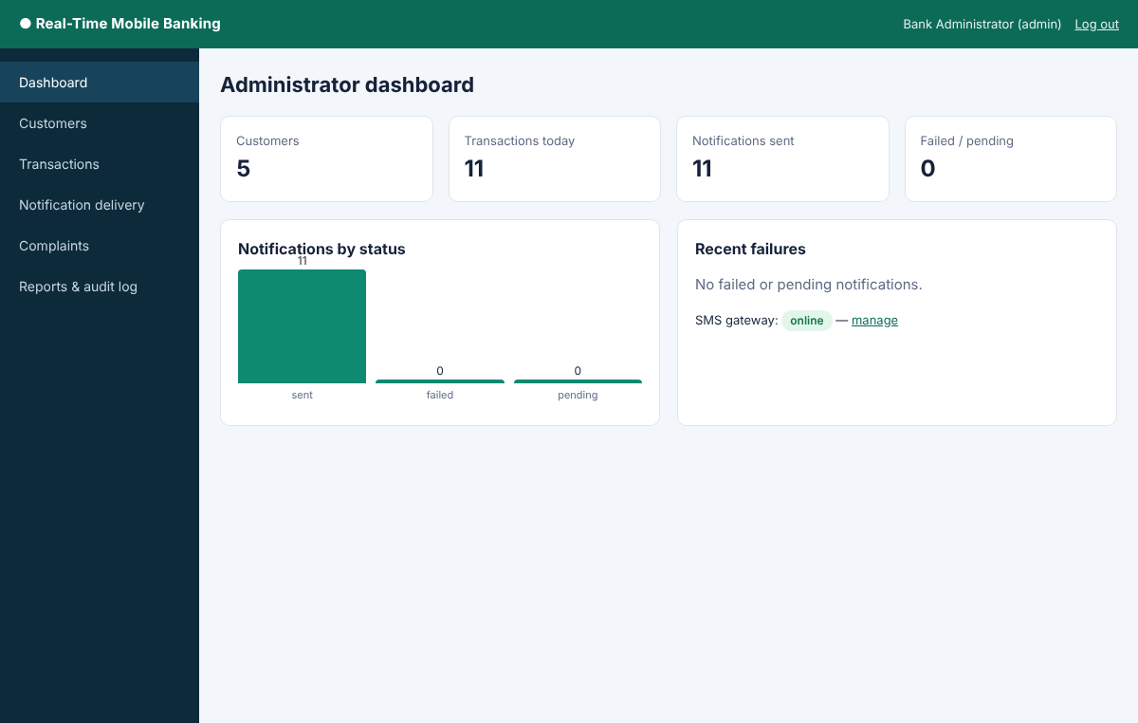

Figure 3.12: Manage customers page
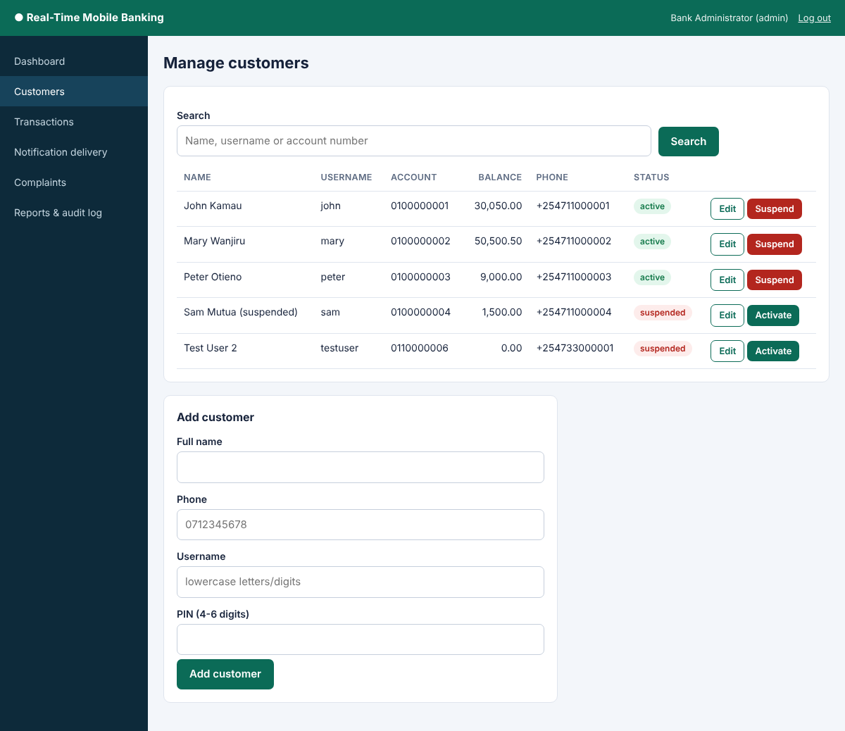

Figure 3.13: Monitor transactions page
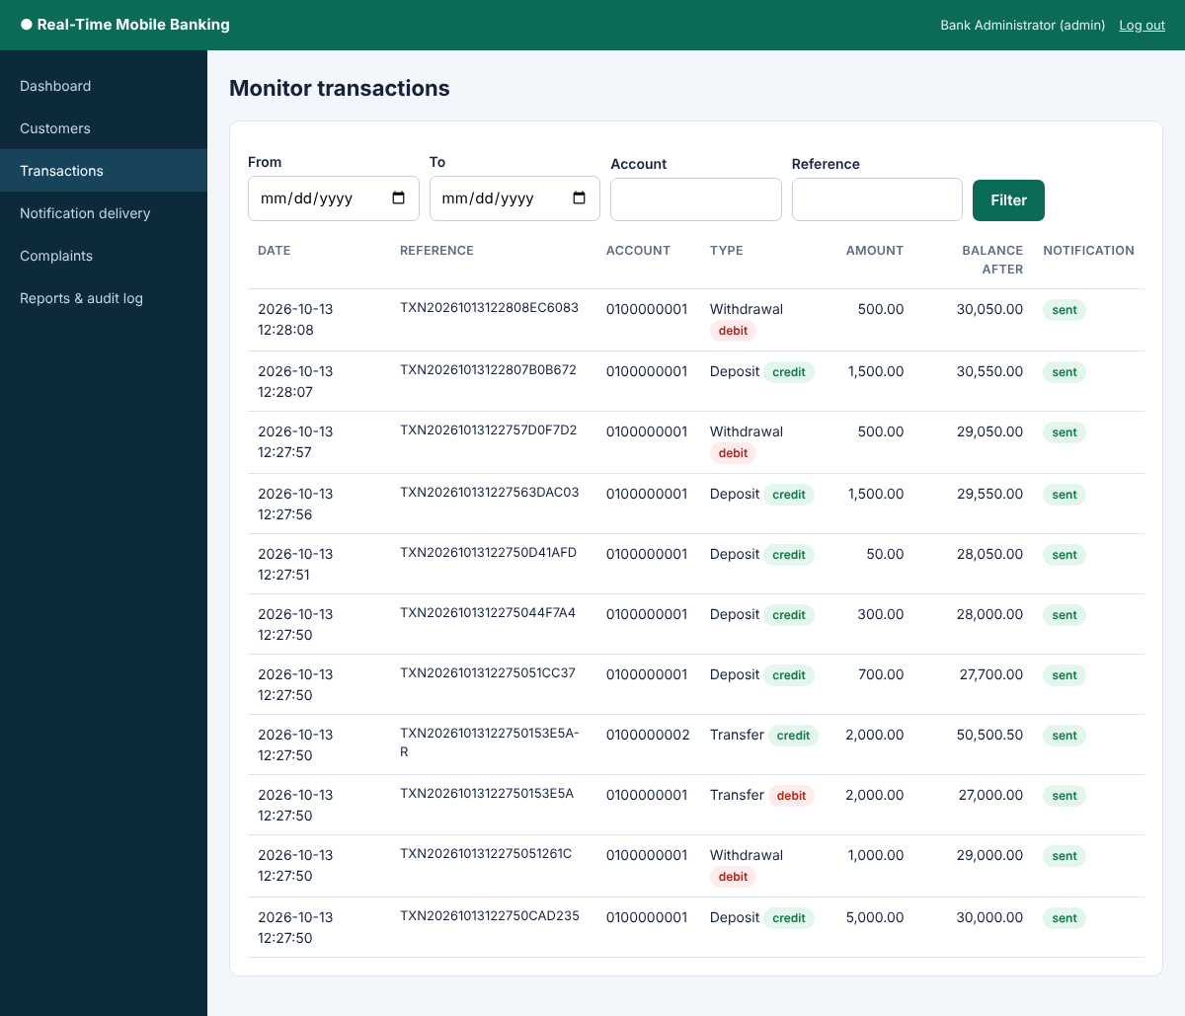

Figure 3.14: Notification delivery monitor
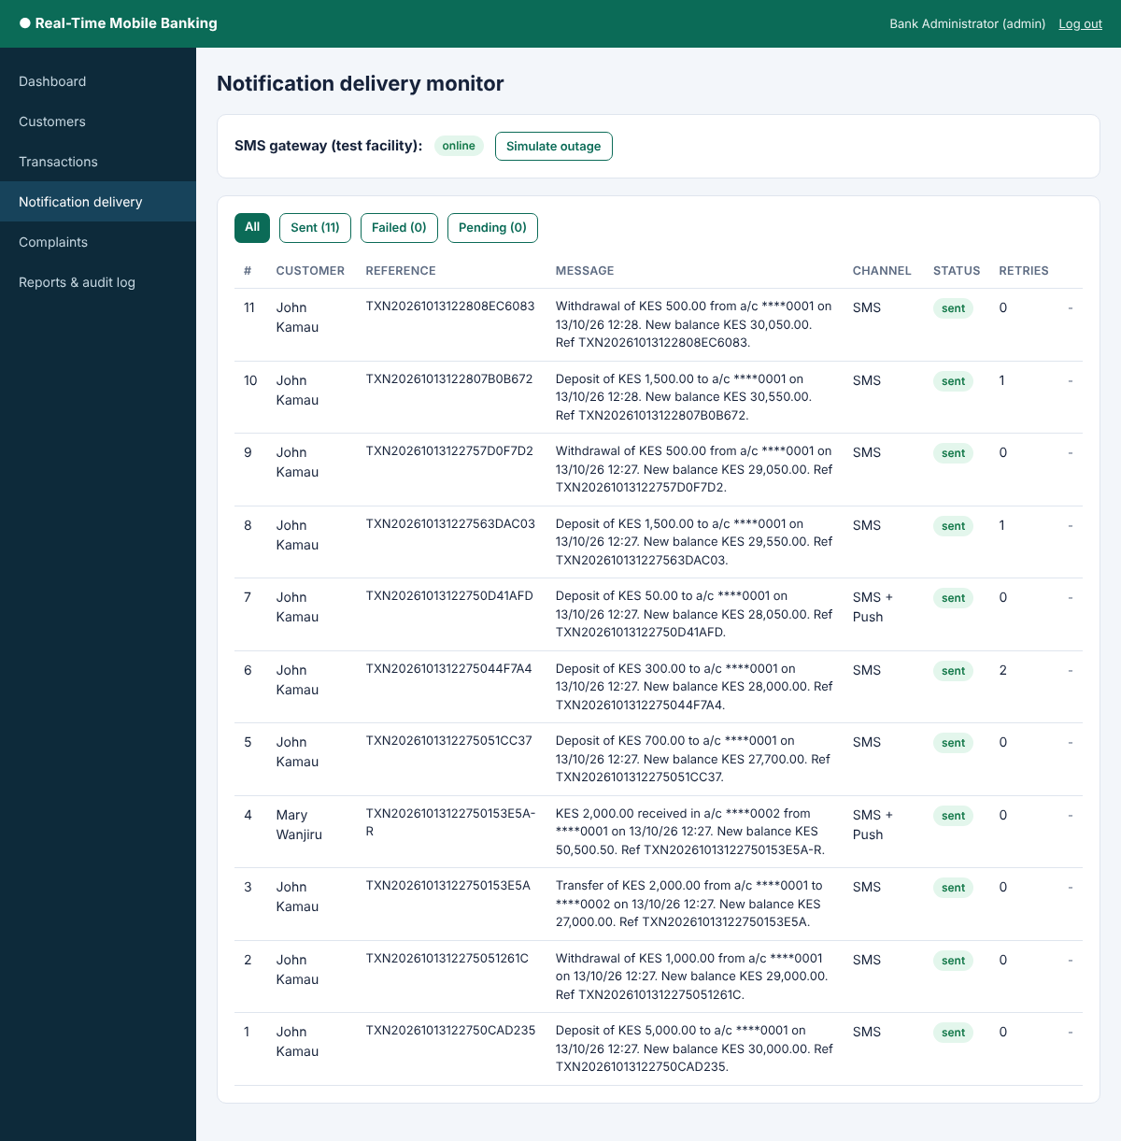

Figure 3.15: Complaints handling page
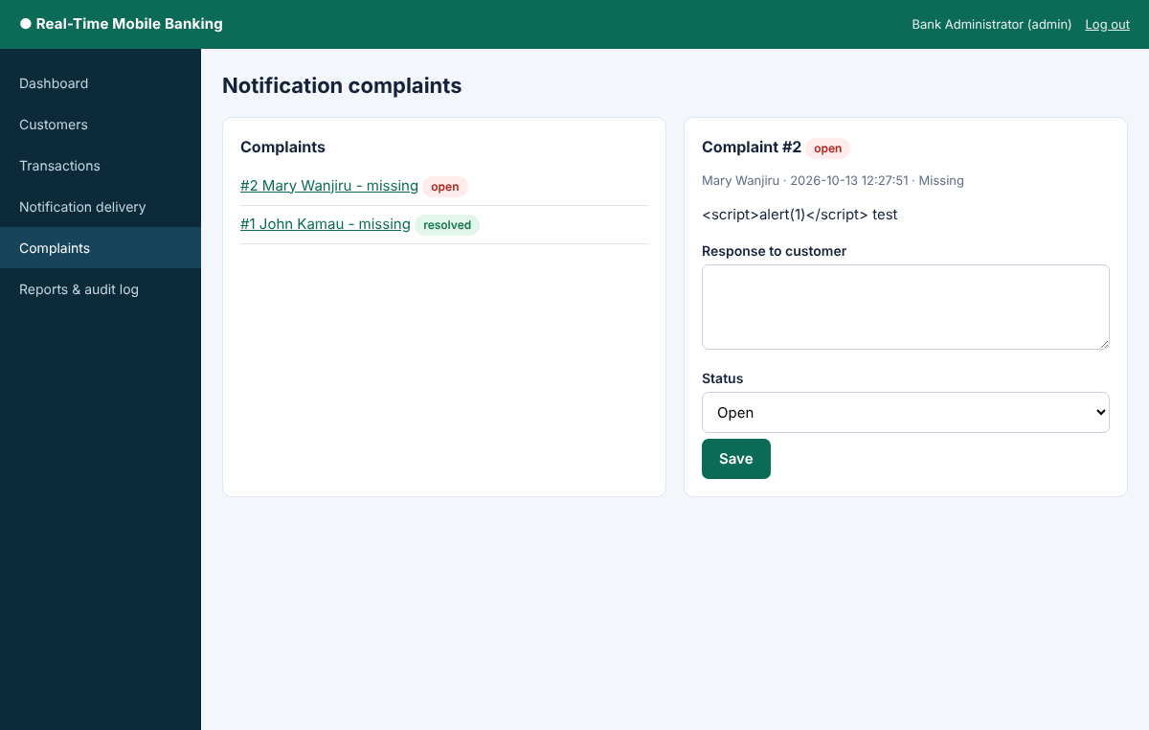

Figure 3.16: Reports and audit log page
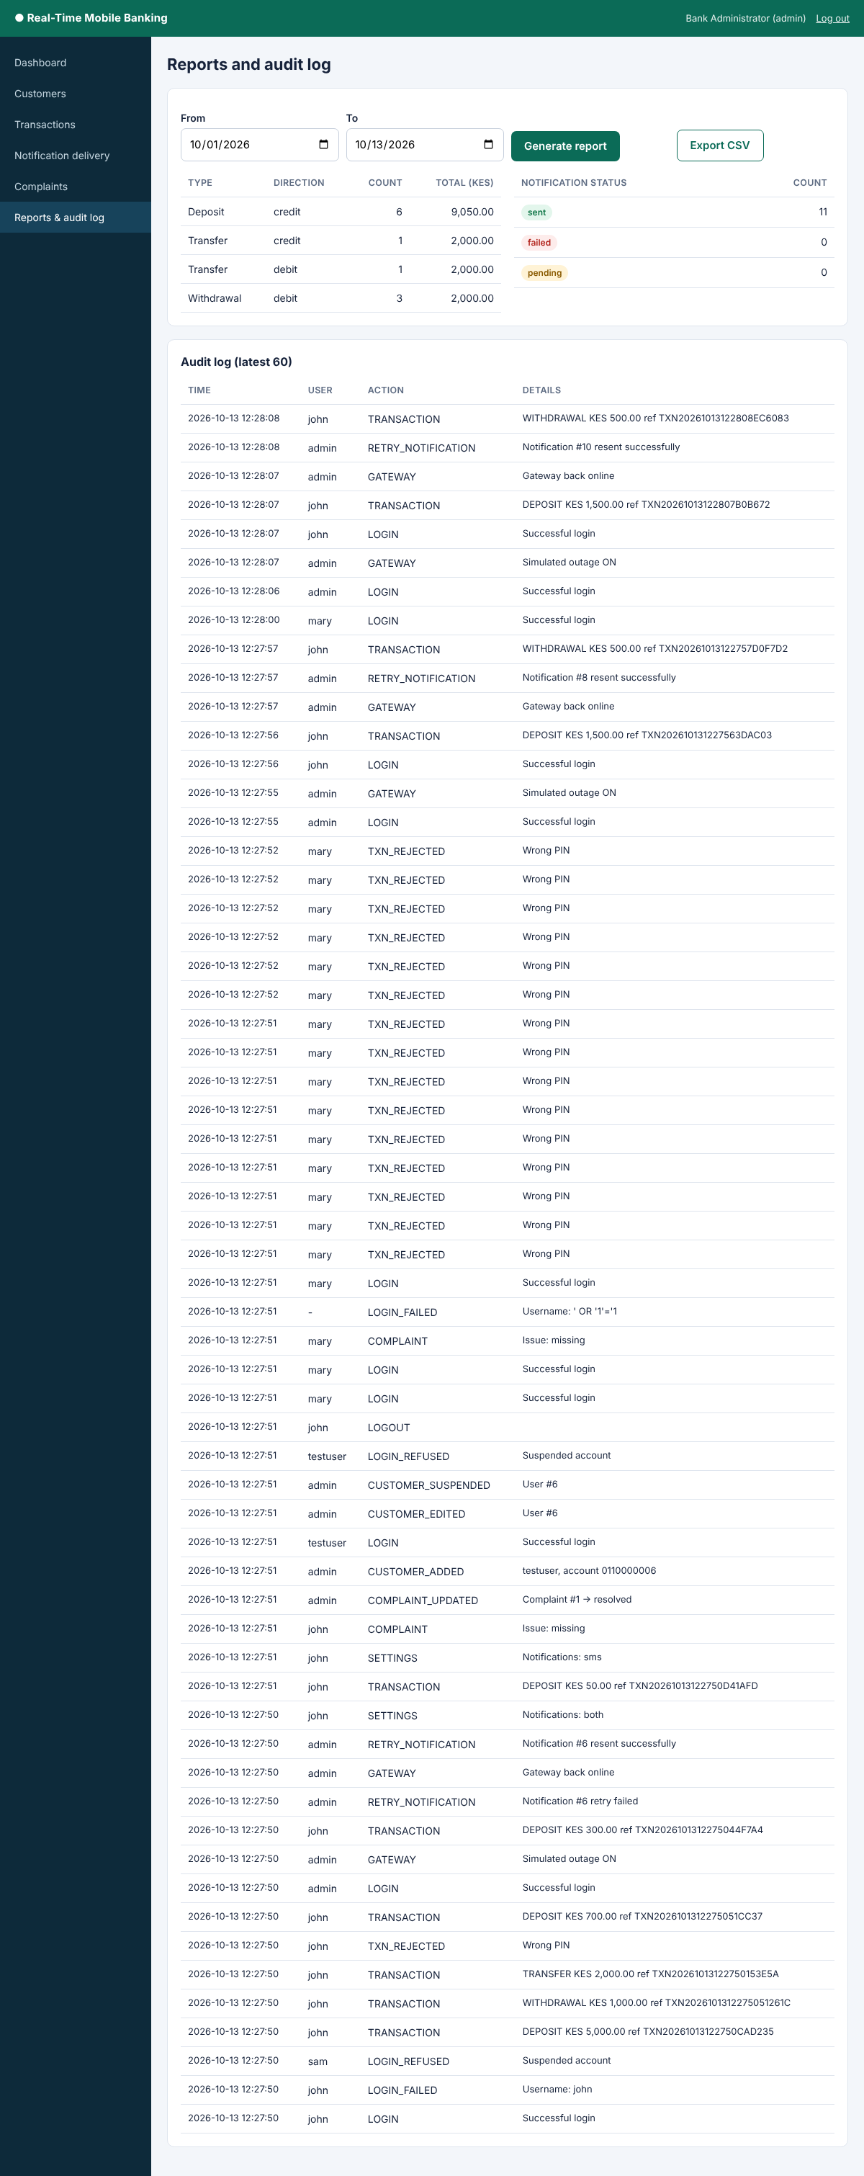

3.7 Debugging
Debugging was done while each feature was being built so that faults did not accumulate. The main techniques were reading the PHP error log, displaying errors on the development server, inspecting the requests and responses in the browser developer tools, and checking the stored records in phpMyAdmin after every test. Test data was chosen to include normal values, boundary values such as a withdrawal equal to the balance, and invalid values such as empty fields, negative amounts and text in numeric fields. Each fault that was found was corrected and the same test was repeated before the work continued. Error display was switched off in the deployed copy, so that technical details are never shown to users.
The faults found and corrected during development were as follows. First, the design did not distinguish the sending record from the receiving record of a transfer, so a direction field was added to the transactions table. Second, a customer who pressed the submit button twice could create two transactions; this was corrected by generating the reference when the form is shown, disabling the button after the first click and redirecting after saving. Third, a customer suspended by the administrator could keep using a session that was already open, so the account status is now checked on every protected request. Fourth, the retry action had to be prevented from resending a message that was already sent, so the status is checked before sending and again in the update statement. Fifth, the top menu was too large and badly arranged on a phone screen and was changed to scroll sideways on small screens. The automated tests were run again after each correction.

3.8 System testing

3.8.1 Testing approach
Testing was carried out at four levels. Unit testing checked individual functions such as validation, reference generation and message composition. Integration testing checked that the modules work together, for example that a committed transaction leads to exactly one notification. System testing checked the complete system against the functional and non-functional requirements in Chapter One, and user acceptance testing, reported in Section 3.9.4, checked whether real users find the system useful and easy to use.

3.8.2 Functional test cases
The functional test cases in Table 3.3 cover every functional requirement. Each test was run with simulated data, and the status column was completed after the test was executed.
Table 3.3: Functional test cases
ID | Feature | Test steps and input | Expected result | Status
TC01 | Login (FR1) | Enter a valid customer username and PIN | Customer dashboard opens | Pass
TC02 | Login (FR1) | Enter a correct username with a wrong password | Error message is shown and the failed attempt is logged | Pass
TC03 | Login (FR1) | Log in with a suspended account | Login is refused with a suspended-account message | Pass
TC04 | Access control (FR1) | Log in as a customer and open an administrator page address | Access is denied or the user is redirected | Pass
TC05 | Access control (FR1) | Open a dashboard address without logging in | User is redirected to the login page | Pass
TC06 | Balance display (FR2) | Open the dashboard | Balance shown equals the balance stored in the database | Pass
TC07 | Deposit (FR3, FR4) | Deposit a valid amount | Balance increases by the amount, the transaction is saved and a notification with the new balance is sent | Pass
TC08 | Withdrawal (FR3, FR4) | Withdraw an amount smaller than the balance | Balance decreases by the amount and a notification is sent | Pass
TC09 | Withdrawal (FR3) | Withdraw more than the balance | Transaction is rejected, nothing is saved and no notification is sent | Pass
TC10 | Transfer (FR3, FR4) | Transfer to a valid account | Both balances are updated and both account holders receive a notification | Pass
TC11 | Transfer (FR3) | Transfer to an account number that does not exist | Transaction is rejected with an error message | Pass
TC12 | Transaction PIN (FR1) | Submit a transaction with a wrong PIN | Transaction is rejected | Pass
TC13 | Input validation (FR3) | Enter zero, a negative amount and text as the amount | Validation error is shown for each and nothing is saved | Pass
TC14 | Duplicate prevention (FR5) | Submit the same transaction twice by pressing the button twice or refreshing the page | Only one transaction and one notification exist | Pass
TC15 | Duplicate prevention (FR5) | Try to insert a second notification for the same transaction in the database | Database rejects the record because of the unique key | Pass
TC16 | Message accuracy (FR4) | Compare the notification text with the stored transaction | Message shows the correct type, amount, reference and a balance equal to the stored balance | Pass
TC17 | Delivery failure (FR4, FR6) | Make the SMS gateway unavailable and make a transaction | Transaction stays saved and the notification status is failed | Pass
TC18 | Retry (FR9) | Retry a failed notification after the gateway is available, then try to retry a sent notification | Status becomes sent and the retry count is updated, and the retry of a sent notification is refused | Pass
TC19 | Preferences (FR7) | Change the channel and phone number and make a transaction | Setting is saved and used for the next notification | Pass
TC20 | Transaction history (FR2) | Filter the history by a date range | Only transactions in the range are shown | Pass
TC21 | Notification history (FR6) | Open the notification history | Messages and statuses match the stored records | Pass
TC22 | Complaint (FR9) | Submit a complaint about a transaction | Complaint is saved as open and appears on the administrator complaints page | Pass
TC23 | Complaint handling (FR9) | Write a response and mark the complaint resolved | Status and response are updated | Pass
TC24 | Customer management (FR8) | Add, edit and suspend a customer | Changes are saved and the suspended customer cannot log in | Pass
TC25 | Reports (FR10) | Generate a report for a period | Figures match the database records | Pass
TC26 | Audit log (FR10) | Log in, make a transaction and retry a notification | Each action appears in the audit log | Pass
TC27 | Logout and timeout (FR1) | Log out, then press the browser back button, and leave a session idle | Session ends and protected pages cannot be opened | Pass

3.8.3 Non-functional tests
The non-functional requirements were tested as shown in Table 3.4.
Table 3.4: Non-functional tests
Requirement | Test performed | Expected outcome | Status
Performance | Record the time between a transaction being saved and the notification being sent | Notification is sent immediately, within a few seconds | Pass
Reliability | Stop the SMS gateway during a transaction and restart it | Failed message is recorded and can be resent, with no loss of transaction data | Pass
Accuracy | Compare balances in messages with balances in the database after many transactions | Balances always match | Pass
Security | Enter SQL and script code in the login, amount and complaint fields, and inspect the stored passwords | Input is rejected or safely handled and passwords are stored as hashes | Pass
Usability | Open the system on a laptop and on a smartphone | Pages display correctly and can be used on both | Pass
Maintainability | Add a new field to a page and to the matching table | Change is made in the expected file only

3.8.4 Summary of test results
Twenty-seven functional test cases (Table 3.3), five of the six non-functional tests (Table 3.4; the maintainability test is still to be recorded) and further checks on duplicate submission by parallel requests and on automatic session timeout were run with simulated data. After the faults described in Section 3.7 were corrected, every functional test case passed, giving 38 of 38 passing automated checks in the final run. The tests were repeated after each correction until every case passed.

3.9 Deployment

3.9.1 Deployment environment
After testing on the development computer, the system was launched in a simulated real-world environment that was separate from the development folder. A clean Apache, PHP and MySQL server was used, on which the database was created from the SQL script and the program files were copied without the development files. The system was opened from a smartphone and from a laptop through a web browser using the address of the server on the local network, which is how customers and administrators would reach it. I used xampp.

3.9.2 Deployment procedure
The deployment followed a fixed order so that it could be repeated. A release copy of the code was prepared and the test files were removed. The database was created from the SQL script and loaded with simulated starting data. The database connection settings were changed to match the new server, the time zone was set to East Africa Time so that transactions carry the correct time, and the display of technical errors was switched off. The SMS gateway credentials were kept in the configuration file and not in the pages. The services were then started and the login page was opened to confirm that the site was running.
Figure 3.17: System running in the deployment environment on a smartphone browser
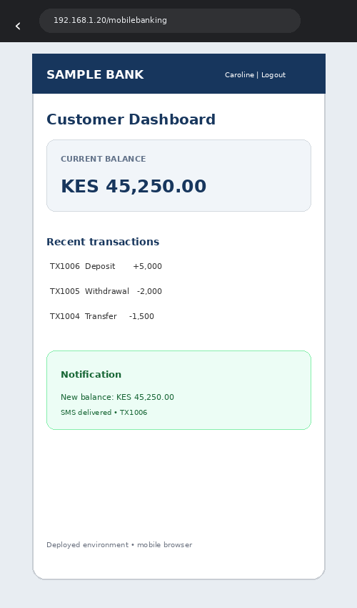

3.9.3 Verification of the features in the deployment environment
After deployment, the main features were tested again to confirm that they work in the new environment. The checks are listed in Table 3.5.
Table 3.5: Verification of features in the deployment environment
Feature | Check carried out in the deployment environment | Status
Login and roles | Customer and administrator log in and see their own dashboards
Database connection | Pages read and save data without errors
Transaction processing | Deposit, withdrawal and transfer update the balances correctly
Real-time notification | A message with the new balance reaches the smartphone immediately after a transaction
Duplicate prevention | Submitting the same transaction twice produces only one notification
Failure handling | A failed message is recorded and can be retried from the administrator page
Complaints | A complaint submitted by a customer appears for the administrator
Reports and audit log | Reports and audit entries match the activity carried out
Mobile layout | All pages display correctly on the smartphone

3.9.4 User acceptance testing
User acceptance testing was carried out in the deployment environment to find out whether the system meets the needs of its users. volunteers took part, acting as bank customers and bank administrators, and each one completed a set of tasks such as logging in, making a transaction, reading the notification, changing the notification settings and reporting a problem. Afterwards each volunteer answered the questionnaire in Appendix I, which was delivered as a Google Form (Appendix II). The questionnaire uses a five-point scale, and the answers were summarised as percentages. 80% accepted that the system meets users needs and the balances were correct.

3.10 Chapter summary
This chapter described how the system was developed feature by feature using PHP and MySQL, how the database was created and connected, how the transaction and notification modules deliver real-time, accurate and non-duplicated messages, and how the system was tested and deployed. The next chapter presents the conclusions of the project and the recommendations.

CHAPTER FOUR: CONCLUSIONS AND RECOMMENDATIONS

4.1 Introduction
This chapter summarises the project, states the conclusions that follow from the work, describes the challenges and limitations that were met, and gives recommendations for banks and for further study.

4.2 Summary of the project
The project set out to develop a real-time mobile banking account balance notification system that improves customer satisfaction in Kenyan banks. The problem was that customers of mobile banking often receive delayed, missing, duplicated or inaccurate notifications, which reduces their trust and increases the workload of bank staff. The requirements were analysed in Chapter One, the system was designed in Chapter Two, and it was developed, tested and deployed in Chapter Three using the Agile approach, PHP, MySQL, HTML, CSS and JavaScript.

4.3 Conclusions
The first objective was to analyse the requirements of the system. The requirements of customers and administrators were identified and written as ten functional requirements and six non-functional requirements, and they were supported by a review of theory, earlier studies and existing notification services.
The second objective was to design and develop a system that records transactions, updates balances and sends a notification immediately after every successful transaction. A system that saves the transaction and the new balance in one database operation and then calls the notification module was designed and built, so the balance in each message is taken from the stored balance.
The third objective was to prevent duplicate and inaccurate notifications and to keep a traceable record of delivery. This was achieved by giving every transaction a unique reference, by checking for an earlier notification before sending, by placing a unique key on the notification table so that the database refuses a second message for the same transaction, and by saving the delivery status of every message so that failed messages can be seen and retried.
The fourth objective was to deploy and test the system to establish whether timely and accurate communication improves customer satisfaction. The system was tested against the requirements and deployed in a simulated real-world environment, and the user acceptance testing gave users the opportunity to judge the timeliness and accuracy of the messages. According to the testing the project was the best since it solve the customers problems.
It is therefore concluded that combining balance updating, immediate notification, duplicate prevention and delivery tracking in one low-cost design addresses the gap identified in the literature, and that the system can help banks to give customers the timely and accurate information that they expect.

4.4 Challenges and limitations
The project was carried out within one academic semester, which limited the number of features that could be built. The system was developed and tested with simulated customers, accounts and transactions and was not connected to the core banking system of a real bank, so its behaviour with real volumes of transactions is not yet known. The SMS notifications were sent through a test facility of an SMS gateway, and the delivery time in a live network may differ. Push notifications depend on the customer using a compatible device, and all notifications depend on the quality of the mobile network, which the system cannot control.

4.5 Recommendations
Banks are recommended to give every transaction a unique reference and to check that reference before sending a notification, because this simple control removes duplicate messages. Banks should also record the delivery status of every notification so that failed messages can be detected and resent, and so that customer complaints can be resolved from records rather than by manual investigation. Where a notification system is connected to real customer data, the bank should carry out a data protection impact assessment and follow the Data Protection Act, 2019 before the system goes live. Banks should also use more than one SMS gateway or channel so that a fault in one of them does not stop customers from receiving their messages. Finally, customers should be educated on how to set their notification preferences and how to report a problem with a notification.

4.6 Areas for further study
Further work could connect the system to a real core banking system through secure programming interfaces and test it with a large number of simultaneous transactions. Other researchers could add a USSD fallback for customers without smartphones, messages in Kiswahili as well as English, and automatic alerts for unusual transactions that may indicate fraud. A study with a larger group of real bank customers would also give stronger evidence of the effect of timely and accurate notifications on customer satisfaction.

REFERENCES

Anthropic. (2026). Claude (Sonnet 5.5) [Large language model]. https://claude.ai
Computer Misuse and Cybercrimes Act, No. 5 of 2018 (Kenya). https://www.kenyalaw.org
Data Protection Act, No. 24 of 2019 (Kenya). https://www.kenyalaw.org
Davis, F. D. (1989). Perceived usefulness, perceived ease of use, and user acceptance of information technology. MIS Quarterly, 13(3), 319–340. https://doi.org/10.2307/249008
DeLone, W. H., & McLean, E. R. (2003). The DeLone and McLean model of information systems success: A ten-year update. Journal of Management Information Systems, 19(4), 9–30. https://doi.org/10.1080/07421222.2003.11045748
Oliver, R. L. (1980). A cognitive model of the antecedents and consequences of satisfaction decisions. Journal of Marketing Research, 17(4), 460–469. https://doi.org/10.1177/002224378001700405
Shaikh, A. A., & Karjaluoto, H. (2015). Mobile banking adoption: A literature review. Telematics and Informatics, 32(1), 129–142. https://doi.org/10.1016/j.tele.2014.05.003

APPENDICES

Appendix I: User acceptance testing questionnaire
Respondents first state whether they acted as a bank customer or a bank administrator. They then rate each statement from 1 (strongly disagree) to 5 (strongly agree) and answer the two open questions at the end.
No. | Statement | Rating (1–5)
1 | I received the balance notification immediately after my transaction.
2 | The balance shown in the notification was correct.
3 | I never received two messages for the same transaction.
4 | The messages were easy to read and understand.
5 | I could easily see whether each notification was delivered.
6 | I could easily change how I receive notifications.
7 | Reporting a notification problem was easy.
8 | The pages were easy to use on my phone.
9 | Monitoring delivery and retrying failed notifications was easy (administrators only).
10 | This system would make me more satisfied with mobile banking.
11 | Open question: What did you like most about the system?
12 | Open question: What should be improved?

Appendix II: Google Form used for user acceptance testing
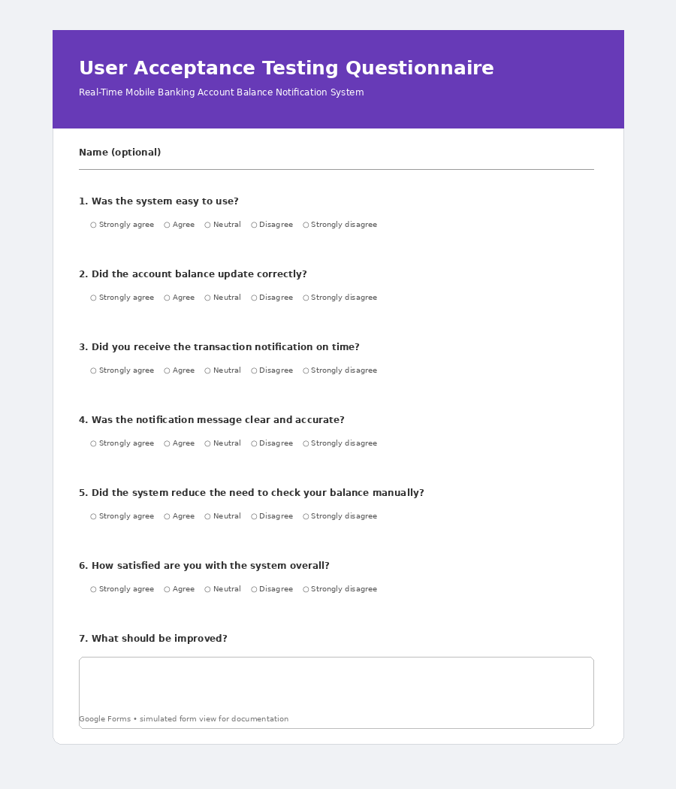

Appendix III: Source code of the system
The complete source code of the working system is listed below, file by file. The files are organised as described in Table 3.2. The database script is in Appendix IV.
File: index.php
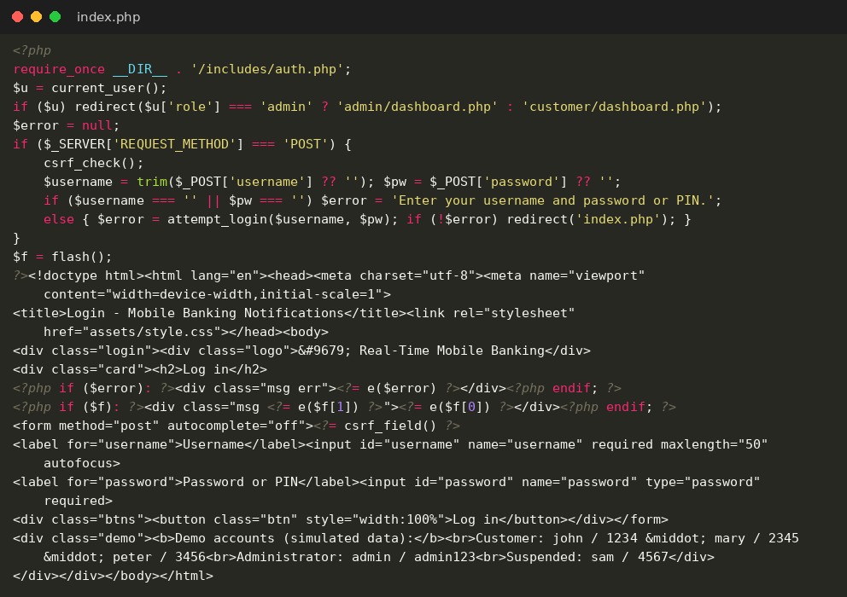
File: logout.php
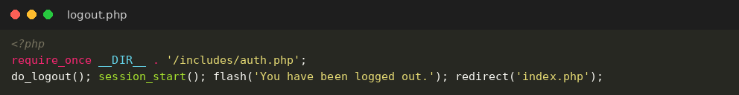
File: install.php
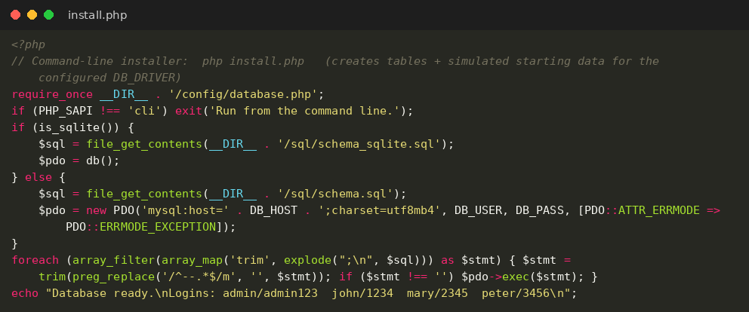
File: config/database.php
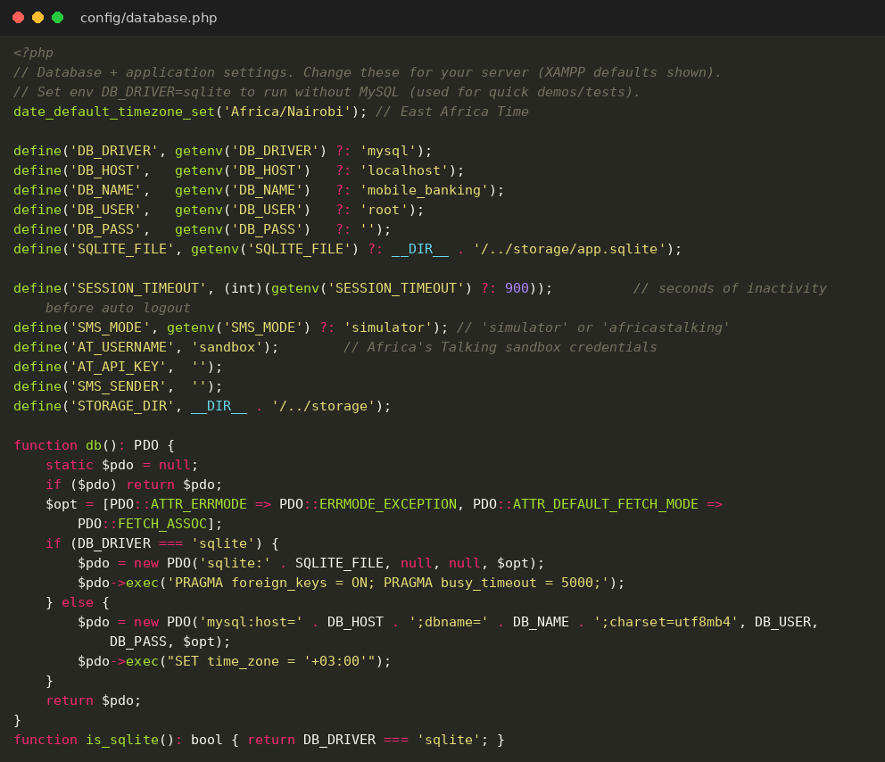
File: includes/auth.php
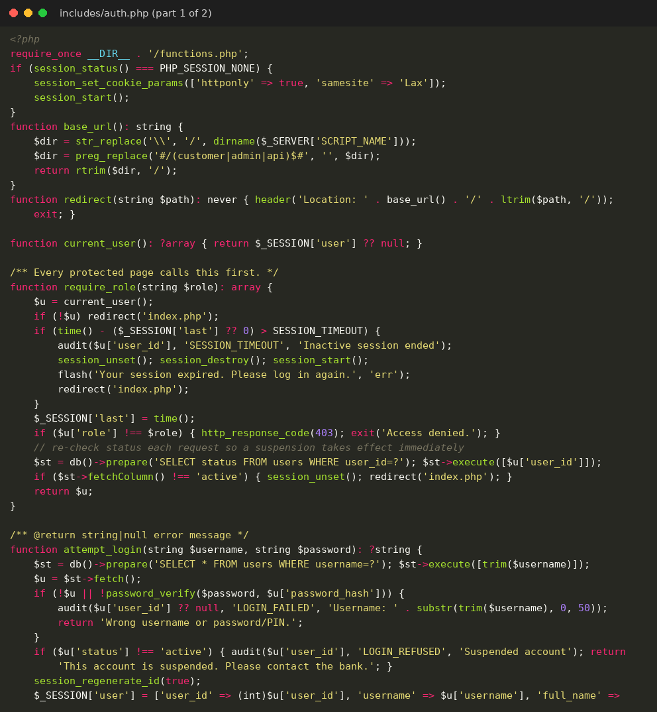
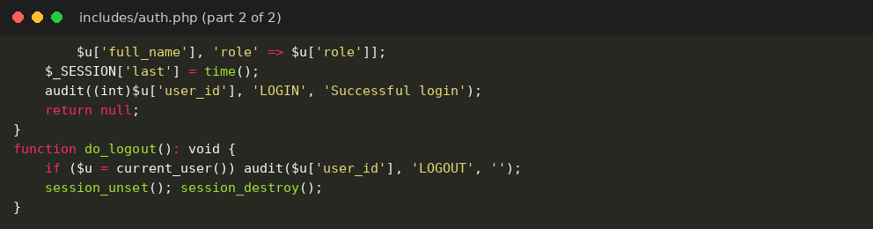
File: includes/functions.php
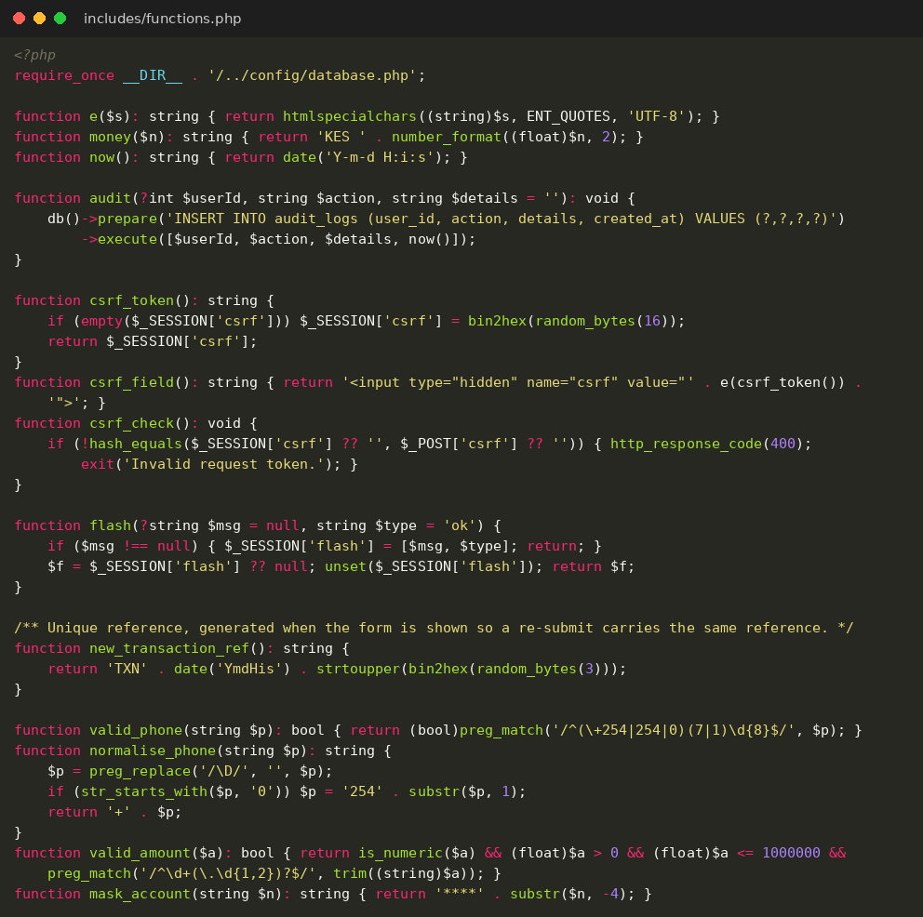
File: includes/layout.php
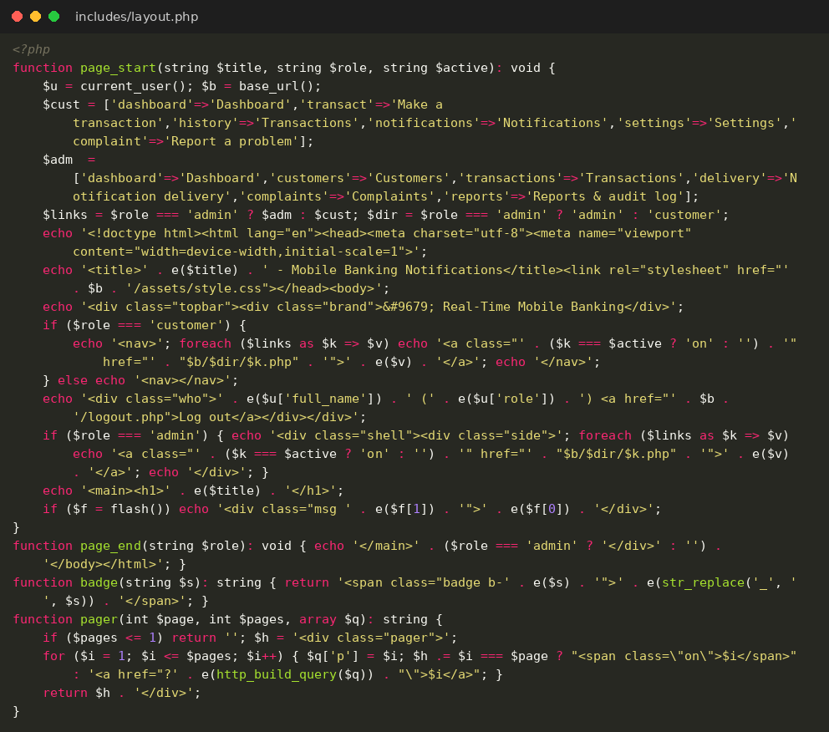
File: includes/sms.php
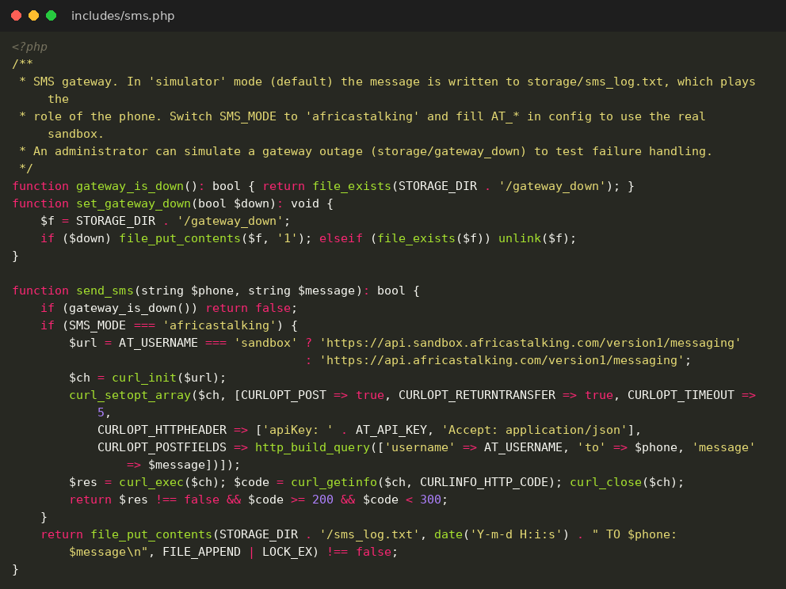
File: includes/notify.php
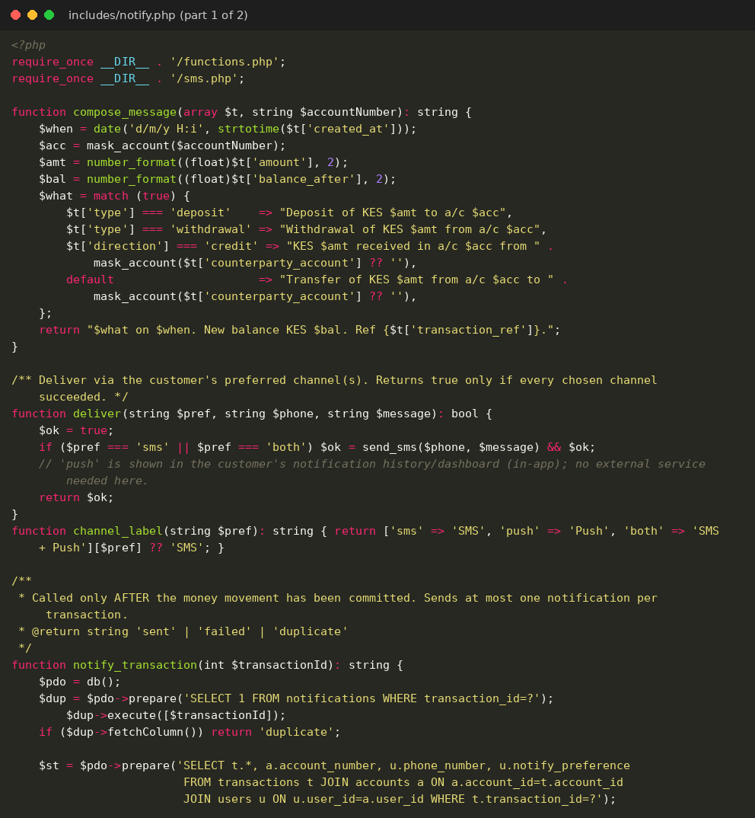
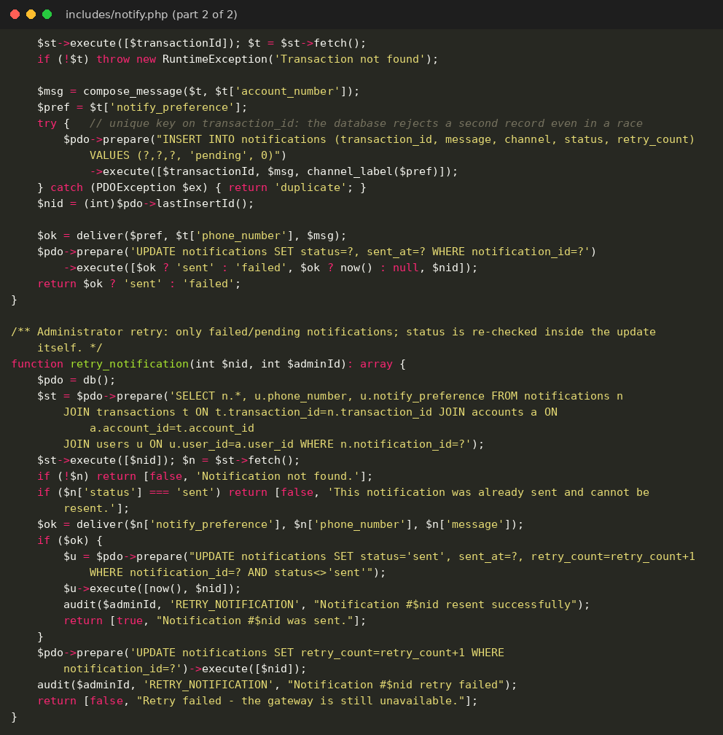
File: includes/transaction.php
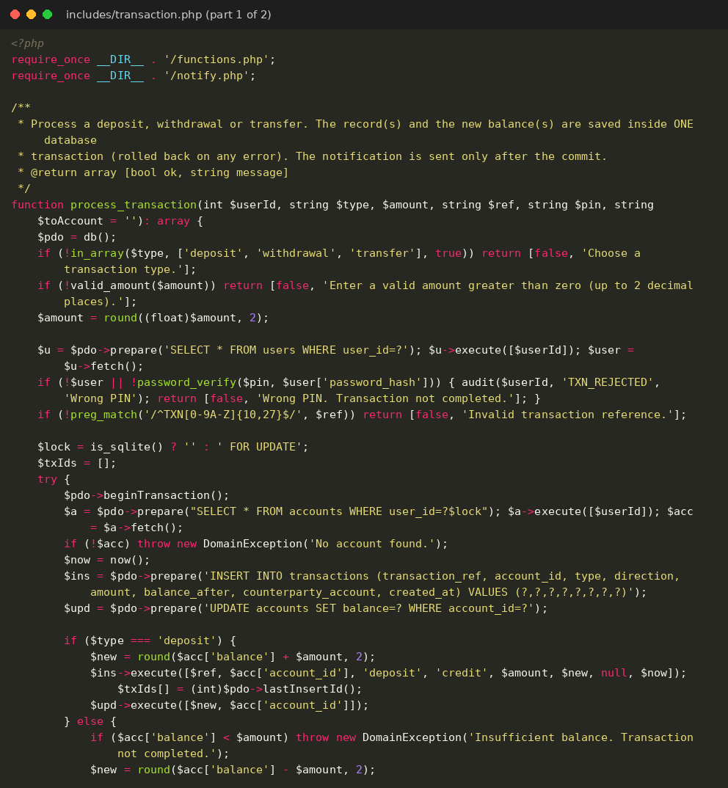
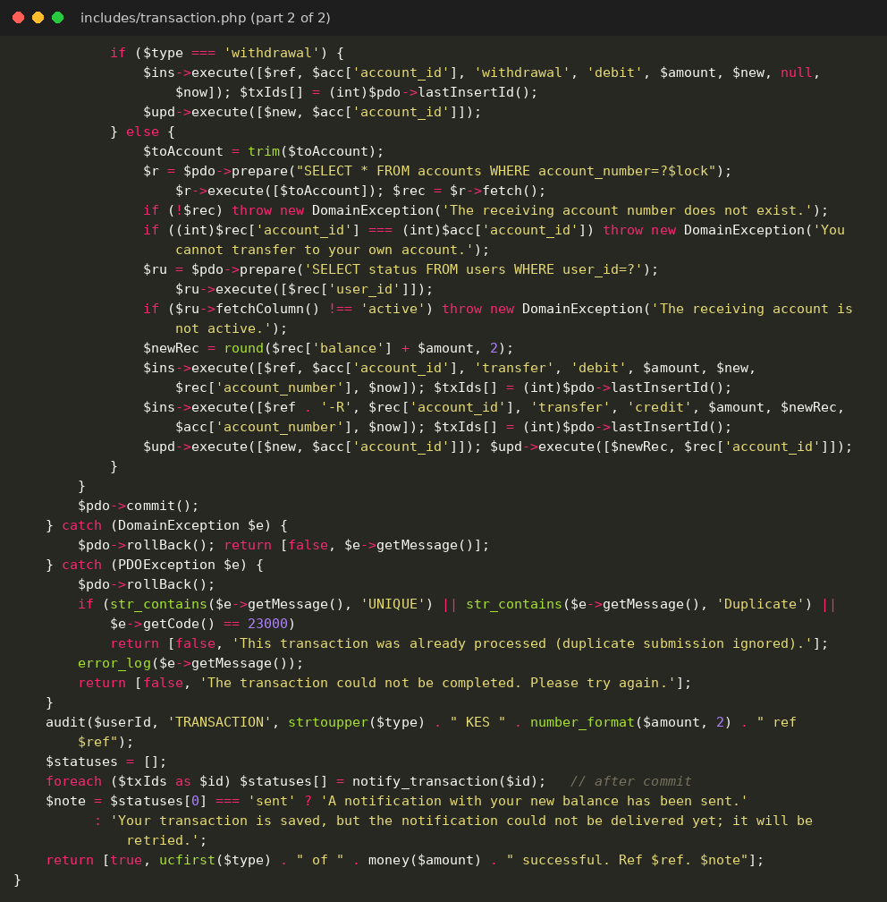
File: api/balance.php
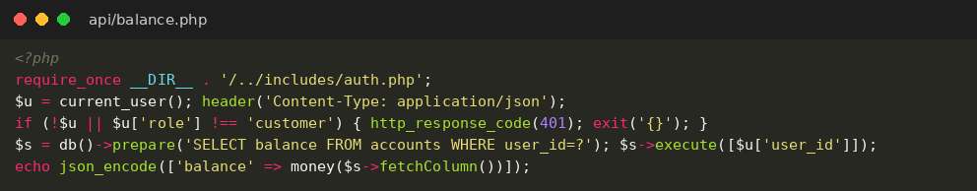
File: customer/dashboard.php
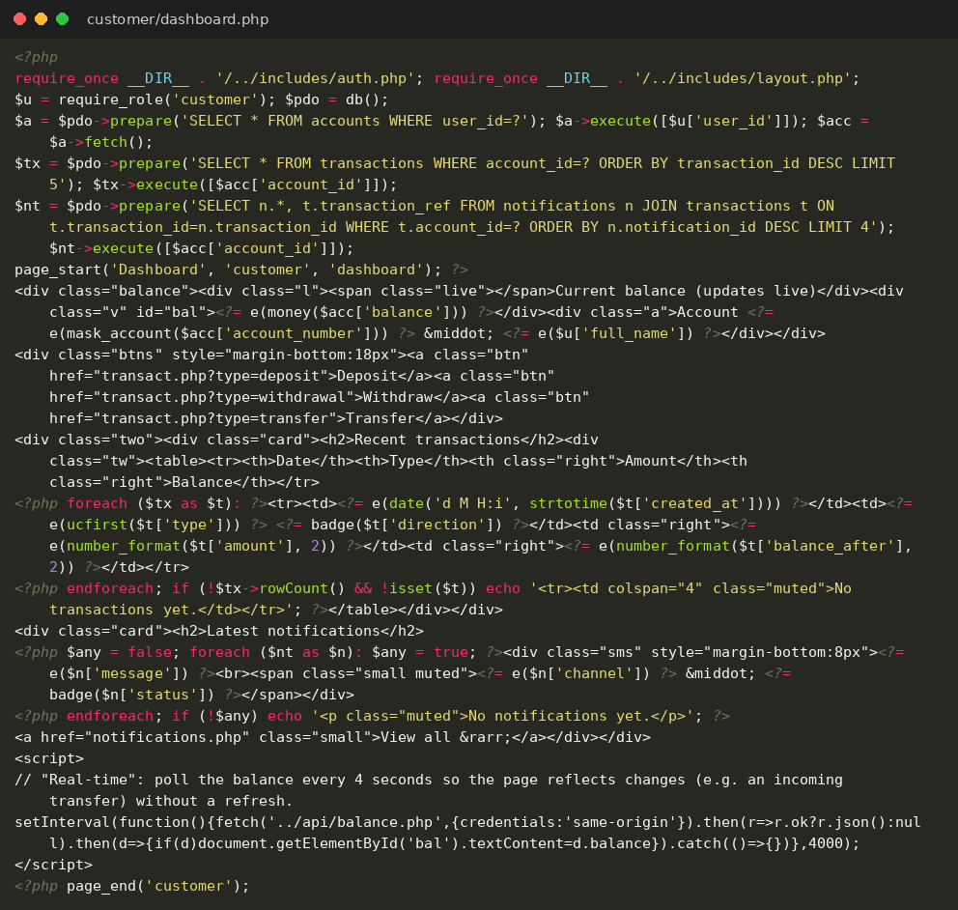
File: customer/transact.php
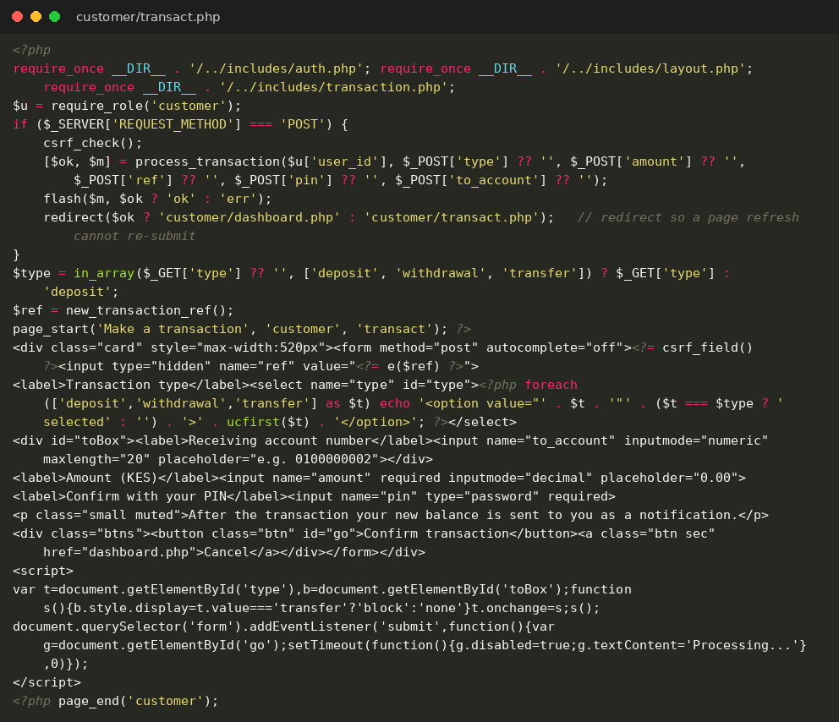
File: customer/history.php
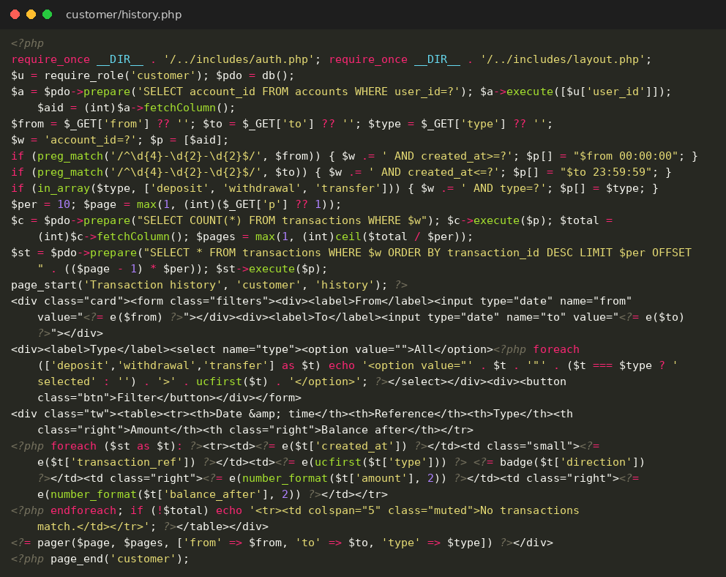
File: customer/notifications.php
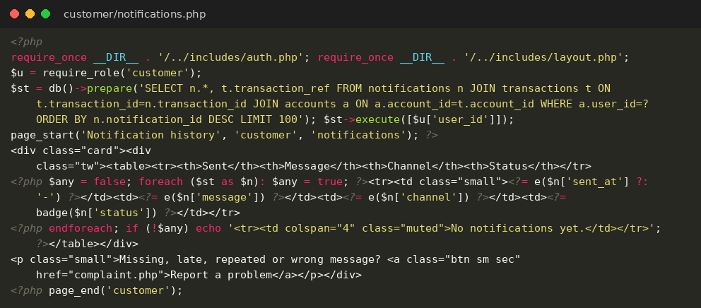
File: customer/settings.php
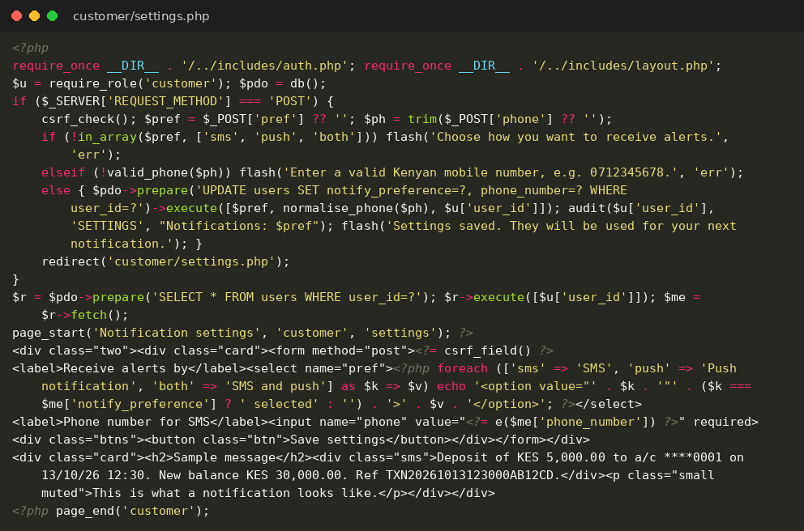
File: customer/complaint.php
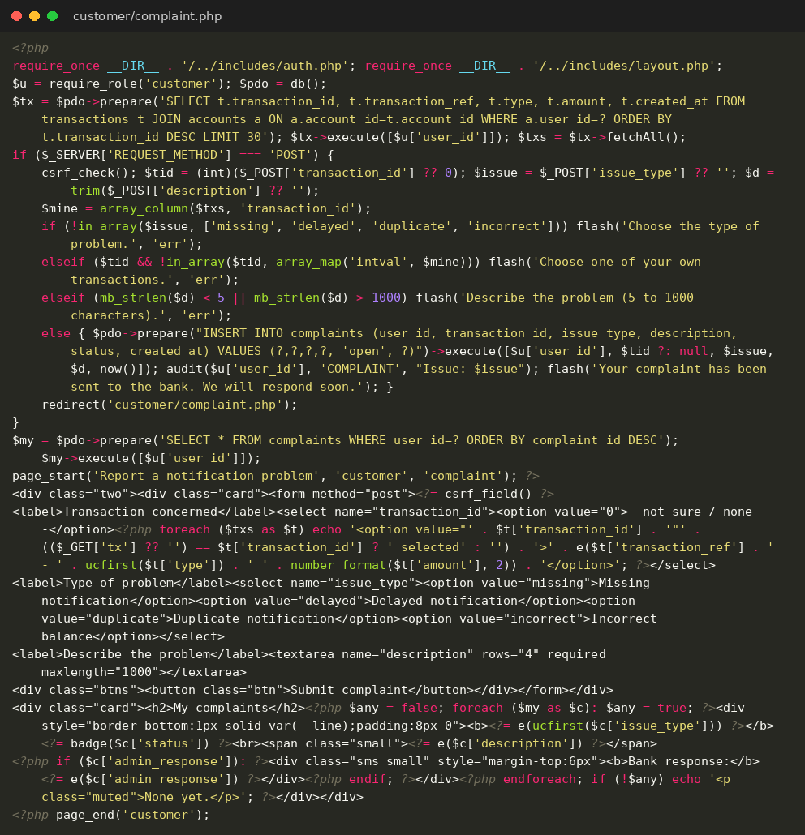
File: admin/dashboard.php
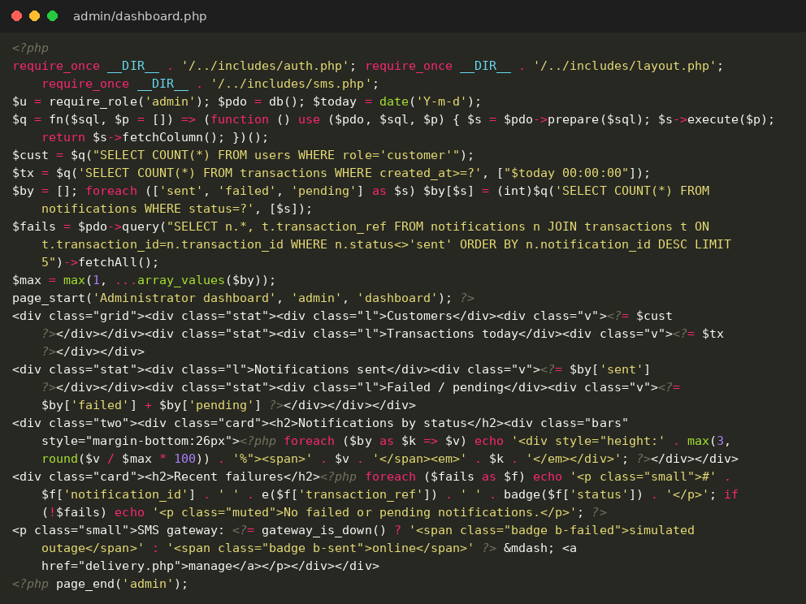
File: admin/customers.php
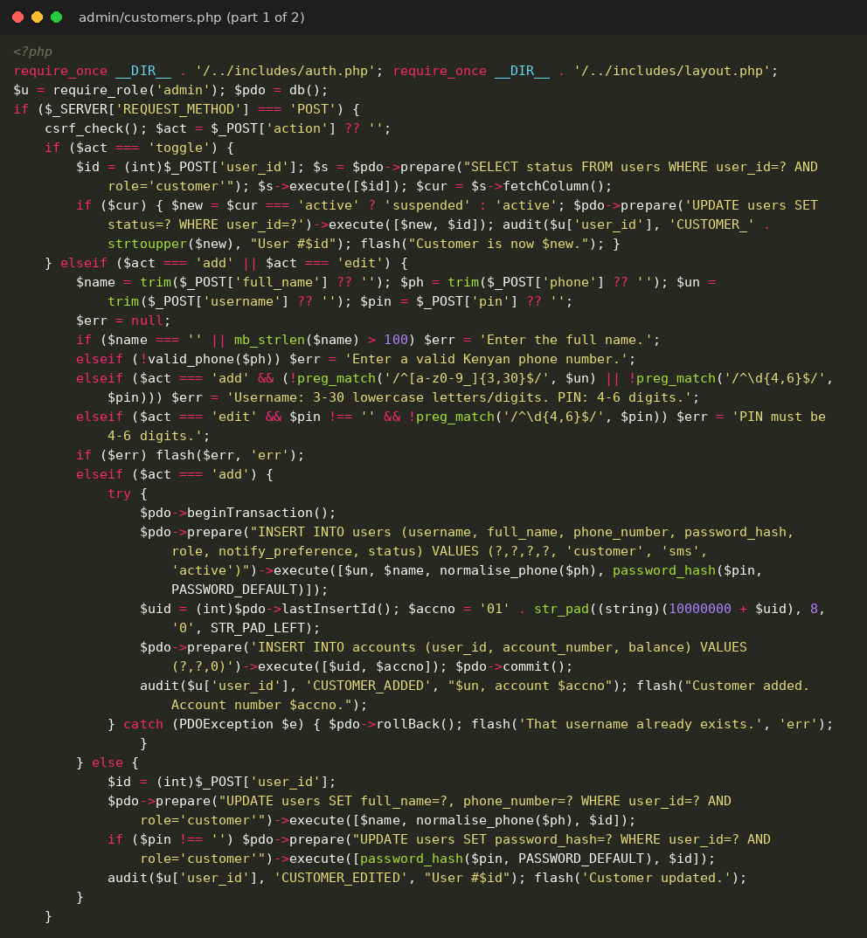
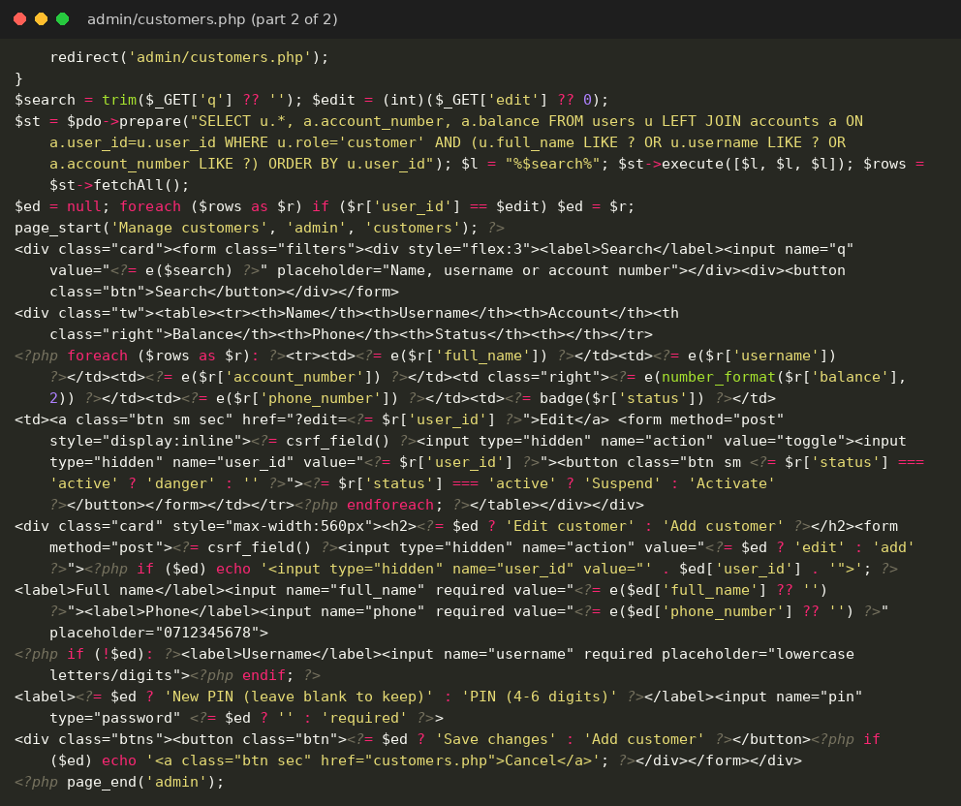
File: admin/transactions.php
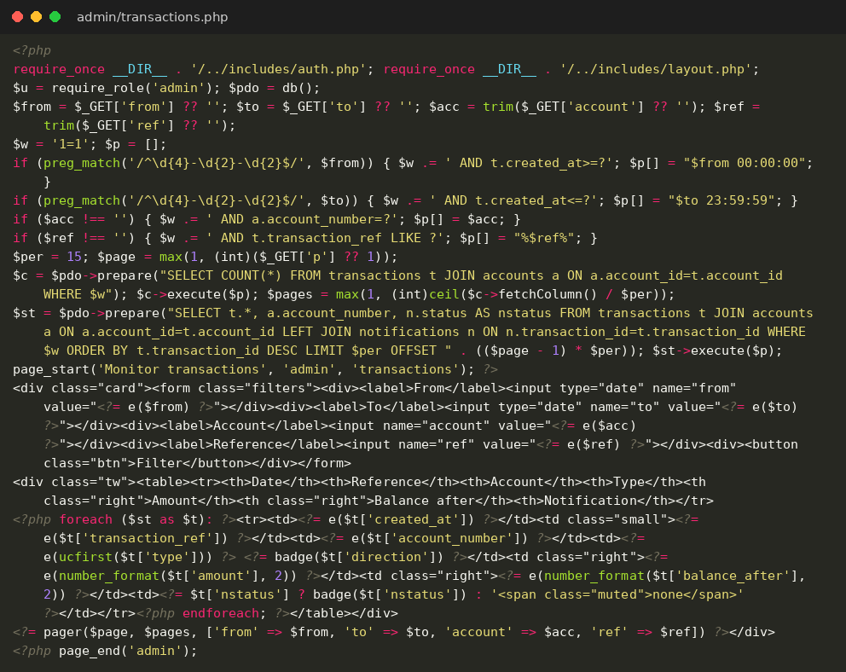
File: admin/delivery.php
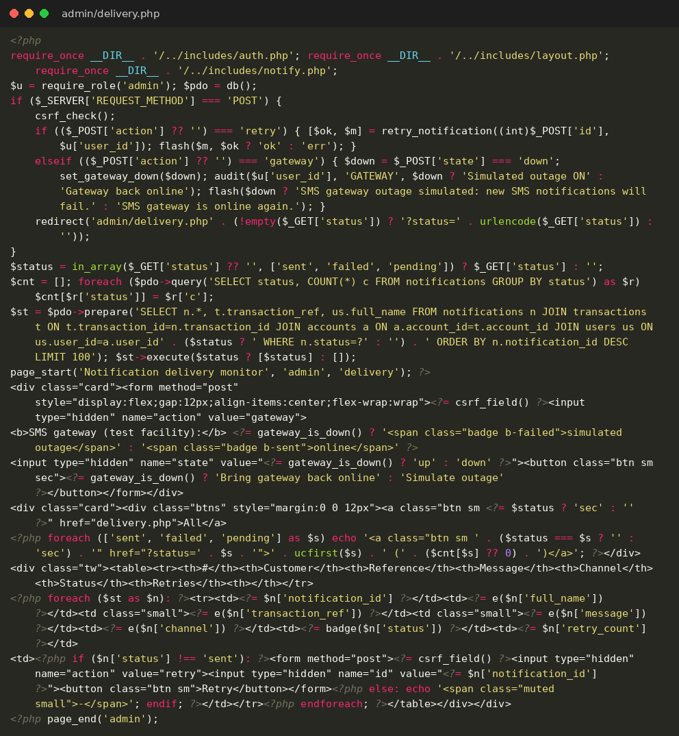
File: admin/complaints.php
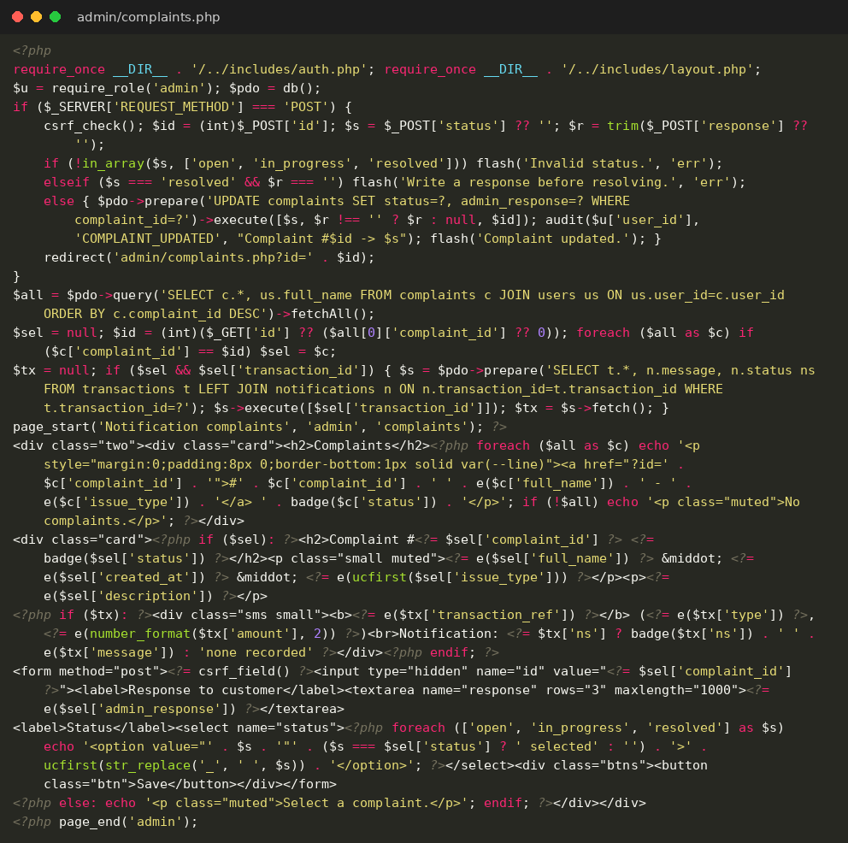
File: admin/reports.php
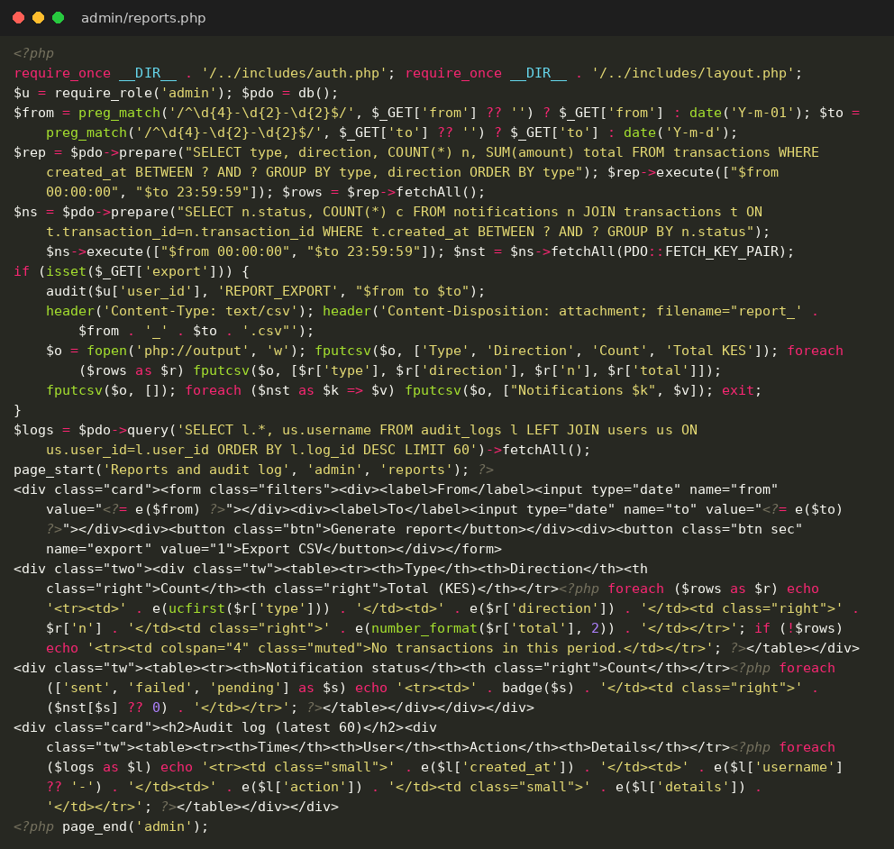
File: assets/style.css
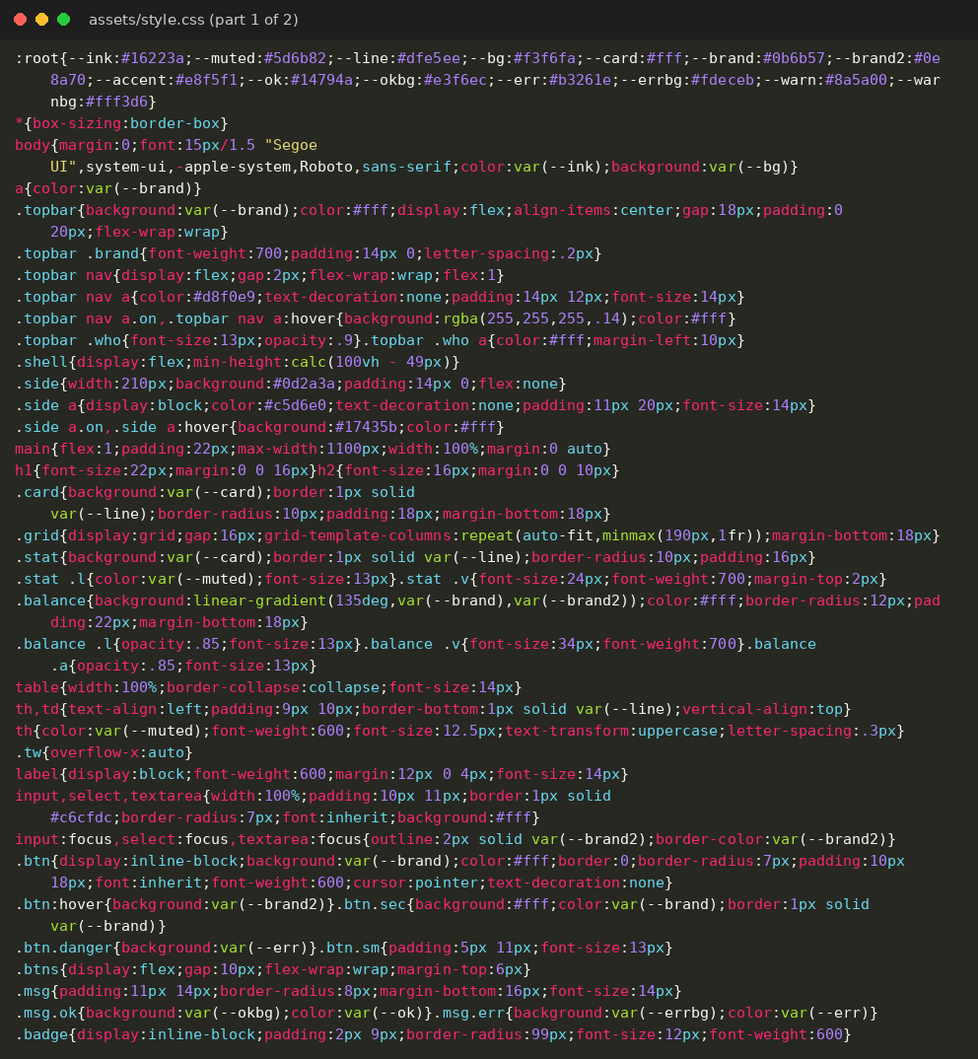
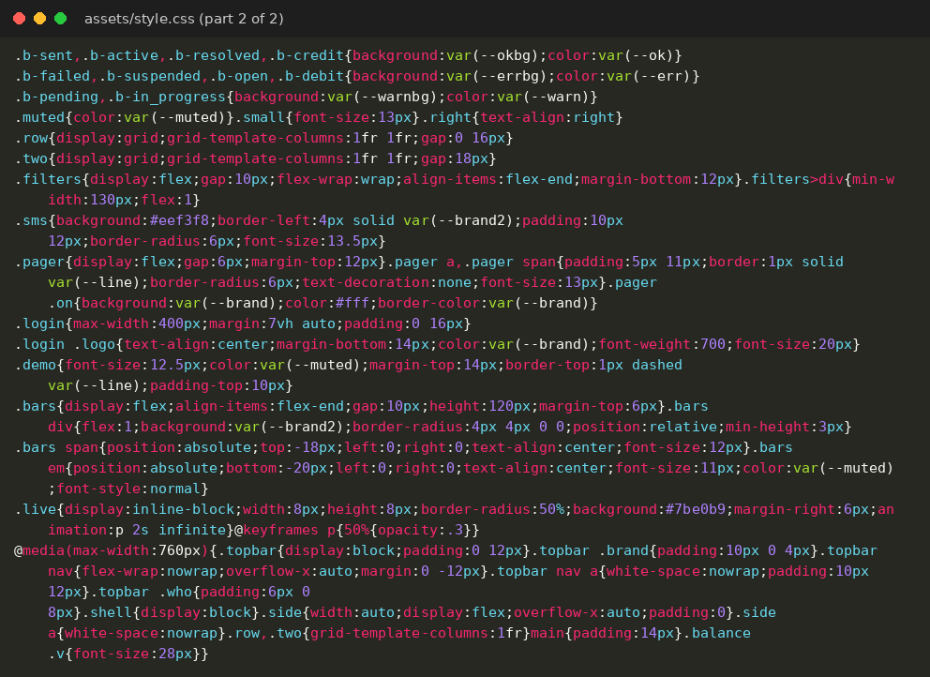
Appendix IV: Database script and test script
The script that creates the database, the tables and the simulated starting data (the passwords and PINs are stored as hashes) and the automated test script used for the tests in Section 3.8 are listed below.
File: sql/schema.sql
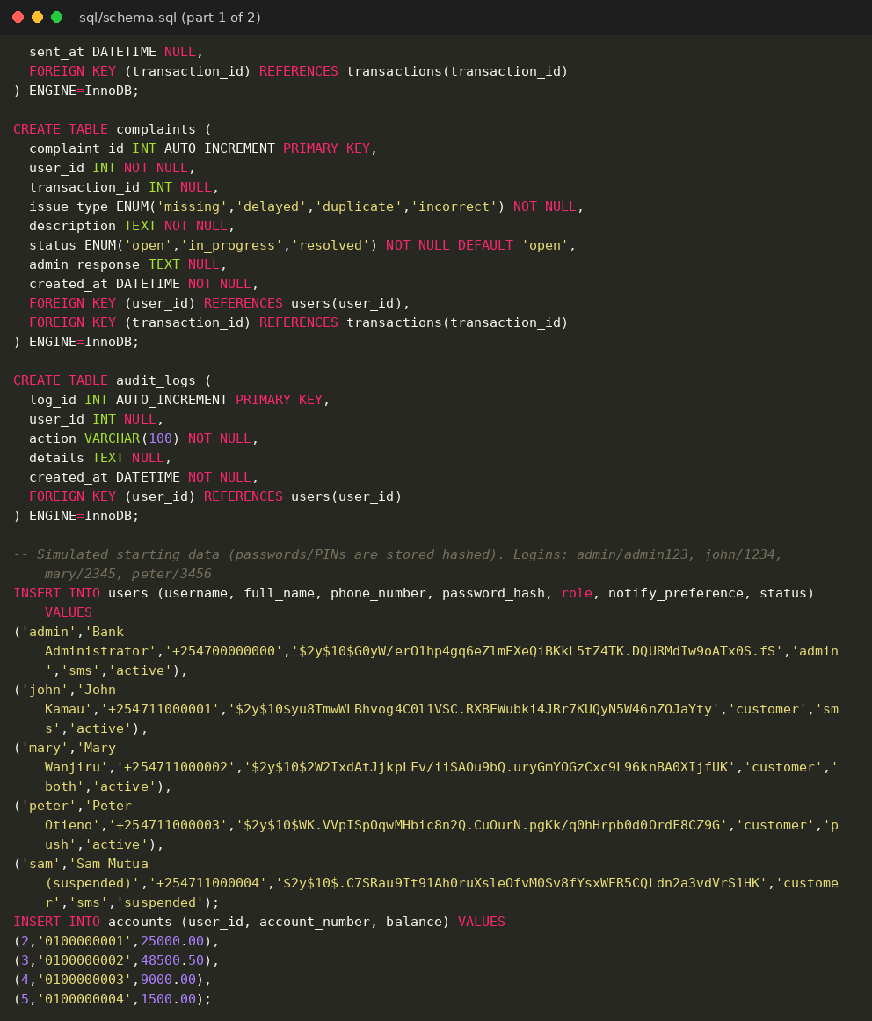
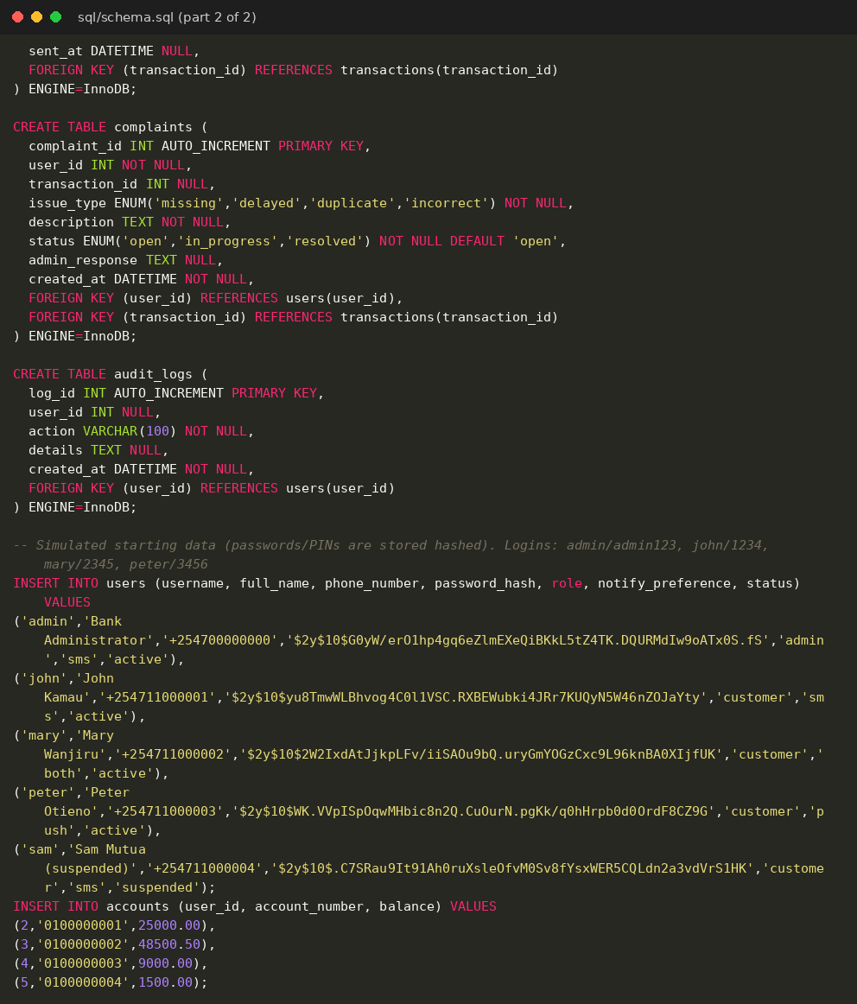
File: tests/e2e.py


